Overview of Electrical Engineering for School Design

Thomas Mason, PE

Course Content

CONTROLLING CODES

The way a construction project works is the Architect does preliminary negotiation with the Authority Having Jurisdiction (AHJ), usually the local municipal Building Department. They agree upon which regulatory Codes will apply and, usually, the Architect presents any innovative design concepts to see what the reaction is. The answer is always, “We will decide when we see the complete design package.”

The AHJ has very little range in negotiating the applicable Codes. The exception (more often than you would expect) is the official date for the project. If the Architect can convince the official that it was started before the latest Code took effect in the locality, he is permitted to design under the previous Code. This is why is critical to get a copy of the Code Sheet from the Architect. Today, critical codes are the State Building Code, the National Electric Code and which Energy Conservation Code(s) has been adopted locally. Energy Codes can be State-wide AND vary from county to county and community to community.

ACTION ITEM: Request a copy of the Code Sheet from the Architect.

The State Building Code is almost always a recent version of the ICC Building Code (iccsafe.org). As Wikipedia says,

“The International Building Code (IBC) is a model building code developed by the International Code Council (ICC). It has been adopted for use as a base code standard by most jurisdictions in the United States.

International Building Code - Wikipedia
https://en.wikipedia.org/wiki/International_Building_Code”

When they say, “base” they mean that the State or municipality can add or delete portions. Usually, these are expensive parts that local Contractors insist on having delayed three years until the next Code cycle. For us, the Building Code is interesting only in which year of the National Electrical Code (NFPA.org) will apply.

While waiting for the Architect’s Code Sheet, you can get an idea (but no certainty) by checking the internet.

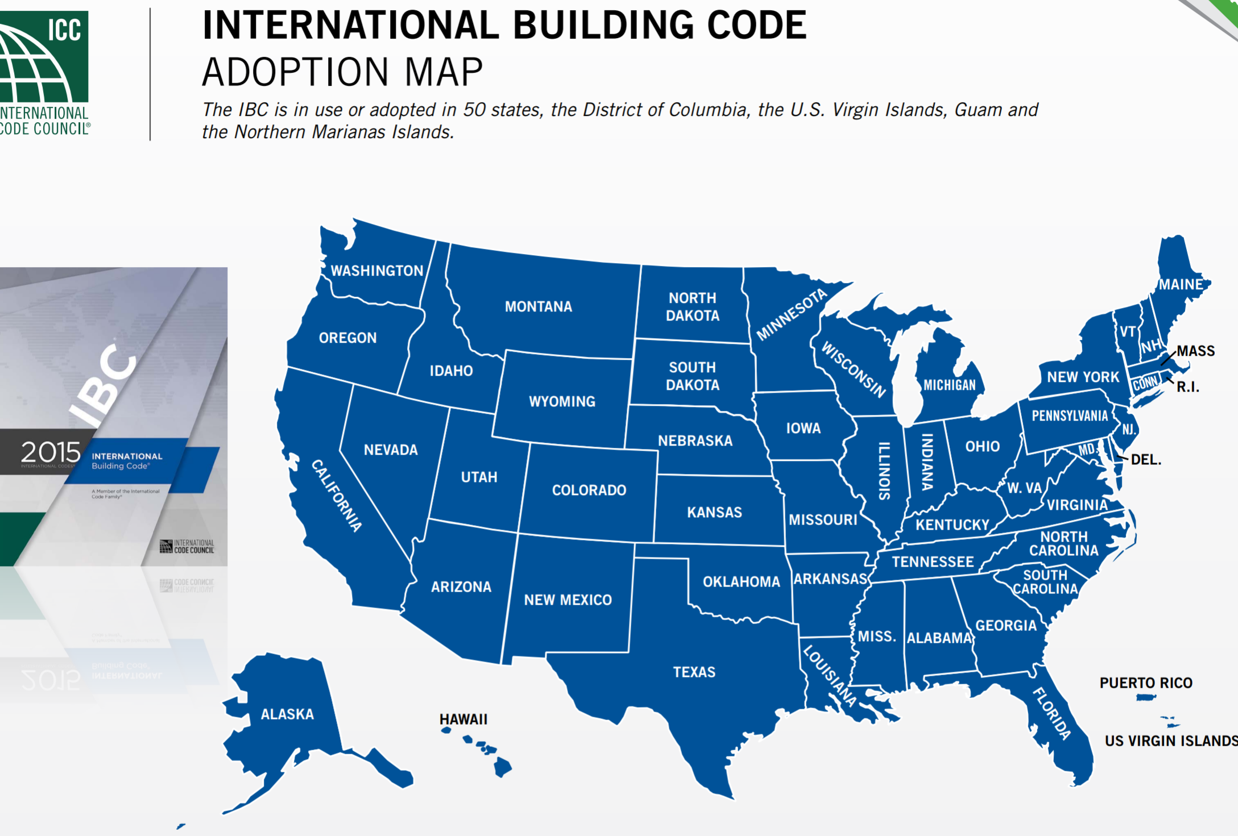
https://www.iccsafe.org/wp-content/uploads/Code_Adoption_Maps.pdf.

You can also call the Building Department and ask them. My experience has been totally favorable on interactions with local Building Departments.

The National Electrical Code also has published maps.

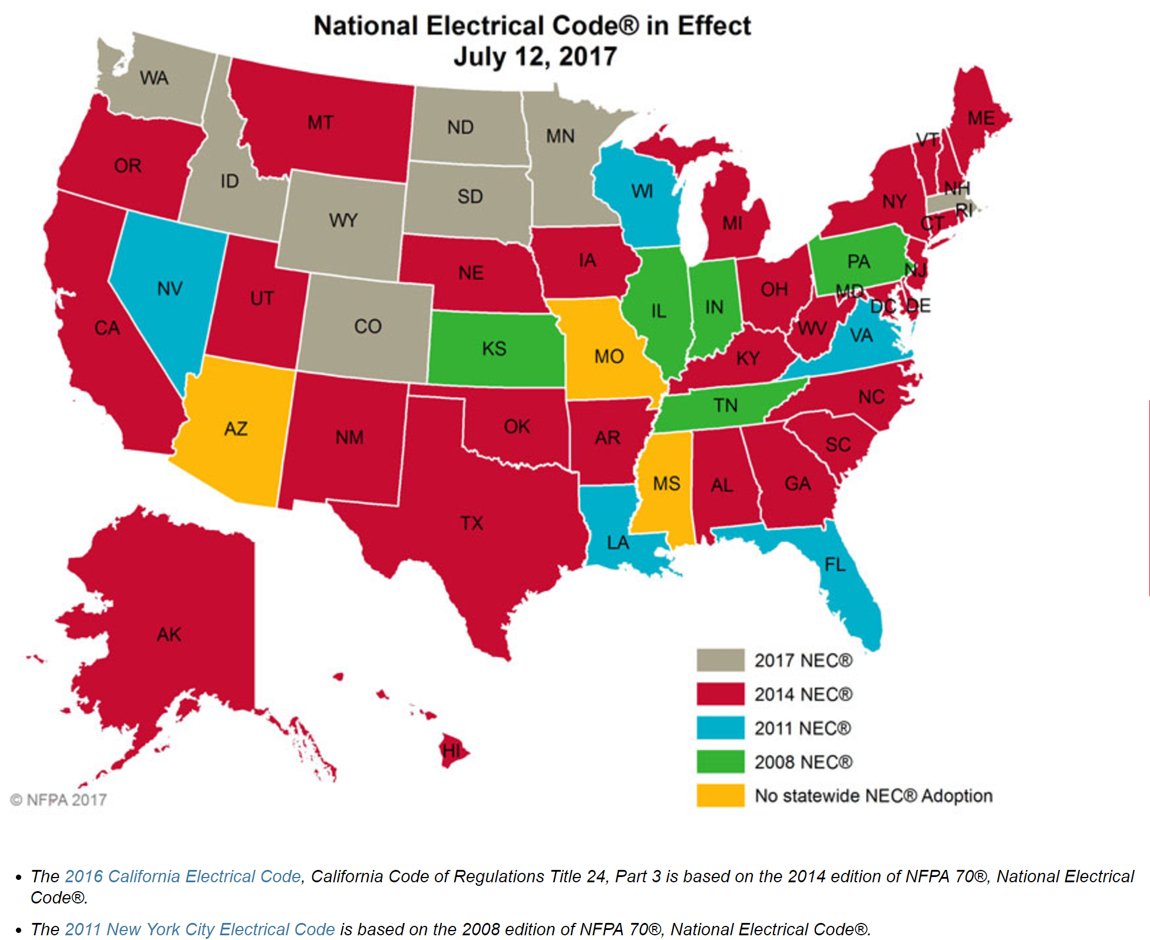

Until recently, it was safe to say that a conservative electrical design was unlikely to have Code-compliance problems with the Plans Review section of getting a Building Permit. Today, however, there have been substantial, expensive increases in the requirements. At the time of this writing, most Plans Reviewers and Electrical Inspectors are not aware of these changes. They will be identified, along with economical compliance methods in the POWER DESIGN section. Note that the resulting trouble is a red circle and note on the returned plans. The required changes are identified and no penalty is applied, beyond the delay of a new submission / review cycle.

Energy Codes have existed since the late 1990’s, but have rarely caused trouble, as they were not enforced by the local Plans Reviewers or Inspectors. Not so today. Almost half of the Building Departments I have worked with are very aggressive in all the fine points of the Energy Code Requirements. The requirements show up in lighting, lighting controls and receptacle circuits.

I will not reproduce here maps of adoption of the International Energy Conservation Code (IECC, ICCsafe.org) or the International Green Construction Code (IGCC, ICCsafe.org). Local adoption is erratic and it is impossible to keep the maps current.

The IECC is the basis for the US Government COMCHECK compliance form, which is very, very common as a required submittal with building plans for review. There are two parts which are critical to compliance - lighting watts per square foot (called Lighting Power Density) and lighting controls, from the last-page checklist. The form calculates PASS or FAIL and tells you what needs to be fixed.

We will review the COMCHECK form here (https://www.energycodes.gov/comcheck) and discuss design complilance when we encounter lighting and receptacles later.

The COMCHECK adoption map follows:
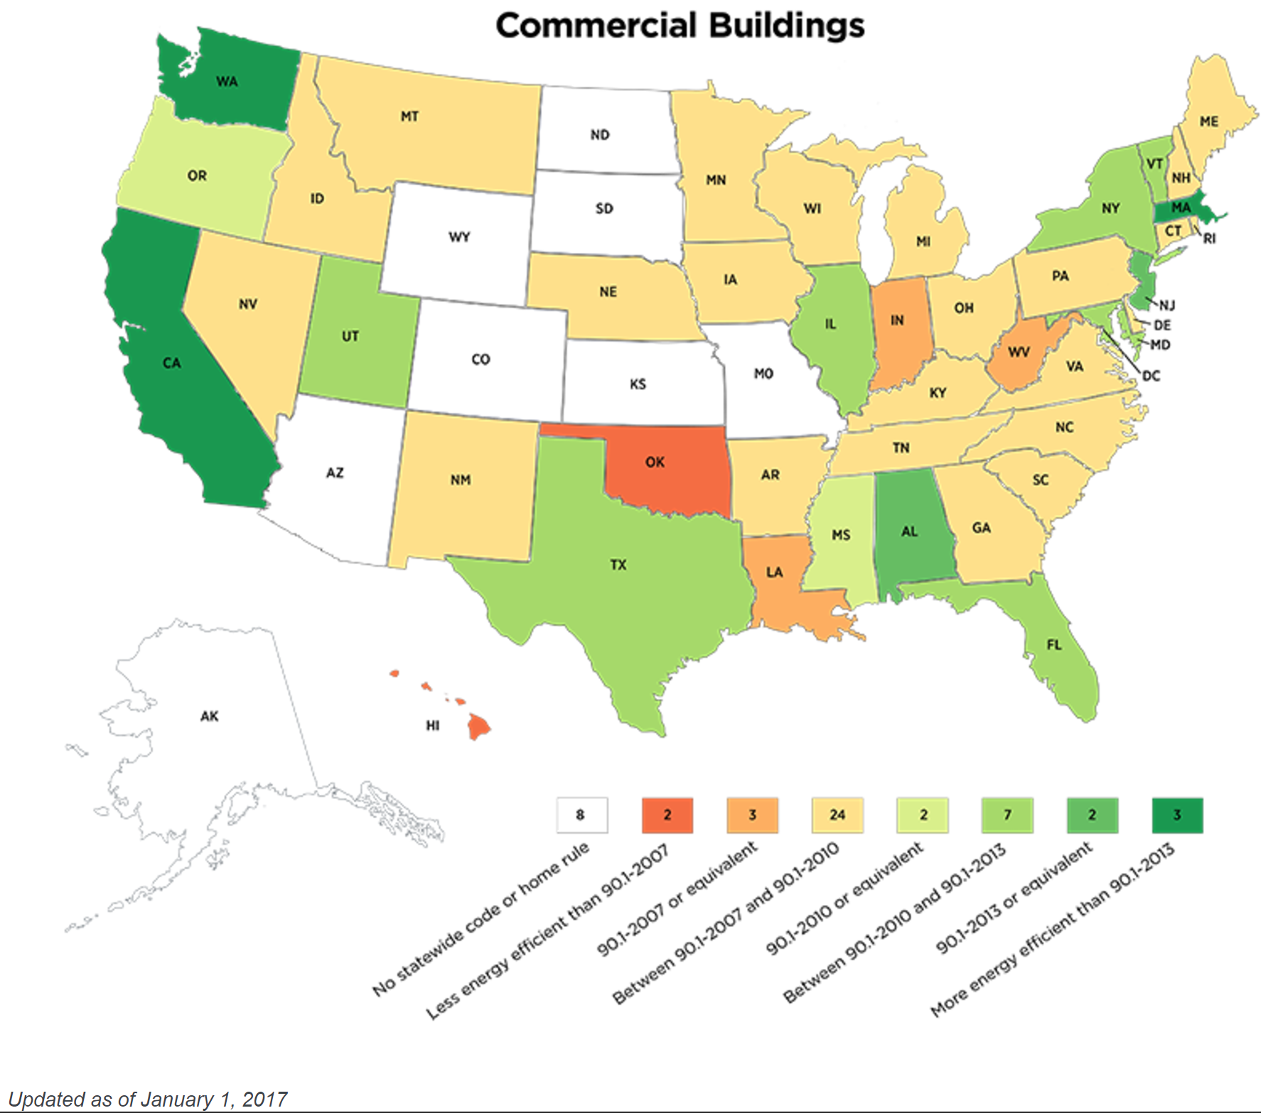
https://www.energycodes.gov/status-state-energy-code-adoption

Do not be concerned by the eight different versions. When you start using the form, it asks for your location and selects the proper version, unless you override it. (This selection shows up on the final form that you attach to your submittal.)

I always recommend download a new version of COMCHECK. It doesn’t change often, but careful is good. The download is 104MB.

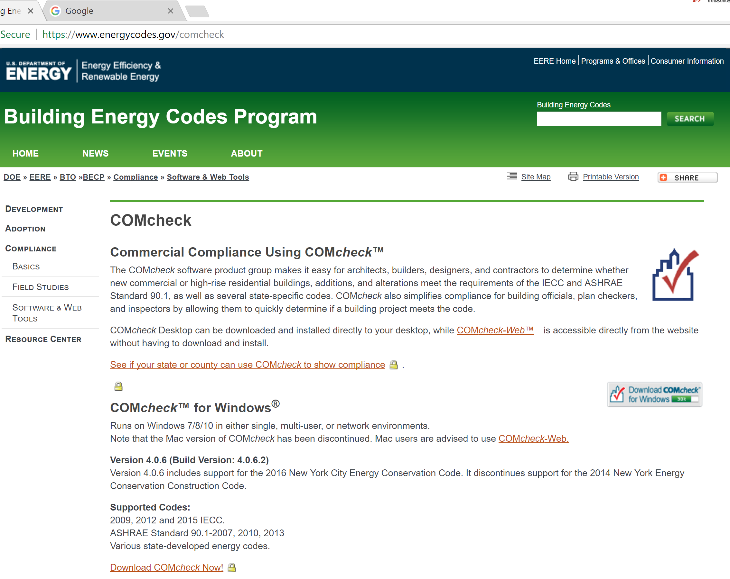
https://www.energycodes.gov/comcheck

I am not going to go through the steps of filling out the form, but I will reproduce the initial section, that tells you the permitted w/sq-ft and I will reproduce the final checklist. These change with different building types and different IECC versions.

COMCHECK wants you to verify that it can be used and offers the following adoption map.
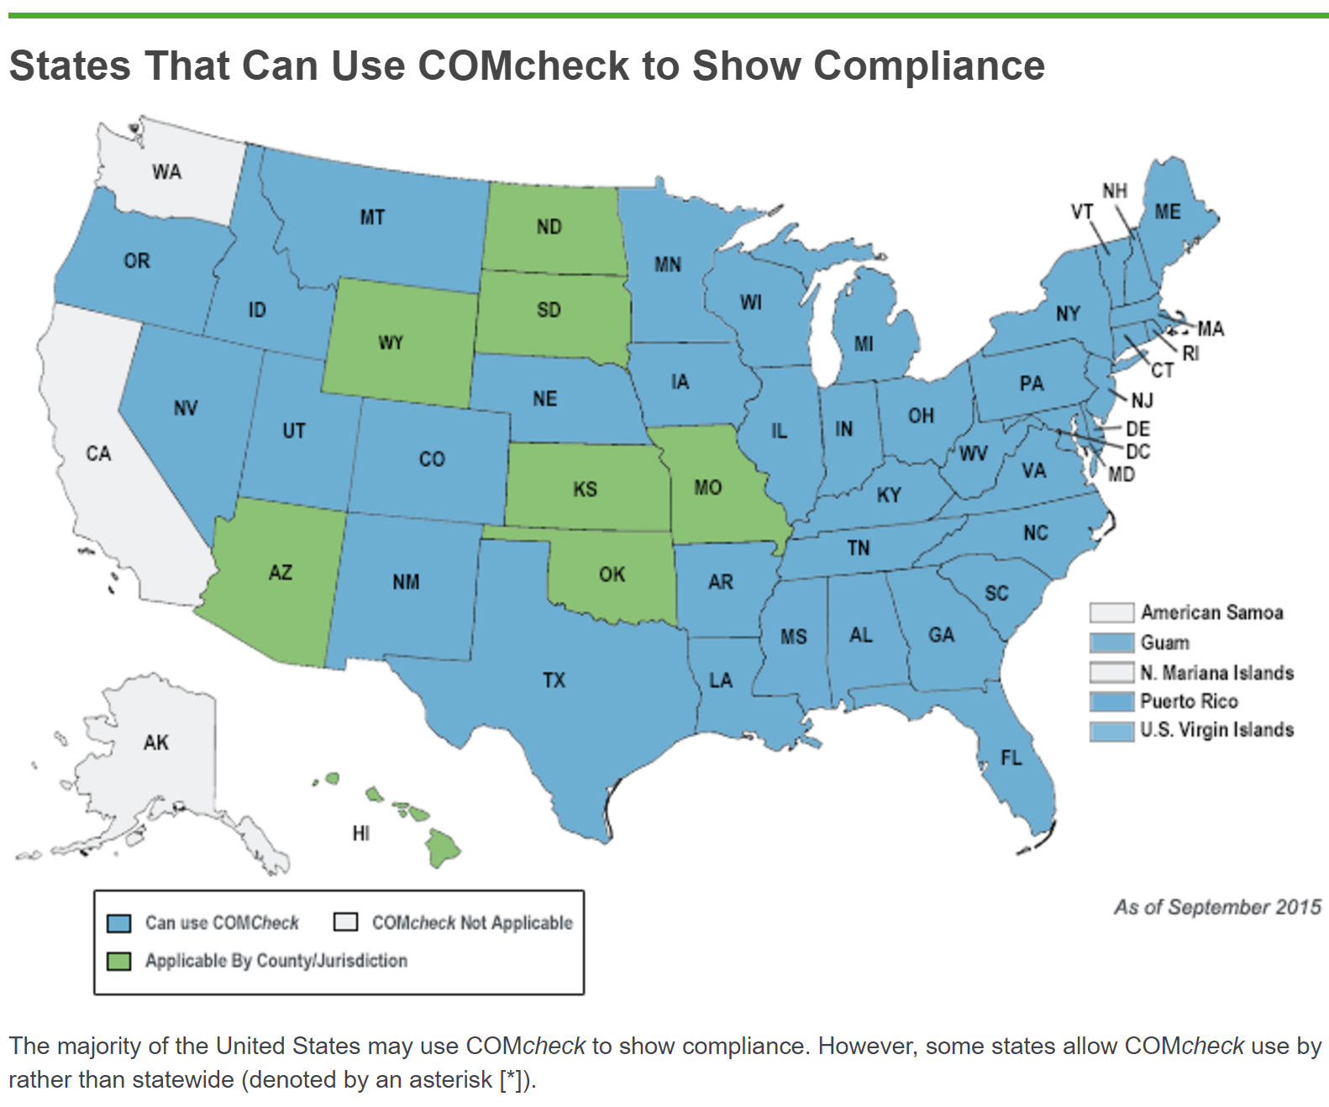
Remember, these maps are indicators only.

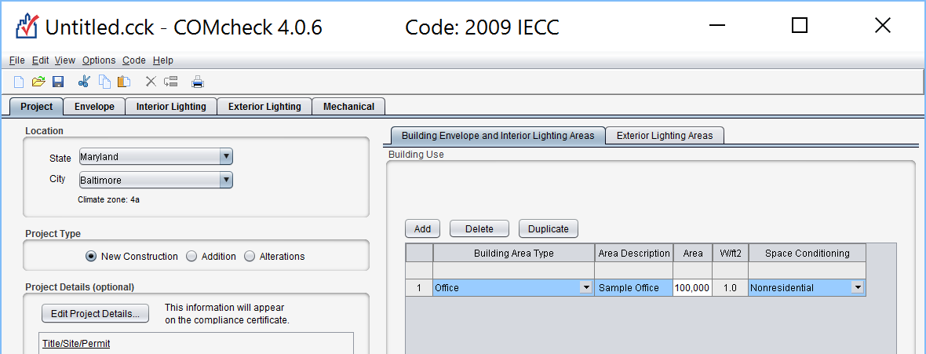

You will be asked for types, counts, watts and some details for each lighting fixture. Note that 1.0 w/sq-ft is permitted for this example. This cannot be achieved without LED fixtures.

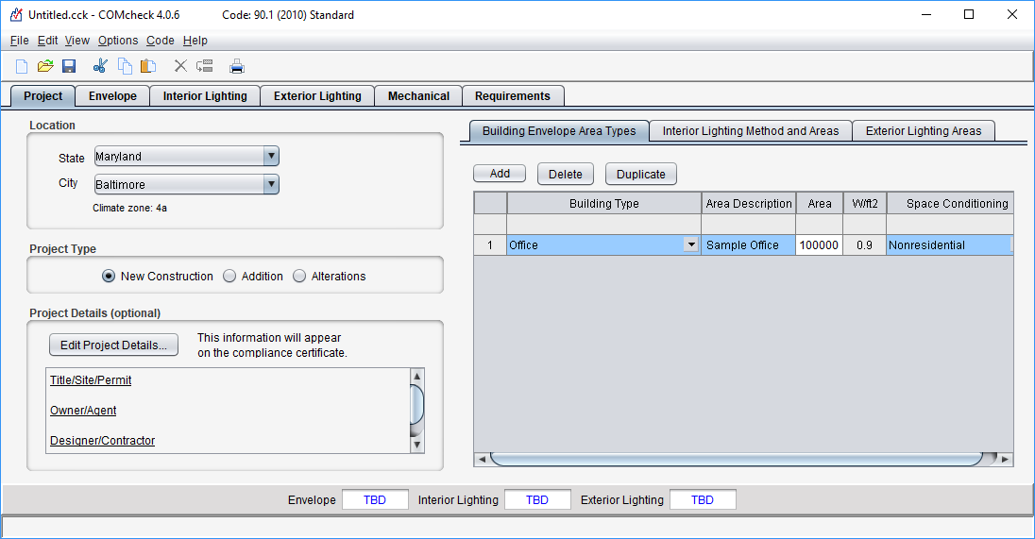

I followed the instructions I just gave you and COMCHECK refused to display the report with the checklist. I went to a different PC and tried again. It worked and would display the checklist, but it chose a DIFFERENT W/SQ-FT LIMIT. I have been using COMCHECK since 1995 and this is the first software problem I have encountered. I think the requirement error results from the software defaulting to the wrong IECC.

We are not going through data entry, but I wanted you to see what the form looks like. For some fixtures, you have to pretend it is an available fixture with the correct values.

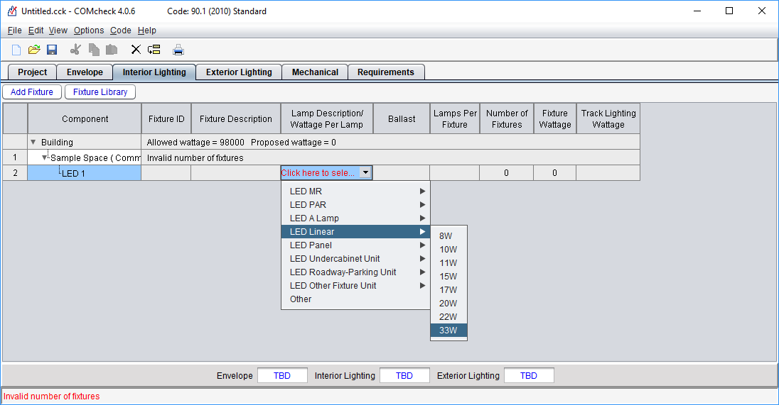
And, I was able to get it to print the checklist.

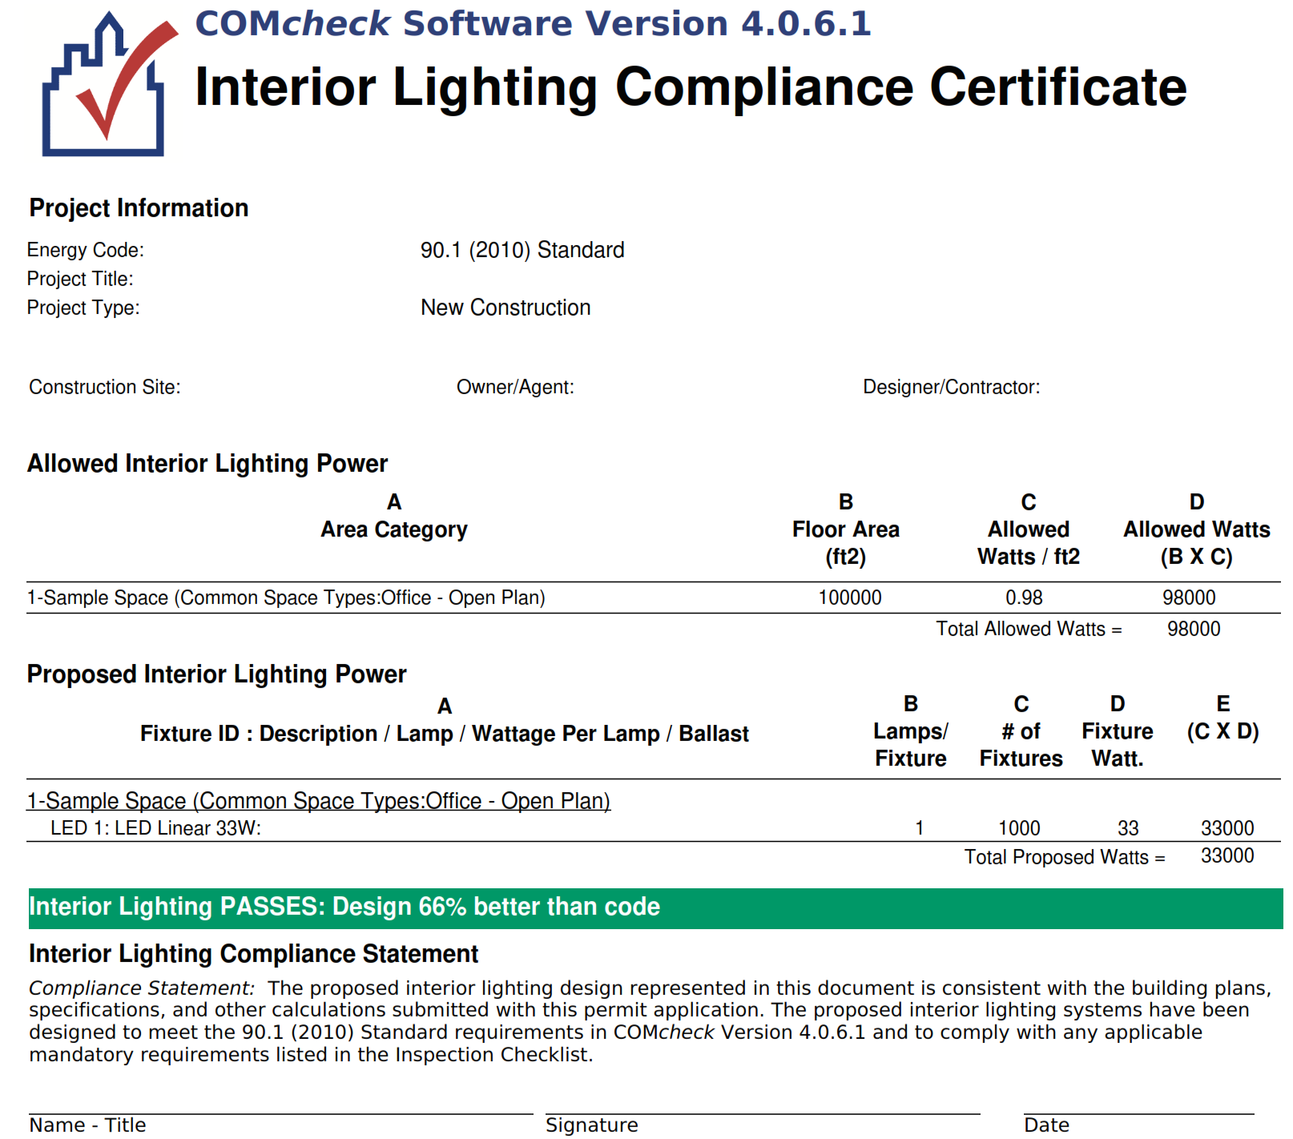

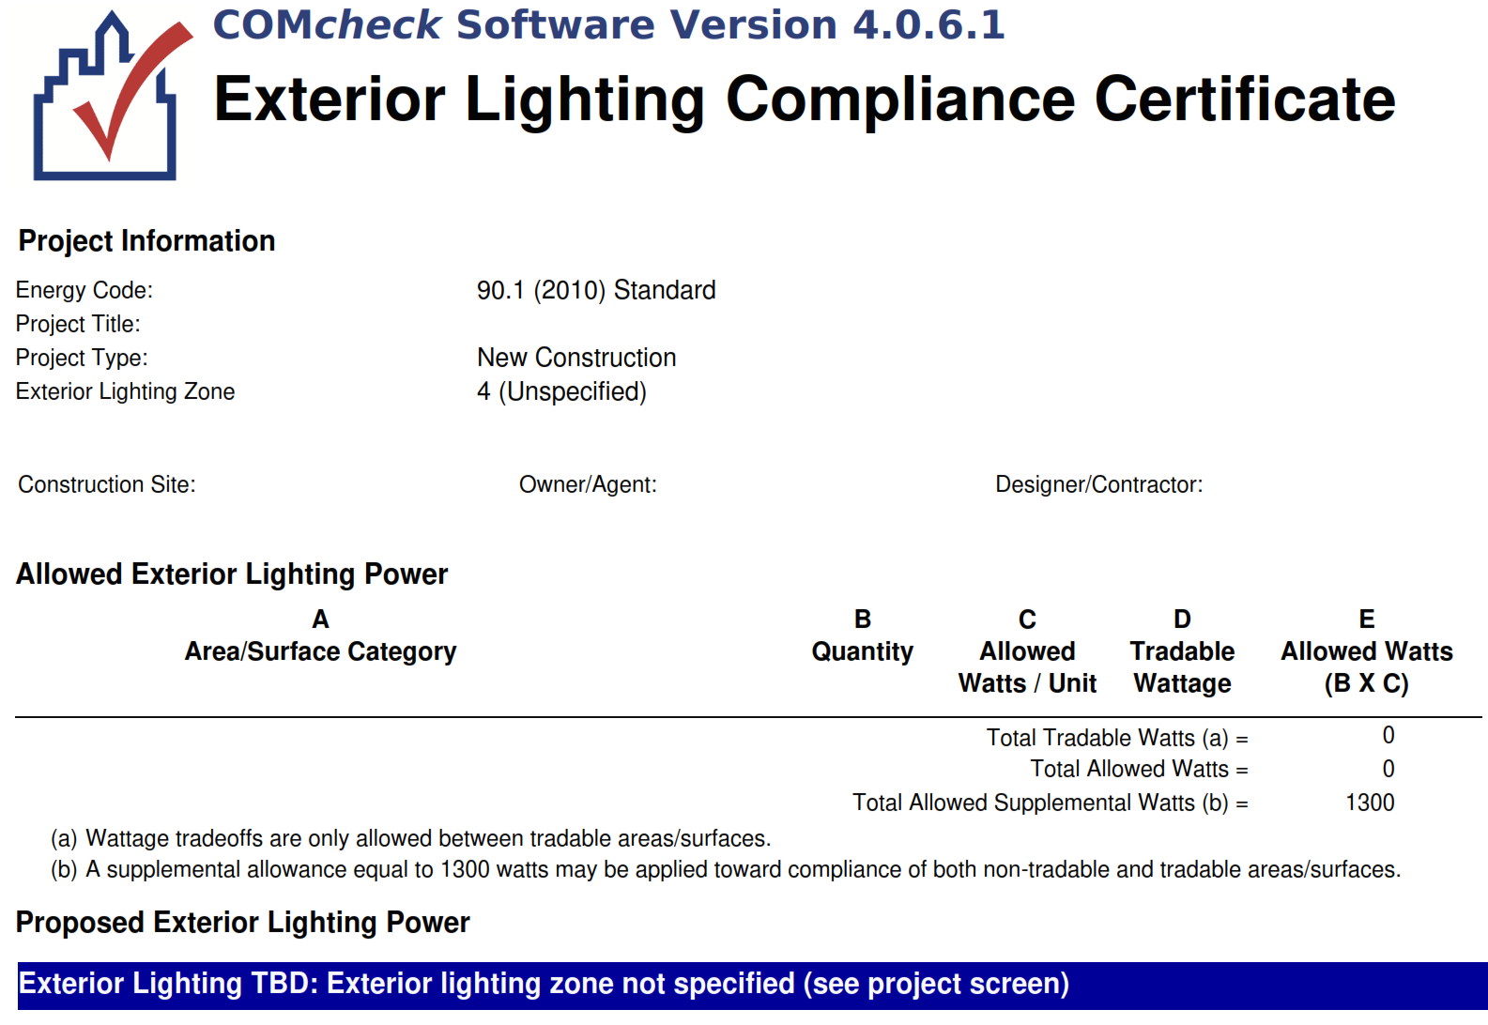

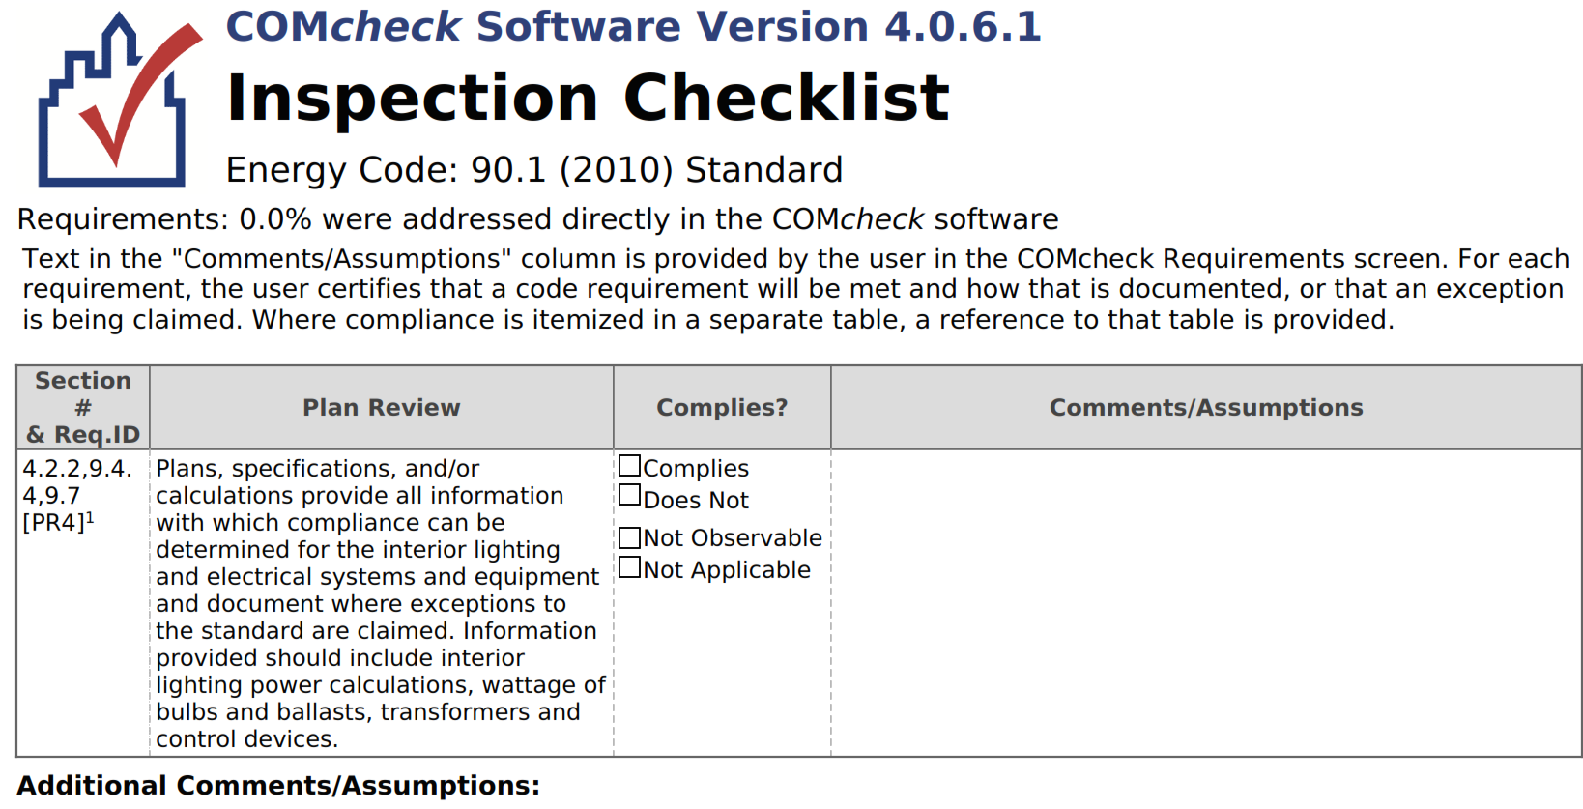

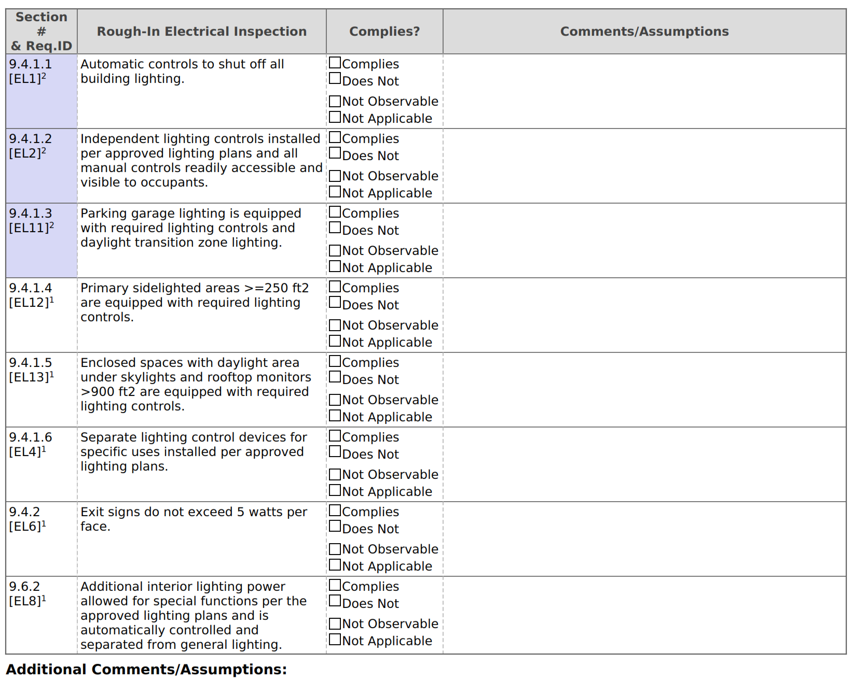
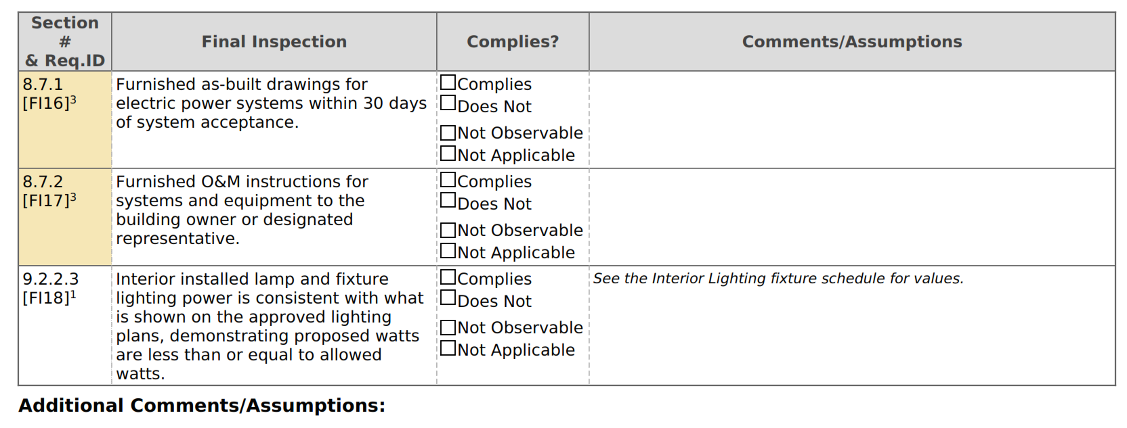

Please study the individual check-off paragraphs. Note that 9.4.1.1 does not exclude hallway lighting, exit signs and security lighting. There may be exceptions in the body of the Code, but most Plans Reviewers and Inspectors go by the words of the paper in front of them. Occupancy sensors now work very well, though, and a completely dark building is not necessarily dangerous.

[Followup: IECC 2015 specifically excludes exit signs from lighting control requirements.]

Occupancy sensors and dual-level lighting are not mentioned in this version of the checklist. That is why it is important to be using the correct version. The “dark building” requirement refers to timeclocks or occupancy sensors. Almost everyone chooses occupancy sensors

9.4.1.2 says, “Independent lighting controls”. That means a local light switch. Most Owners do not want local light switches. They blank off the switch after the last Inspector leaves. With occupancy sensors doing the actual control, eliminating local switches is arguable. However, the IECC and COMCHECK require them as part of the design.

9.4.1.5 requires photocells to turn off lights next to windows or under skylights. This is just a different sensor on the same WattStopper power pack (www.legrand.us/wattstopper.aspx) we have used for occupancy sensors for decades.

LEED requirements will not be discussed here, though it is likely that you will run into them on government projects and some high-end commercial projects. Your author has a strong distaste for this opportunistic marketing organization which latched onto the environmental movement to make money. Their requirements are derived from ASHRAE 90.1, IECC and IGCC. Your interest in LEED is limited to their forms and required calculations.

ASHRAE 90.1 requirements are not discussed here because they are rarely applied directly. Instead, the ASHRAE 90.1 requirements are copied, intact, into the newest IECC. IGCC starts out with the statement that they are demanding 10% better performance than IECC

For State-funded public schools, the State issues a design guide, indicating what is required in each room they are paying for. My personal experience is limited to Ohio and Michigan, who use exactly the same two-volume requirement with tiny revisions differentiating each state. An example follows:

ofcc.ohio.gov/Resources/DesignManual(OSDM)/2017OSDM.aspx

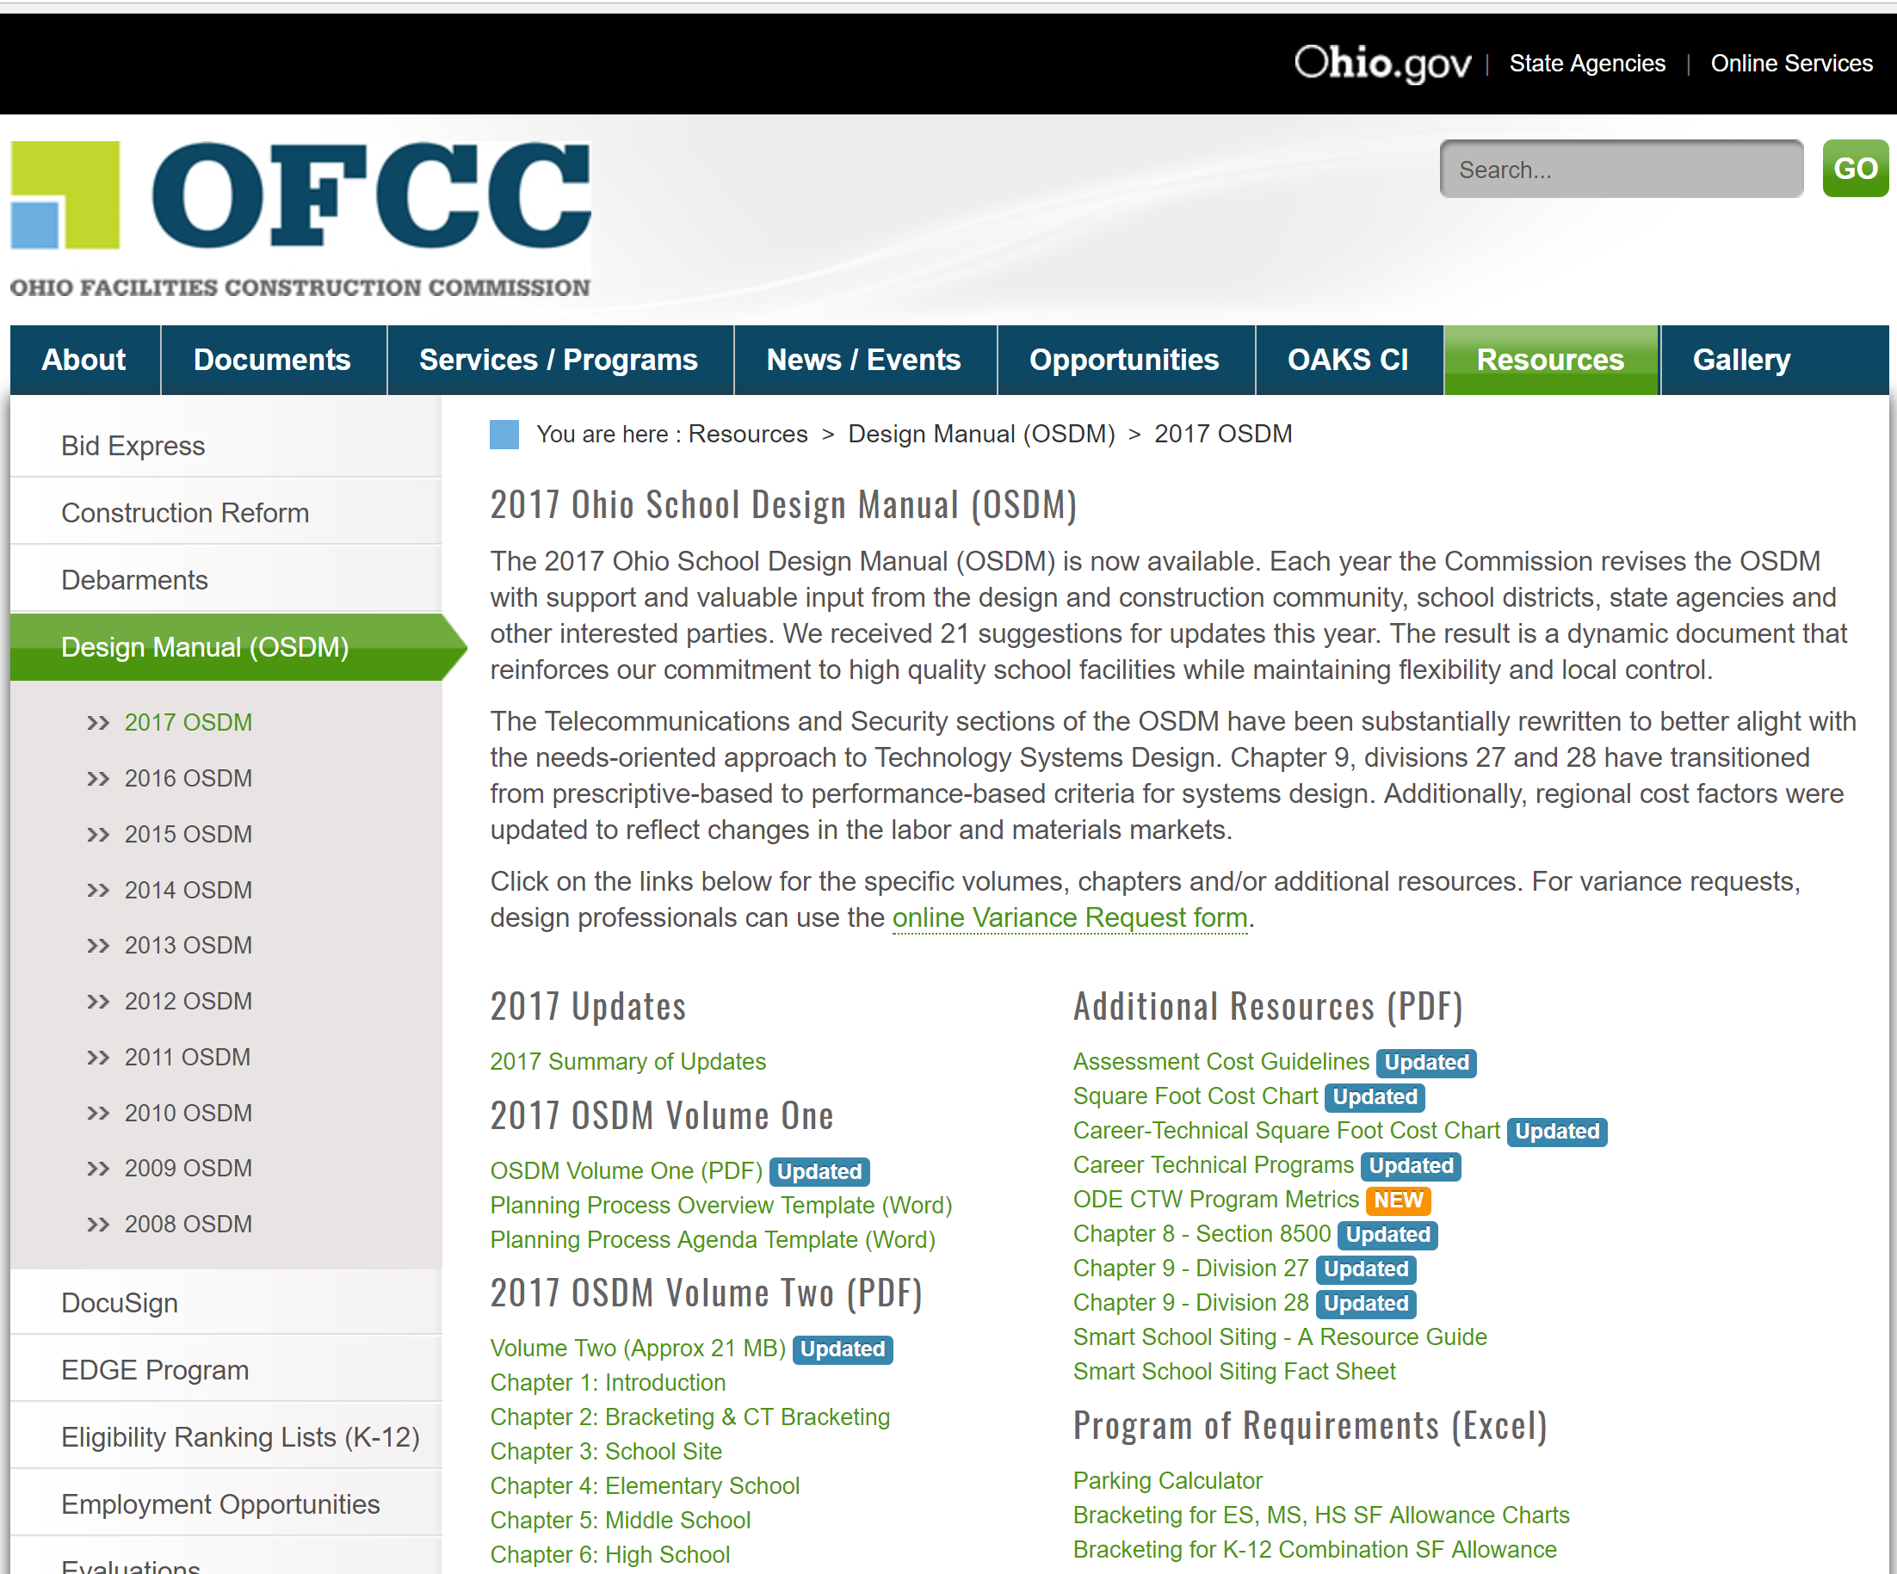

Note that each year has a different pair of books. The negotiated date of start of the design determines which controls.

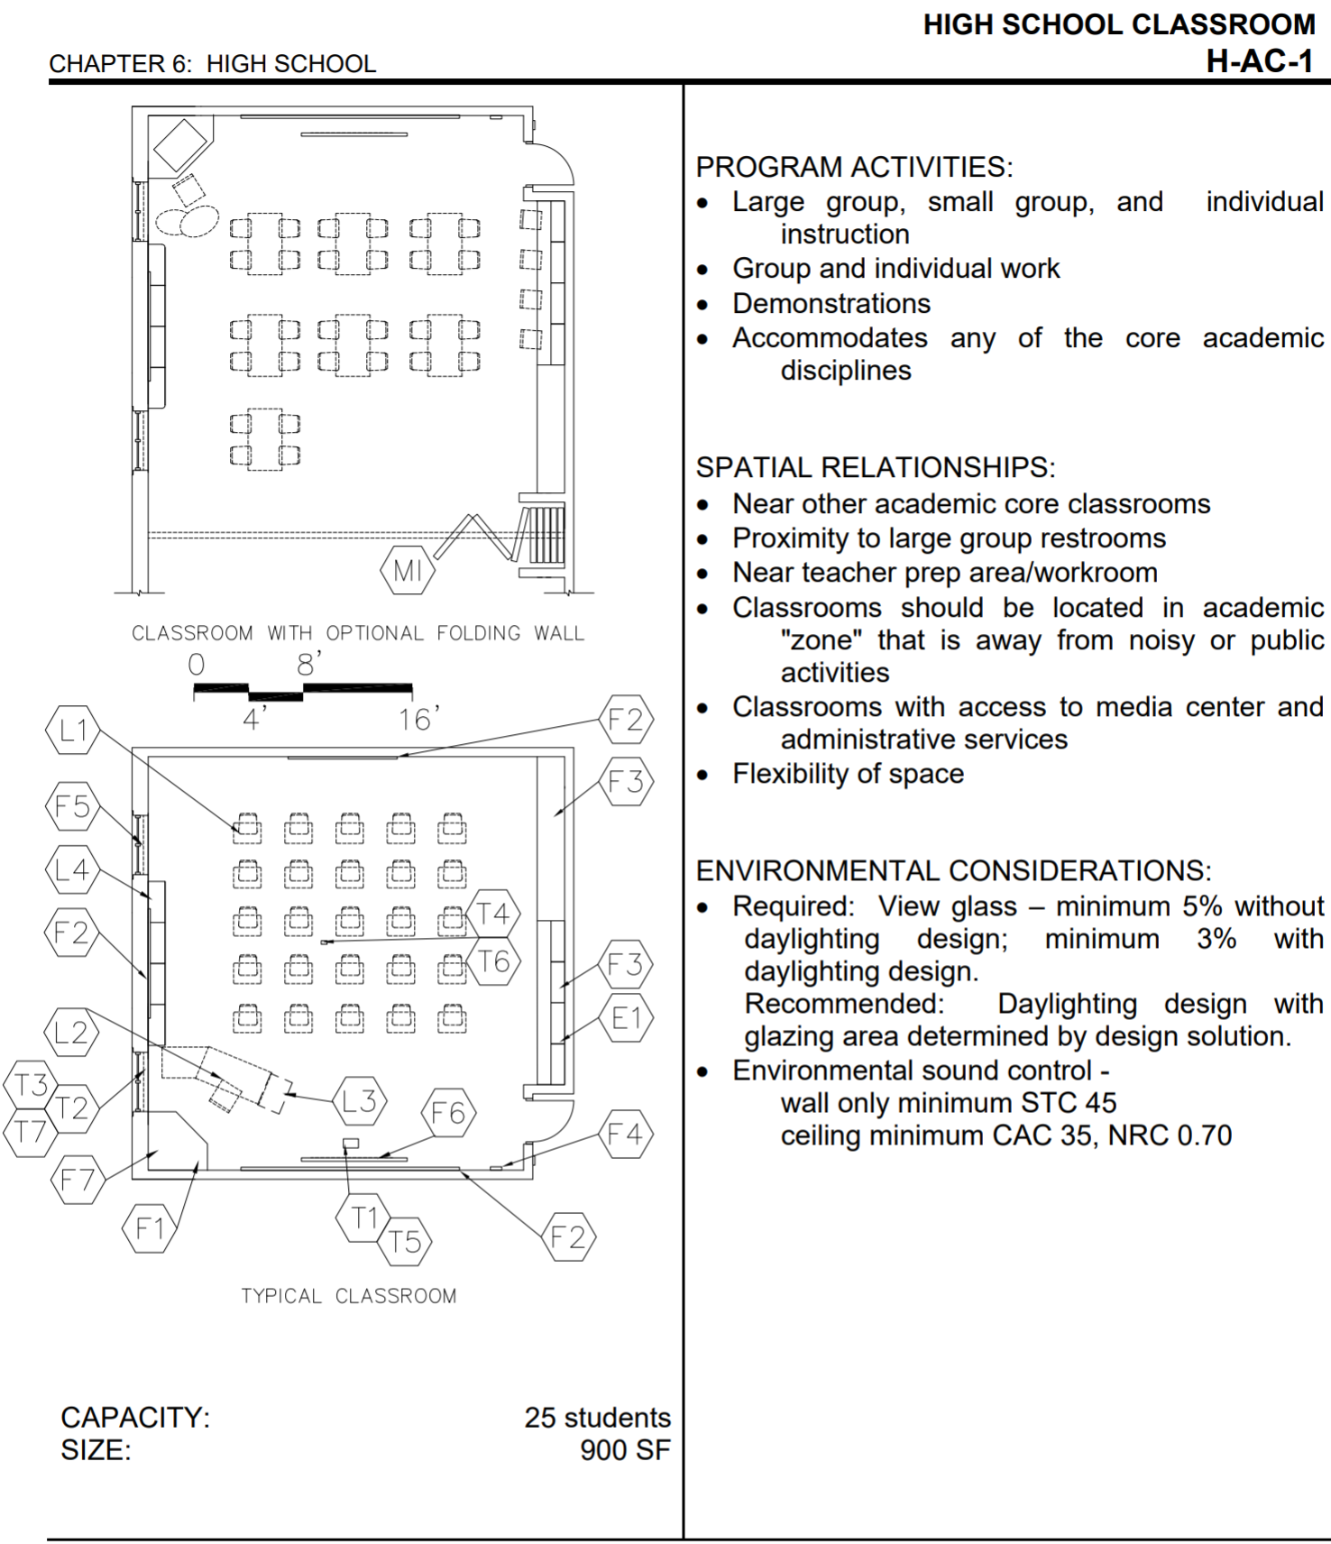
This is an academic classroom, accessed through the 2017 version but actually the 2014 version with no changes. You can see that almost all of the requirements are for the Architect.

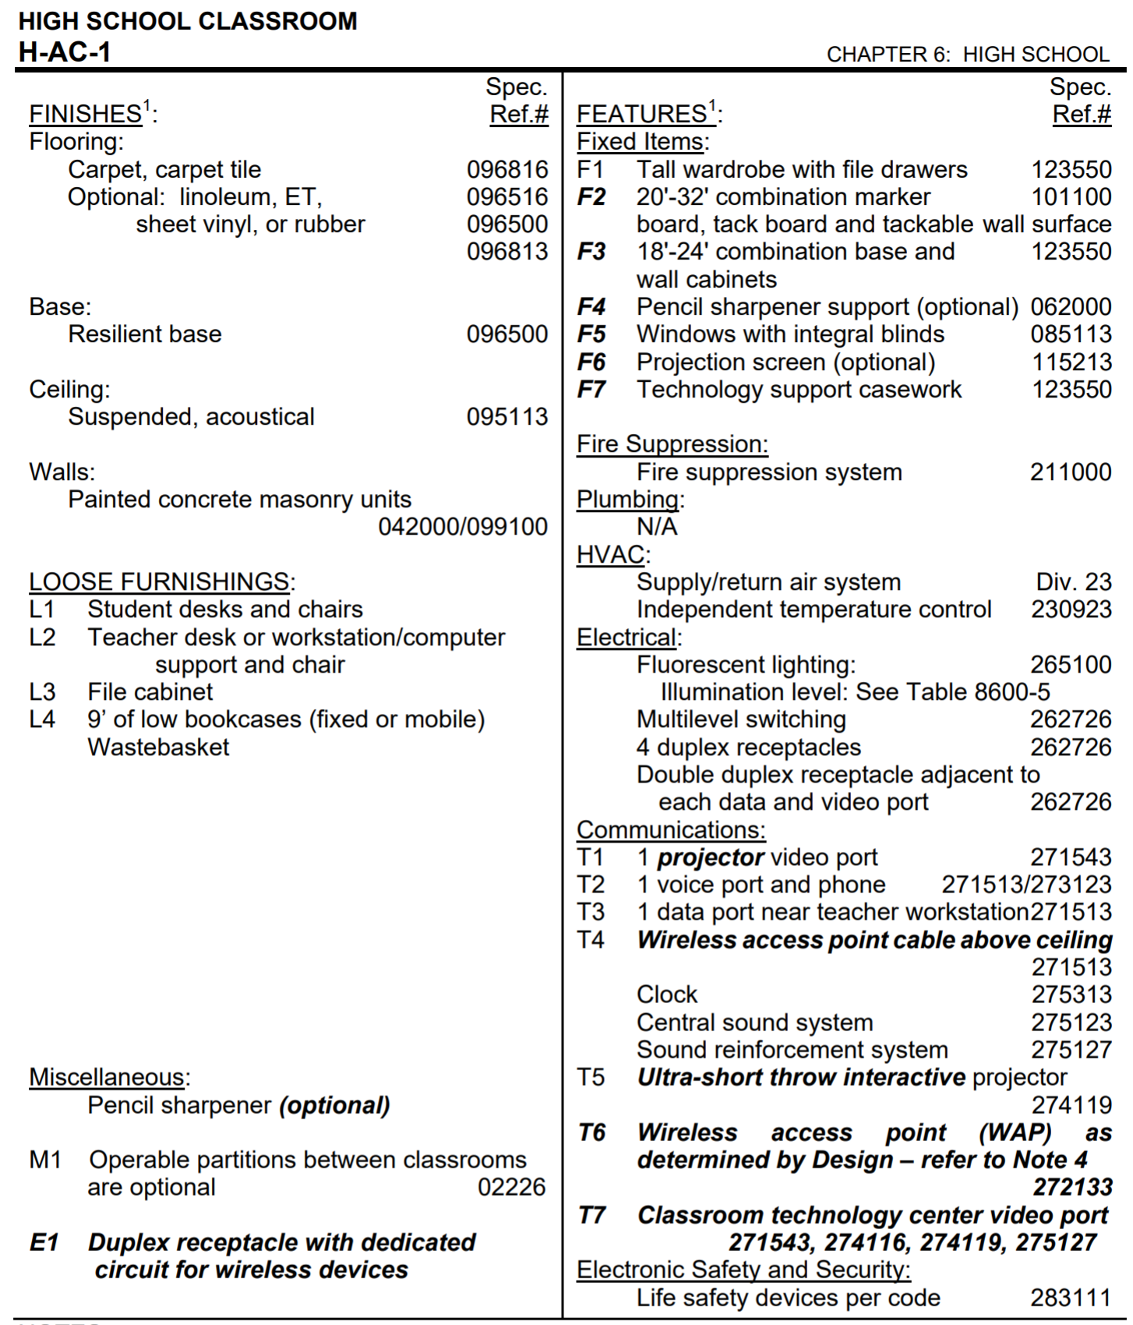

This is the textual version which follows immediately. The bold sections are revisions from the previous version. There are only four items of Electrical shown, and fluorescent lighting cannot comply with the present IECC. The reference numbers, which look like CSI Electrical Specification Sections, refer to guideform specs provided by the State.

CSI specifications can be purchased from MasterSpec. Public domain versions are available on the internet. Search by the MasterSpec number.

MasterSpec - ARCOM - The Specification Experts
https://www.arcomnet.com/masterspec/

Building Specifications. MasterSpec®, a product of the American Institute of Architects (AIA), is the ultimate resource for producing specifications your way.

UTILITY SERVICES

The electrical designer for a school project has a number of responsibilities regarding Utility power service to the project. The first is to make contact with the Utility and get them to start the project on their end. Usually the School District has a good ongoing relationship with the Utility. Ask the Architect to ask the School for Utility contact information. It goes a long way to have someone high up in the Utility paving the way.

The worst way is to call the Utility. In my experience, the clerks you will encounter want to talk to the Owner and want a signed statement from him that the project is starting. My experience, again, is that you cannot talk to a technical person until the clerks are happy.

When you get through to a technical person, called a Planner, he will need the location, occupancy date, requested voltage / phase and amp capacity and the size of the largest load and the starting means of the largest load. [You can say that you have a 100-ton chiller and the four stages are started individually across-the-line.]

In your conversation, press the Planner to say that the Utility can provide that service by that date. Write formal telephone notes and send a copy to the Architect.

Not at this stage, but after the Planner has reviewed the lines in that area, there will be a discussion of Aid in Construction. Utilities demonstrate a wide range of behavior, even at different times and in different parts of the same city. Sometimes they want many thousands of dollars to bring high-voltage lines into the area so that they can provide 480Y277V service to the school. I have never been involved in the discussions. They take place between the Utility officials and the School officials.

ELECTRICAL POWER DESIGN

Electrical power design starts at the utility pole. It is critical to finish as soon as possible a plan drawing which shows conduit routing and transformer location. Next, you need a preliminary one-line diagram, showing the utility service and distribution within the building. You do this before the HVAC designer has figured out what he is doing. The sheets are necessary to confirm Utility commitment to the scheme and give the design team an opportunity to get comfortable with it. If there are problems, as needed space in the Electrical Room, they will surface when they can be remedied easily.

The civil site plan will look something like the following:

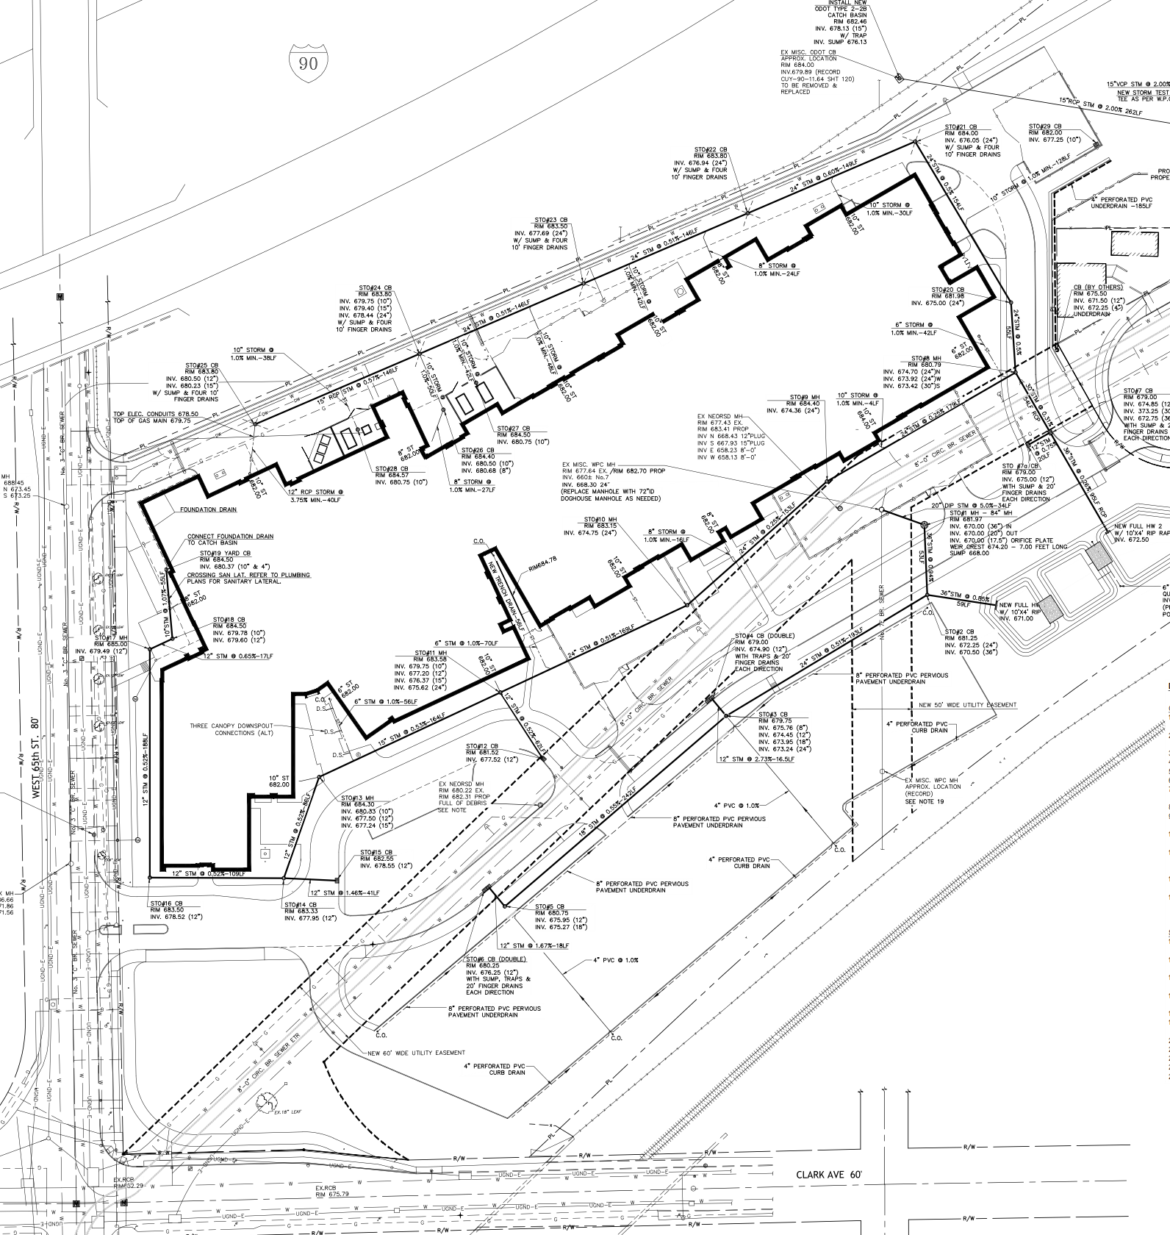

This is not an especially busy Civil drawing. You can see that it is a fairly large school. Elevations are not obvious, but InterState-90 is up an embankment to the North. There is a very busy city street to the West and a road in front which is to be abandoned.

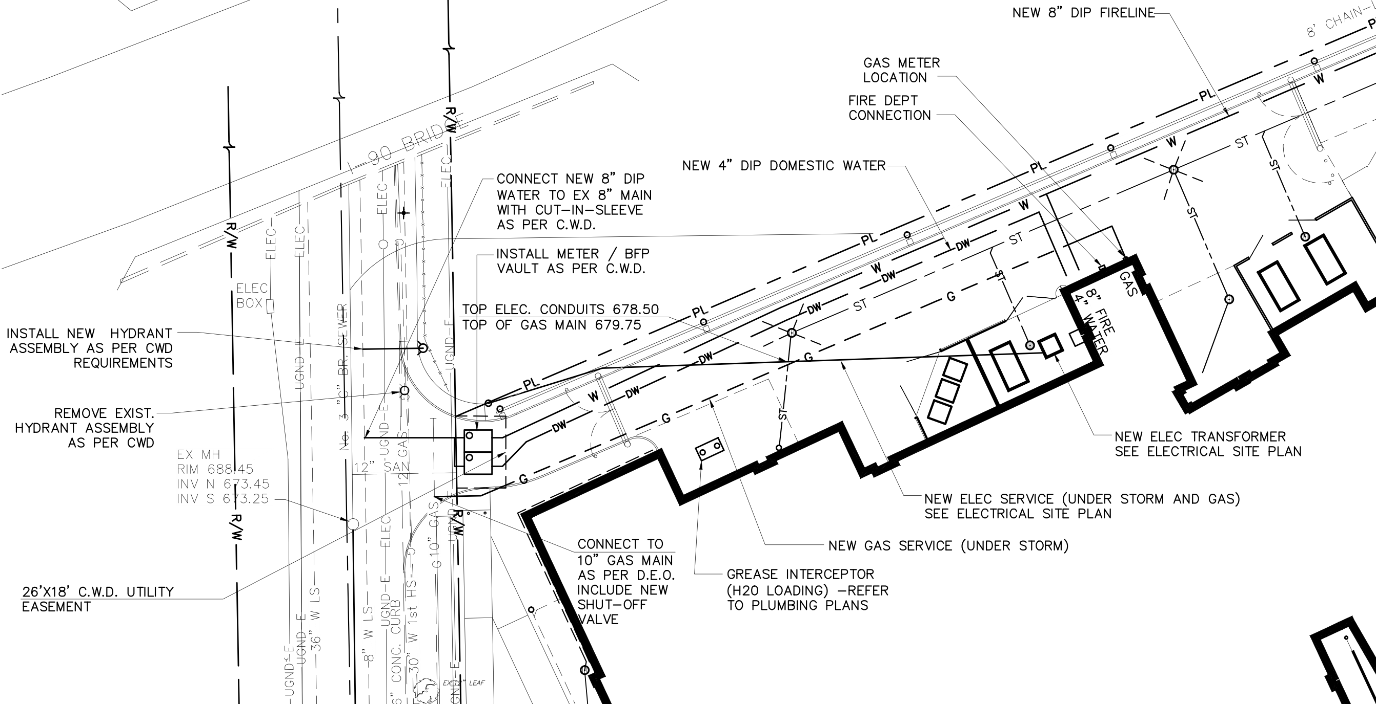

The electrical designer does not do the final drawing for installation of the overhead line or underground conduits. He marks on a Civil drawing and the Civil designer coordinates with the Electric Utility and other interested parties. You can see the result here. It is an underground conduit route from a Utility pole on the street fairly directly to the transformer location selected by the electrical designer. In fact, 2-4” PVC conduits are provided. One for immediate use and one for future use. Similarly, 2-4” PVC conduits are typically provided for data and telephone. One active and one spare. For this job, the data and telephone entered from the abandoned street on the South, at the request of the provider.

All one-line diagrams are the same, some pieces may be duplicated many times and some pieces may be deleted, but they all have a similar form, as follows:

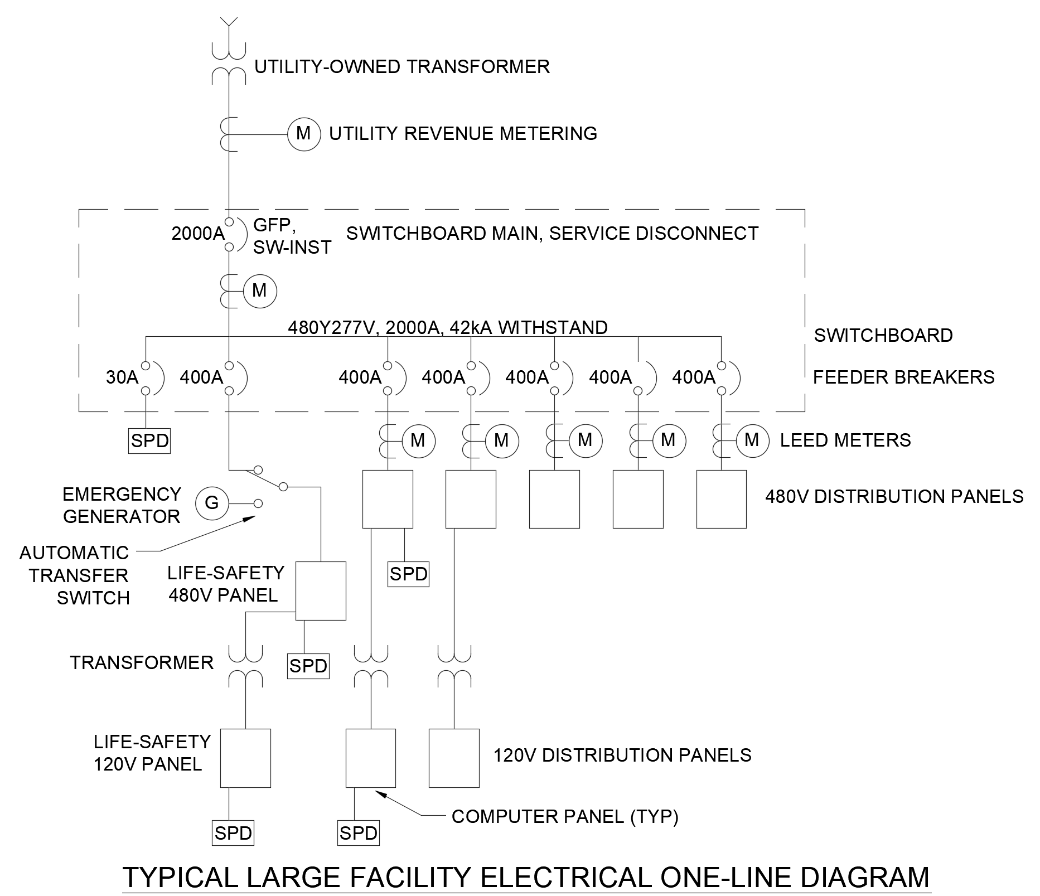

You read this drawing from the top. The power starts at the Utility. You don’t know and don’t care what voltage or which substation - just which pole your conduit will terminate at. The installing Contractor must work closely with the Utility. They Utility always does the high-voltage tie-in and frequently does the high-voltage connection at the transformer. Recently, the Contractor does all of the conduits and cabling and 480V connections.

The power enters the school site and goes to a Utility-owned dry-type pad-mount transformer. Again, details are not your business. You need to show the conduit routing and a detail (provided by the Utility) of the concrete base for the transformer. You then show 480V conduits from the transformer to the building.

The National Electrical Code (NEC, NFPA.org) applies, starting on the 480V connection to the transformer. Before that, there are limitations on the Utility, but, mostly, the State and local governments trust the Utility to make safe, economic decisions.

The NEC has strict rules on wires and circuit breakers. The NEC rules are discussed in other PDHonline courses. Electrical designers do read the Code, but, mostly, work from tables that extract and combine the most-used values. The values are shown in the form they appear on the construction drawings. An example follows:
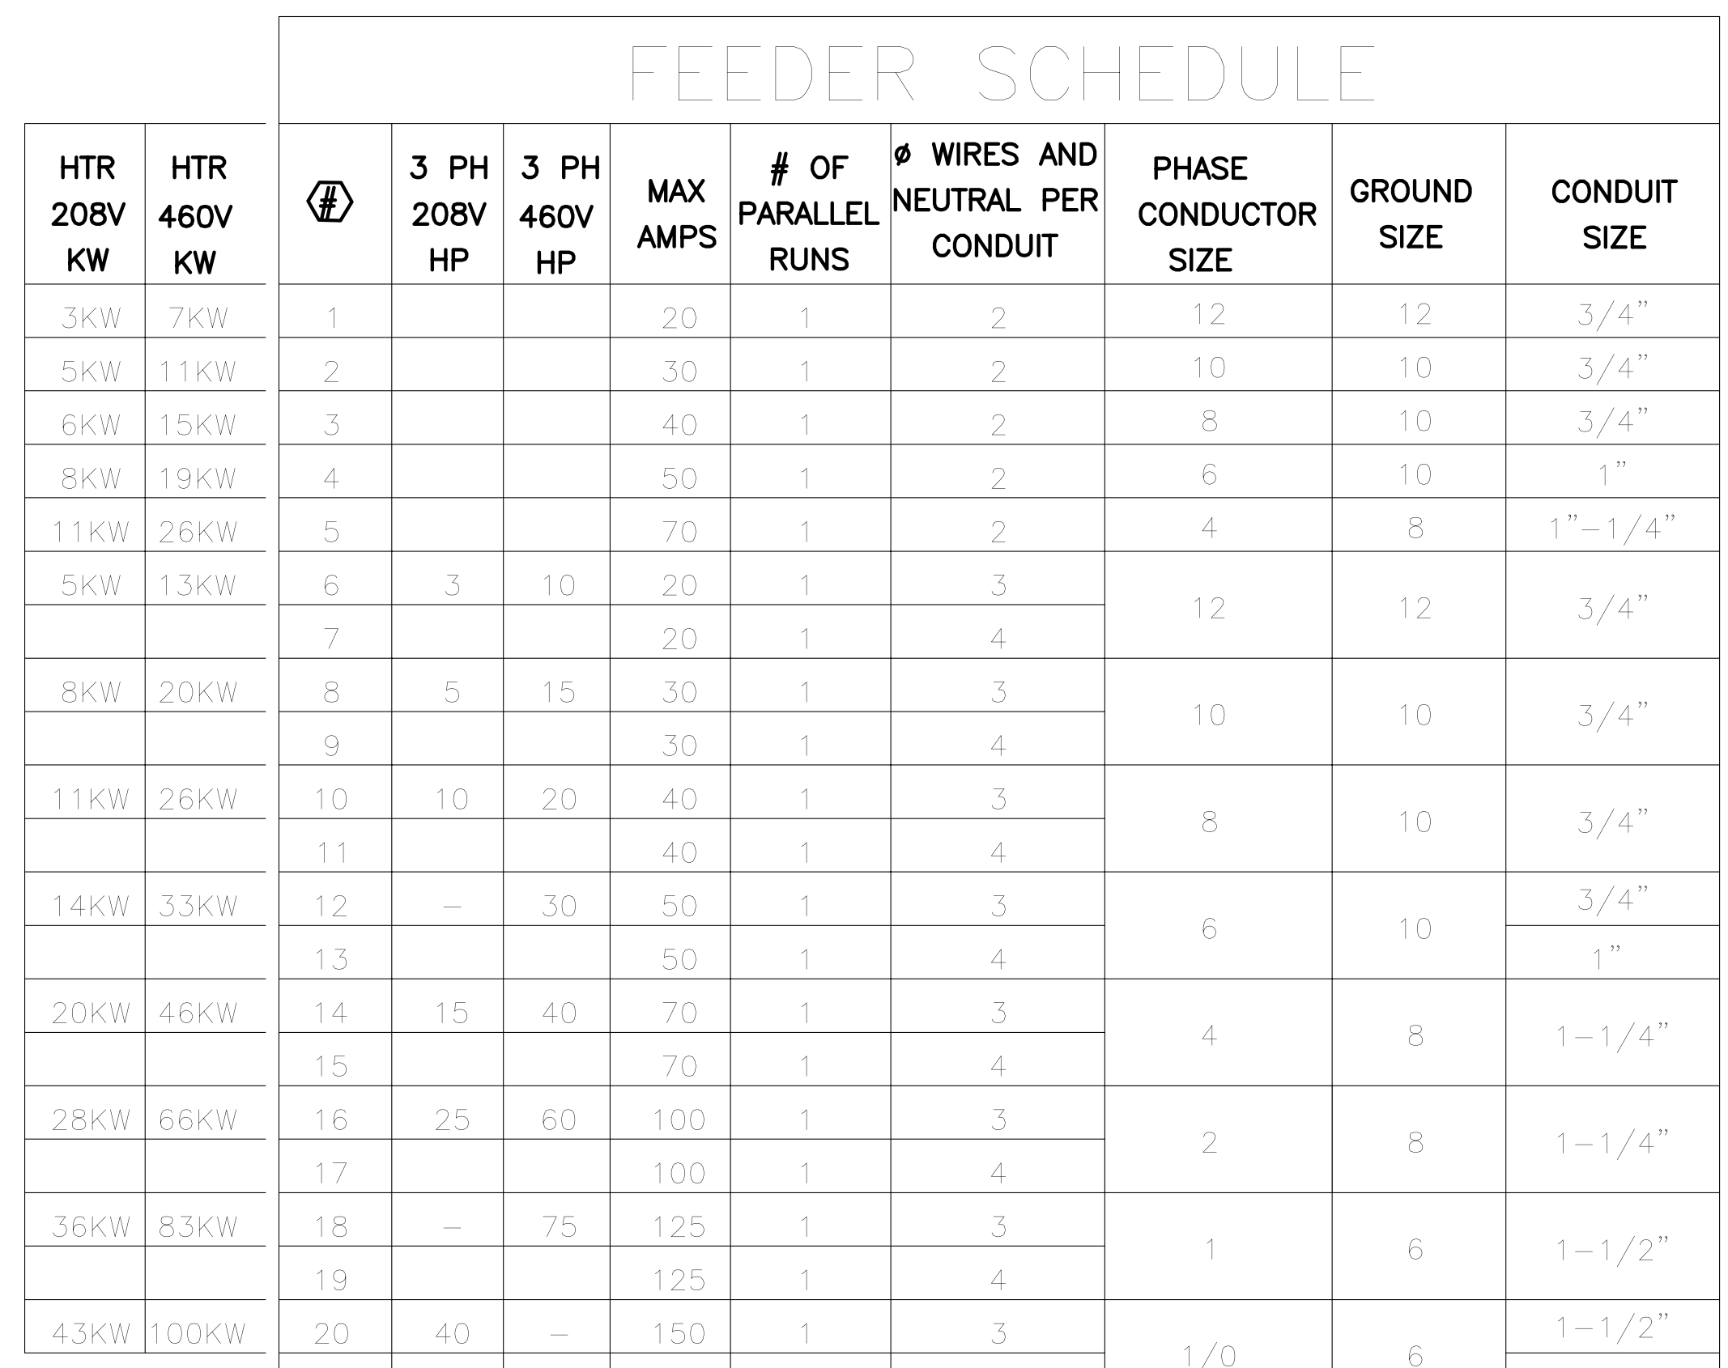
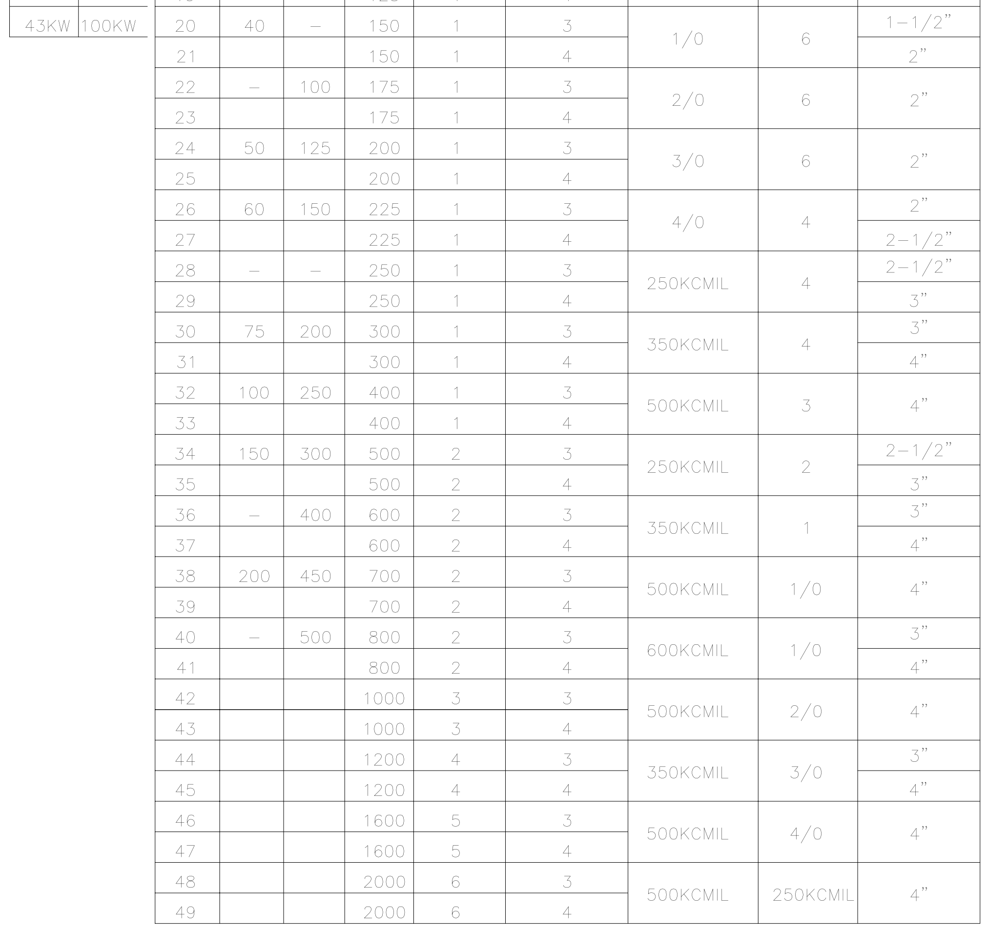

To answer the immediate question, “What conduits and wires for 2000A at 480Y277V ?” We see only one choice: 6 runs of 4/C 500kCMIL (250kCMIL ground) in 4” conduit. That is, there are six separate conduits. Each conduit contains three phase conductors, a neutral conductor and no ground conductor.

This is the only place that a ground conductor does not accompany a power circuit. The building ground connection is defined by connections at the switchboard end of the conduits. Let us show the detail for those ground connections:

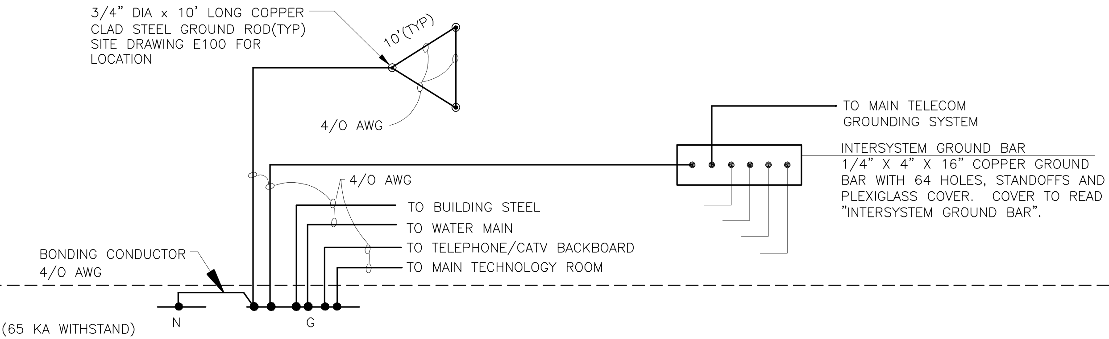

This example is conservative. A Code revision reduced the number of required driven ground rods to two, but requires a measurement of acceptable ground resistance. With three rods, no measurement is required. Also, the rods must be buried all ten feet. It is not permitted to leave the connection exposed. The intersystem ground is relatively new and rarely present in this form. However, this is a good detail to remind the installing Contractor.

Let us return to the design represented by the One-Line Diagram. The main circuit breaker is rated 2000A. This is based upon NEC calculation or the application of professional judgement to the loads connected, or a preliminary guess, necessary to get the job started. (In fact, it is a very common value for a modern school.)

The notation, “GFP, SW-INST” emphasize NEC requirements for Ground Fault Protection and a Switched Instantaneous Trip. GFP is a long-standing requirement. SW-INST is an economical solution to a relatively new (2014) requirement for Arc Flash Mitigation. An electronic-trip circuit breaker will contain both features.

“480Y277V” is the formal name for the power supplied by the Utility. There are three 480V phase conductors and a neutral conductor. As mentioned, each circuit must be accompanied by a ground conductor. Large equipment, as the chiller, big fans and elevator will be powered by all three 480V phases. Lighting will be powered by a single 480V phase and neutral, called 277V, because of the form of the connection. Kitchen equipment, small exhaust fans and receptacles will be powered by 120V from the low-side of the transformers shown. For reasons of economy, the actual transformers are 480V to 208Y120V. 208V connections are rarely used, except in the Kitchen.

Utility revenue metering can be in several forms. The most simple is to pass the incoming conductors through a CT box and send signal wires to a conventional meter. The CT box has current transformers which sample the current which is flowing into the school. The meter also needs a sample of the voltage from each phase.

Other forms of metering include the Utility providing all the pieces on the enclosure for the transformer, in a separate enclosure nearby or using space within the switchboard. Regardless, the Utility decides and usually works it out with the installing Contractor without including the Engineer or Architect in the discussions.

This simplified design shows five normal power distribution panels. One may feed HVAC equipment. One may feed a transformer reserved for computer loads. One may feed all the 277V lighting panels in the school. Big circuit breakers are more expensive than small circuit breakers. Use of three levels – switchboard, distribution panel and lighting or receptacle panel is the economic form and permits installing spare circuit breakers for unknown future needs. It is a major controversy whether to provide spares and how many.

Note the Surge Protective Device (SPD) on a 30A cb in the switchboard, on distribution panels that feed receptacle transformers and on receptacle panels. Shown is the correct way to design this portion. SPD’s are a bit unique. They only take off the very top of the surge. By having tiers of protection, each takes off a bit of the top of the surge and you build confidence of safety at the computer panel. SPD’s are consumable items. Each hit destroys a portion of the device. 50kA is a reasonable SPD, at ~$400. 100kA devices will last longer. 10kA devices should be avoided.

The State of Ohio requires an electrical generator at each school. Their reasoning is that the generator will keep the boilers and pumps operating, to avoid pipes bursting in the -30F winter. They say that the generator is less expensive than many, many battery-operated emergency egress lights and EXIT signs. Lack of maintenance on the generators makes such justification moot.

The One-Line Diagram presented is correct for emergency loads. It is in error if the generator is also supplying the boilers, boiler pumps and lights in the office. The later loads are non-Life Safety and cannot be combined with Life-Safety (Emergency) loads. A more correct detail follows:

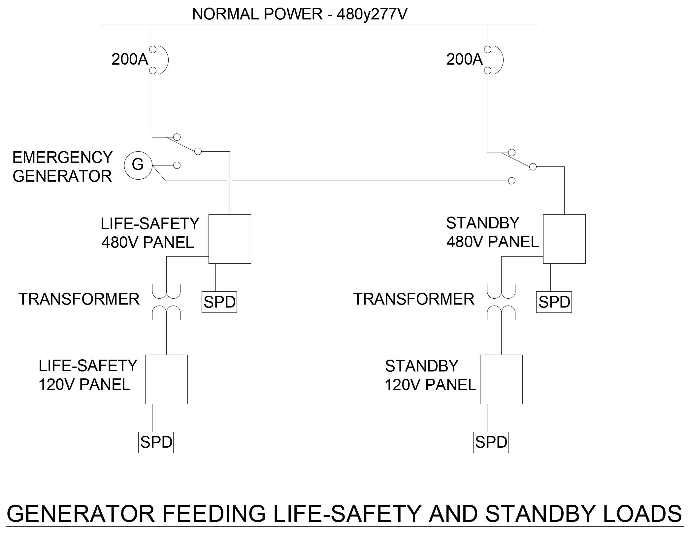

It is becoming common to buy a natural gas-fired emergency generator, because of environmental concerns regarding fuel oil. It still requires specific approval by the AHJ. This circuit does not show load-shedding, to drop off the standby loads if there is a problem. Typically, however, the generator is under-loaded rather than over-loaded. During emergency use, the generator is watched closely, or, at least, frequently.

There is little to say about receptacles beyond the NEC limit of 10 per 20A circuit and the reasonable limit of 6 per 20A circuit. The NEC requires GFI-type receptacles at sinks, in kitchens, bathrooms and any wet areas, as outside. There are receptacle installation details in the DATA section of this course.

A new section of the NEC requires wall outlets and floor outlets in conference rooms 12-ft wide and less than 1000 sq-ft (32-ft x 32-ft).

It was mentioned that the State provides guideform specifications. These are very reasonable, but exclude some cost saving choices. The restrictions are relaxed when the project goes over budget and enters the Value Engineering phase.

Specifically, the State requires copper conductors. In VE, aluminum feeders, above 50A or 100A are acceptable. The State requires bolt-on circuit breakers. In VE, snap-on breakers are acceptable.

A common procedure for detailed design is for the designer to import a toolkit of the symbols he expects to use. These act as a source for the symbols and as a reminder for the various components required.

The detailed electrical designer might use the attached plan and power toolkit to do his job:

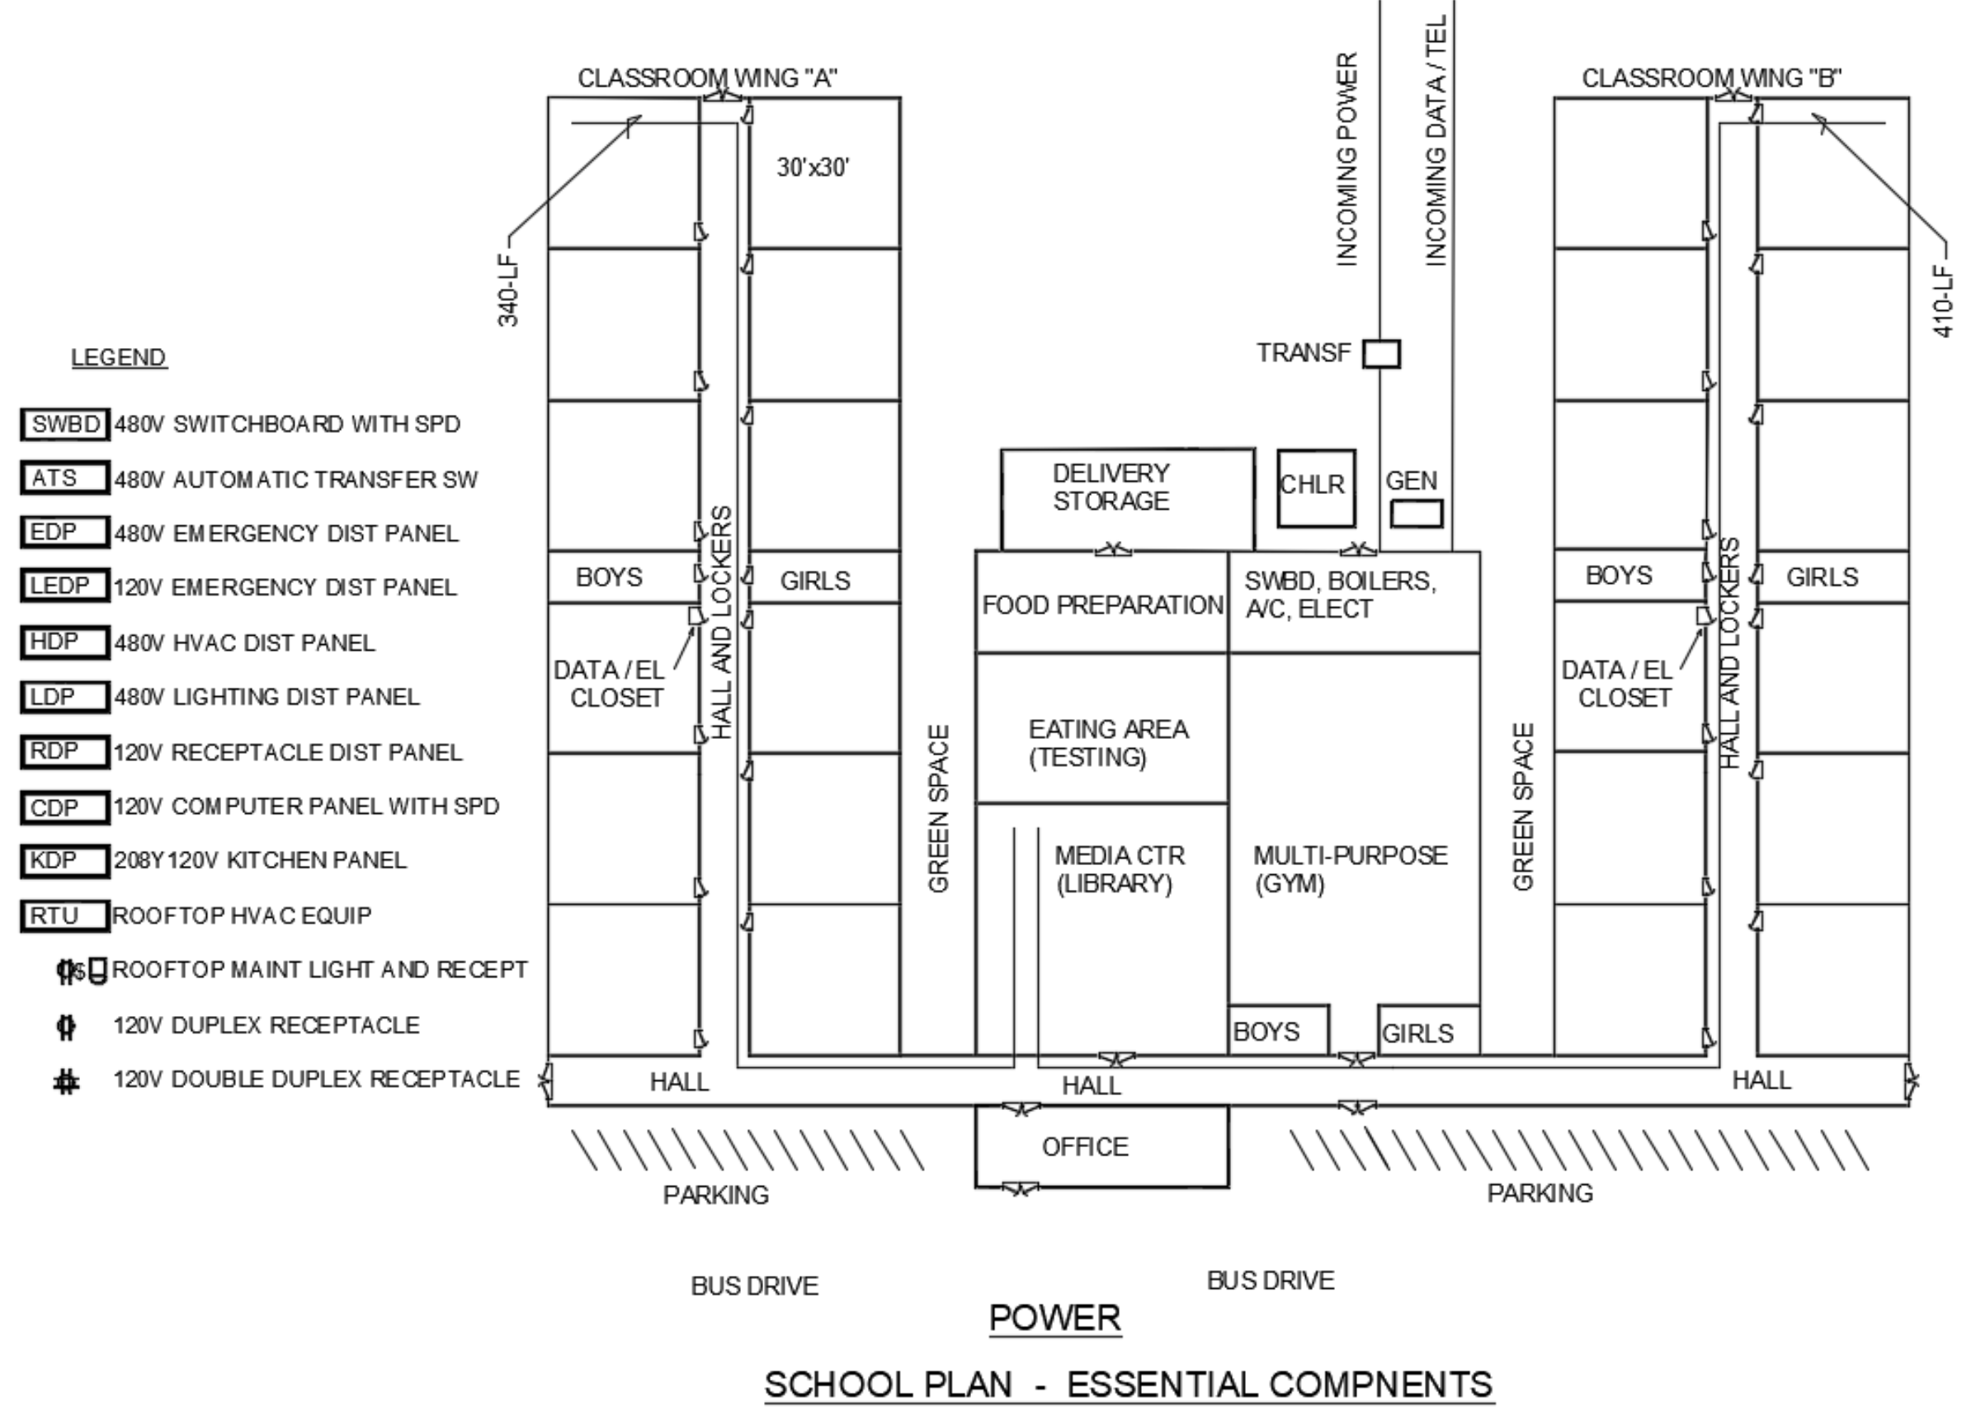
Note that the intermediate data / electrical closets have been added and there are symbols for a disconnect, maintenance receptacle and light for the rooftop HVAC unit. The light was required by a previous Code. Presently, only a receptacle, within 50-ft, is required.

ELECTRICAL LIGHTING AND LIGHTING CONTROLS

A plan sketch follows which demonstrates the State requirements for classroom lighting control:

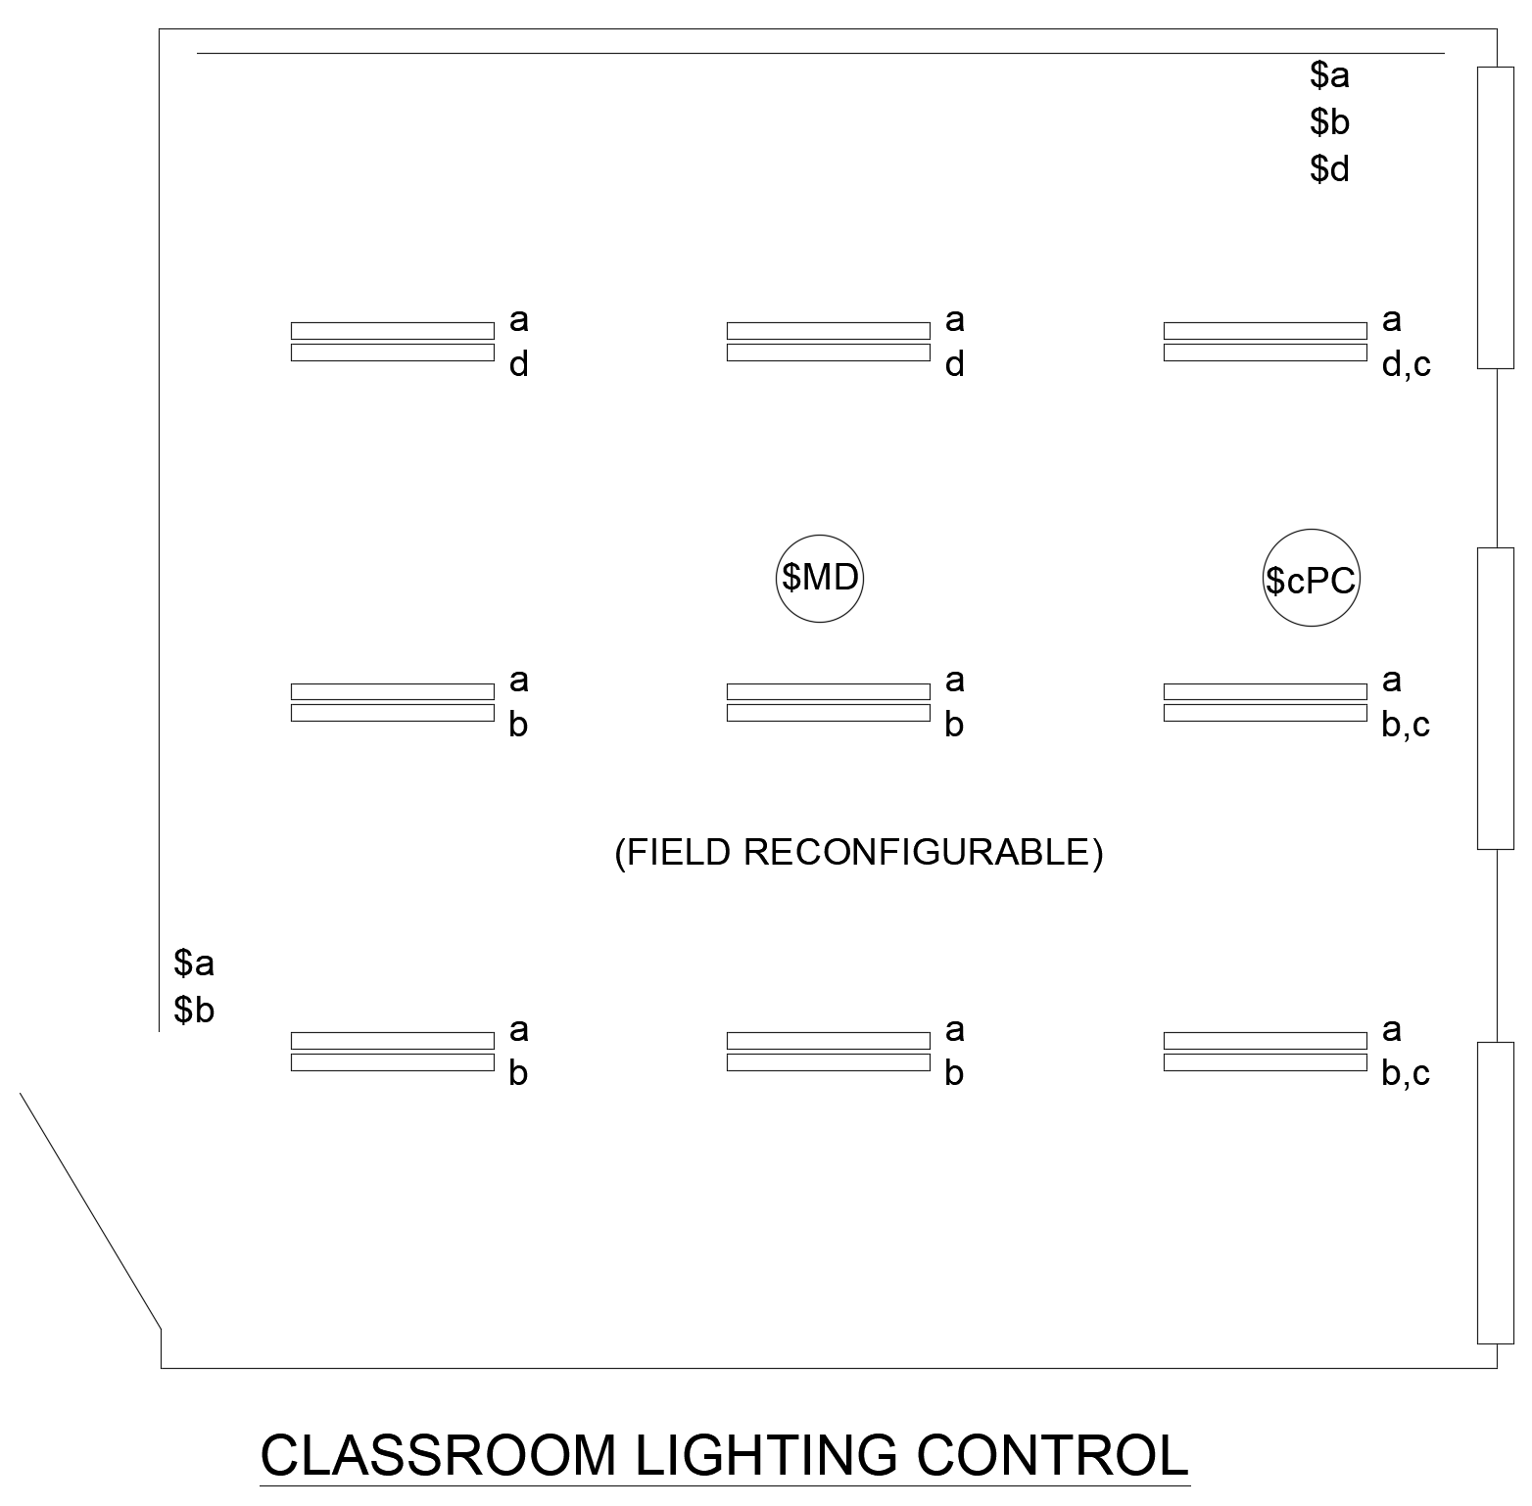

To orient yourself, note the door from the hall on the lower left and the windows on the right. There is a “board wall” at the top. Today, this is a whiteboard for use with markers and for use as a projection screen. The State requires that lighting fixtures be parallel to the board wall. $a and $b are manual switches to turn on the fixtures marked “a” and “b”. This provides dual-level lighting and permits control from the door and from the teacher station in the upper right.

Conventional notation would list the switches as $(3)a and $(3)b, indicating 3-way switches for the actual power going to the fixtures. Because the zoning of the fixtures must be field-reconfigurable, the switches cannot be hard-wired to the fixtures and must go through a computer.

Manual switch $d gives the teacher control of half the lights on the board wall separately. This is for use of the wall as a projector screen.

$MD is a motion detector which switches off all of the lights when it detects no motion, as, during a test or if the lecture is interesting.

$cPC is a photocell to switch off lights along the windows if the sun is shining

The wording of the Green Energy Construction Code that requires field reconfigurability does not precisely define it and does permit groups of fixtures to be controlled commonly, as all “a-fixtures” and all “simple b-fixtures.” However, if the group is hardwired together, the fixtures cannot be split off for reconfiguration.

Previous Codes specify that the motion detector must have adjustable sensitivity and time delay. Similarly, the photocell must have adjustable sensitivities and time delays.

The product that I use as a design basis for these controls is the Lutron LFR / MRF / RMJ (www.lutron.com/). The LRF is an in-ceiling occupancy / daylight control; the MRF is an in-wall wireless dimmer control; the RMJ is a box-attached power pack /lighting control. Batteries are rated 10-years and the systems are paired (like BlueTooth) so that one room’s controls do not affect the next room. The Lutron product can be preconfigured (paired) at the factory. Lutron uses buttons on the units to field reconfigure the system.

Again, this is a design basis and specification, not a requirement to purchase these units at ~$50 per module, totaling ~$500 for each similar classroom.

Exit signs are only a small problem. The exit signs are supposed to be on all the time. Power supplied through the Automatic Transfer Switch from the generator is supposed to be on all of the time. Therefore, use a single circuit breaker in the 120V Emergency Panel to power all of the exit signs in the building. They are 3W each and cannot total a sizeable load. Formerly, each exit sign had its own battery and was powered from the local lighting circuit, before the switch. When power went off, the sign used its battery.

Emergency egress lights require more attention. They are supposed to be on or off, based upon local switches and occupancy sensors. They must come on when power fails. That means that each emergency fixture, or nearby group of emergency fixtures, must have a Life-Safety-rated Emergency Transfer Relay. The relay is powered before the automatic transfer switch, so that it gets power only when the emergency generator is operating. The National Electrical Code requires that each power circuit have an associated neutral, so each emergency egress light must get a power conductor from the switched normal source and a neutral from the normal source, in addition to a power conductor and a neutral from the generator. (There is another scheme described in vendor literature called, “Switch Shunt.” I don’t understand it.)

A very similar method, used where both bug-eye battery lights and an emergency generator are to be avoided is a central battery / inverter. Such a device costs $500-1500 and can power all of the emergency lights in the building. A wiring sketch follows:
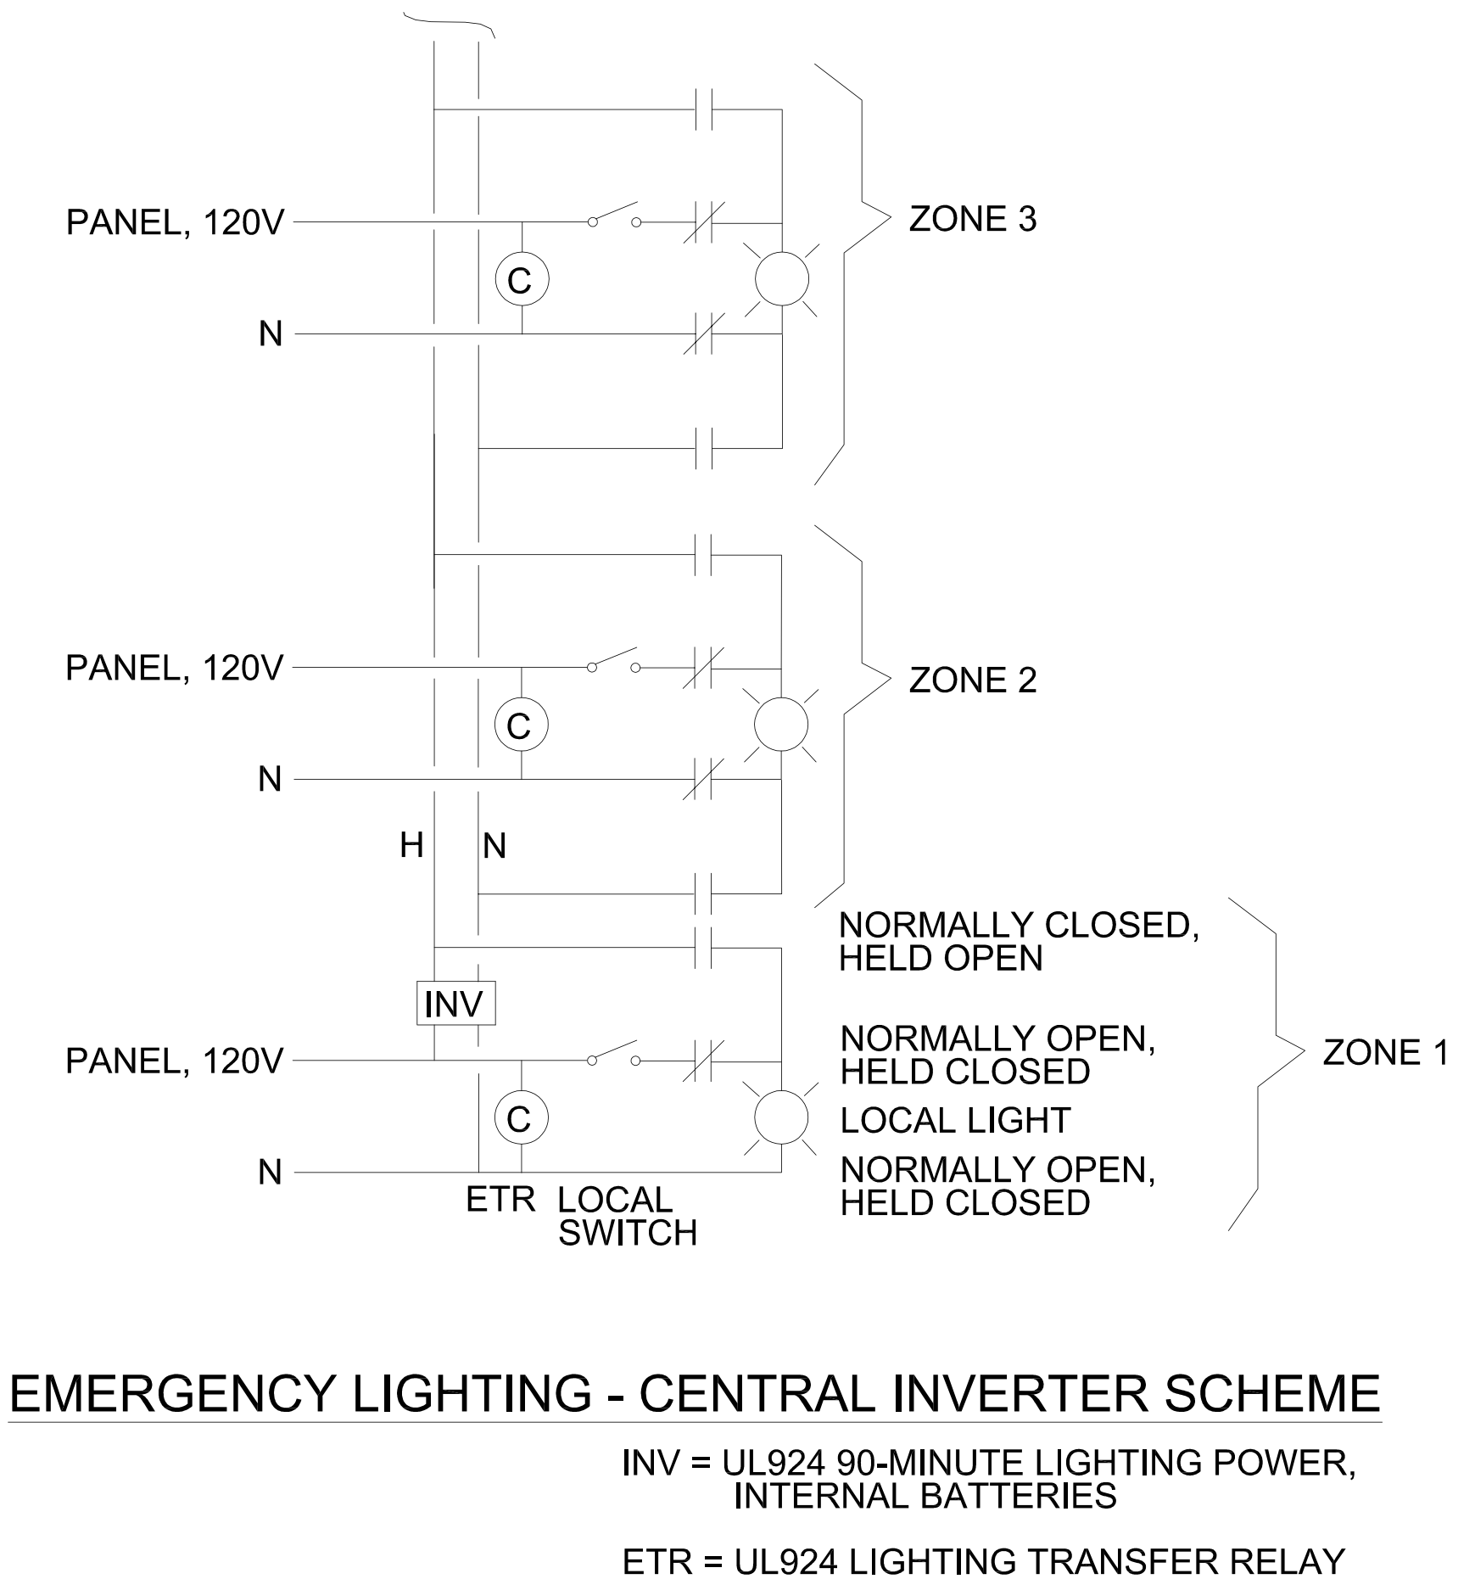

Be careful reading this diagram. The symbols for relay contacts are not “shelf condition” but, “normally open – held closed” and “normally closed – held-open”, as noted. This makes reading the diagram easier.

There is a little bit of “muddy mind” represented by this diagram. The narrative says that the generator coming on switches the ETR. The diagram, however, shows loss of the normal power, before the switch and occupancy sensor, as switching the relay. Both ways work.

The UL924 (https://standardscatalog.ul.com/standards/en/standard_924_10 ) reference is to make sure the installing Contractor does not save money by purchasing a non-Life Safety-listed device.

Outside lighting usually receives little attention. If fact, I did a State Technology Audit of one rural system which had no external lights !

Conventionally, we place parking lots along the incoming and exiting driveways and at the bus discharge sidewalk. In Ohio, school starts before the sun comes up and some extra-curricular activities (with busses) finish after sundown.

In addition, it is common to put wallpacks along all outside walls. The Energy Code restrictions are severe, but eight 100W LED 20-ft pole lights and twelve 30W LED wallpacks produce a lot of light, still within the energy limits. An electronic astronomic timer provides proper control. Make sure to include a Hand-Off-Auto switch (H-O-A) so that the lights can be forced on for testing or for late-night public use of the facility. Modern electronic astronomic times cannot be set by normal humans. Include a separate, labeled H-O-A control.

Wallpaks are small, non-intrusive lights that illuminate a portion of the wall and a portion of the yard. The Energy Codes require “sharp cut-off” which means glare to motorists and neighbors is eliminated. A sample is shown below:



I am not recommending that you buy lights from Amazon for your next commercial project. I am providing a picture of an economical low-wattage LED fixture with full cutoff.

FIRE ALARM

The fire alarm for a school is a very conventional fire alarm. The essential components are the Fire Alarm Control Unit (big box) with a smoke alarm over it, a Remote Annunciator at the Fire Fighter Entrance, so they know where the detector in alarm is located, manual pull stations at each personnel exit door, smoke detectors in each occupied space, at 30-ft c-c in large spaces, heat detectors in wet spaces where smoke detectors don’t work, smoke detectors on HVAC fans with visible Alarm / Test / Reset stations, speaker strobes in each occupied space, at 50-ft c-c in large spaces and strobe-only devices in bathrooms and conference rooms.

An analog-addressable fire alarm is recommended. The “analog” part utilizes sensors that transmit the % smoke present and the actual temperature, rather than just “normal” or “in-alarm”. The analog information permits the fire alarm computer to predict an alarm start before the threshold is reached. It also provides useful information to the fire investigator after the fire.

Voice-notification systems are required by the State and are recommended in all new and retrofit project. The voice portion permits use for natural disasters, toxic spills weather events and terrorism events. “Real soon now” are promised modules for the fire alarm to permit public authorities to take control and make the announcements automatically. In the meantime, there is a microphone for the Principal or Fire Chief.

PDHonline has an excellent webinar on Fire Alarms that discusses the details for four hours.

The Fire Alarm part of a school electrical design is studied closely by the Plans Review Officer and, usually, the local Fire Department. Any oversight will be identified and the drawings returned for correction. A sample Fire Alarm Riser Diagram follows:

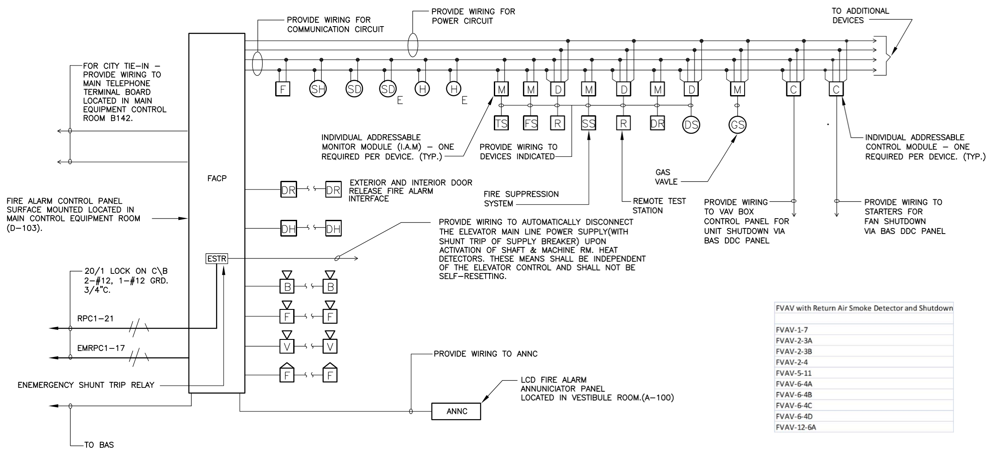
Typical Fire Alarm Riser Diagram

This diagram is worth studying because it has so many details. These can remind you of things to look for in your job.

Unfortunately, it also contains many errors. I will list some below:

  - It is an error to detail out the fire alarm wiring, unless you are very sophisticated in fire alarm design. It is much better to say, “Provide and install wiring as recommended by the manufacturer and in conformance with NEC and local requirements.”

  - This diagram does not show the required smoke detector over the FACP (now called FACU). It is the first thing the Plans Reviewer looks for.

  - The ESTR for the elevator is done wrong. The Fire Alarm Code requires that the power for the shunt trip be monitored by the fire alarm panel. If the power is not available, then the shunt trip cannot operate. It is important to call out a UL-listed Life Safety relay.

  - A modern voice-notification fire alarm system requires a microphone or telephone handset at the fire alarm panel and at the annunicator panel.

  - I like to add an outside yellow strobe to call to the fire truck.

  - I like to add an outside alarm bell. This is required by the Sprinkler Code, but easiest if provided with the fire alarm.

  - FVAV is a fan-powered VAV terminal unit. The HVAC code requires that big fans (over 2,000 cfm) have smoke detectors and shutdown by the fire alarm. The fans on the FVAV may be this big, or, the designers may have been extra conservative. I have seen smoke detectors and local shut-down on big fan-coil units in the hallways.

There are many details on locating smoke and heat detectors. Basically, try to get them in the center of the room, away of HVAC supply and return grilles. If it is large space, put them on 30-ft c-c spacing. Smoke detectors are preferred. Heat detectors are acceptable in wet spaces or where fume are present. Duct smoke detectors are required on large HVAC fans (ash your HVAC designer). Provide an Alarm / Test / Reset station at an accessible point for concealed detectors. Provide carbon monoxide (CO) detectors outside spaces that contain natural gas appliances. (Such appliances can burp in normal operation and this is not considered dangerous.)

There are many types of strobe-horns and a number of rules for applying them. In Ohio, we just identify the location and let the Contractor and AHJ decide which type to use. Visual-only notification devices are used in bathrooms and conference rooms.

The detailed electrical designer might use the attached plan and fire alarm toolkit to do his job:

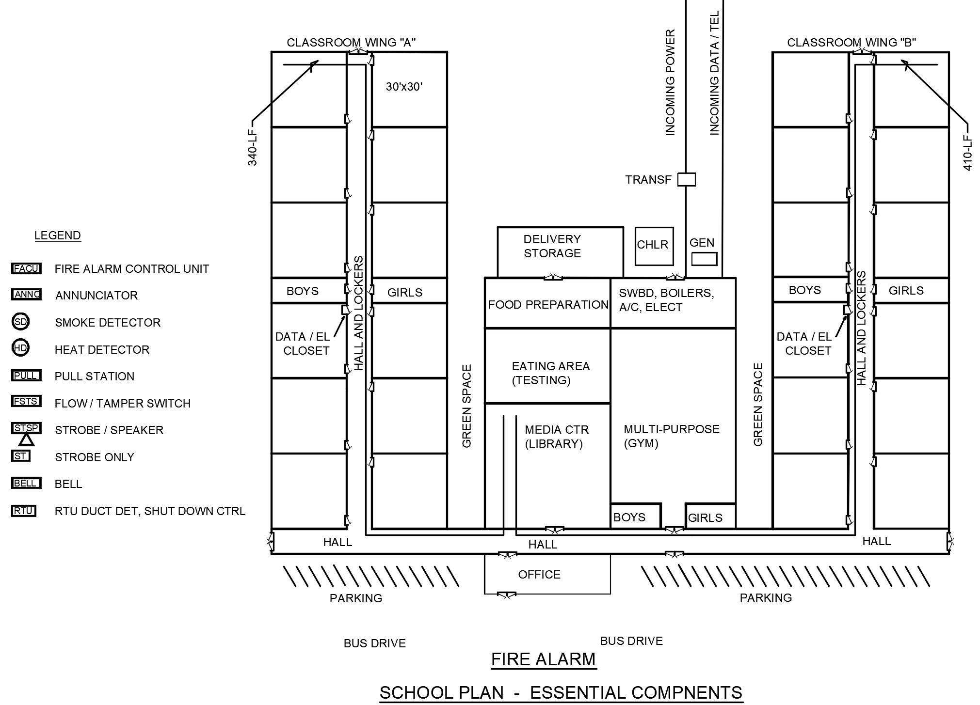
The duct smoke detector is shown, but not the Alarm / Test / Reset station at the occupied level.

DATA, COMMUNICATIONS AND SECURITY

Modern data, communications and security are all radial systems with distributed operation.

Data systems get an outside connection from an Internet Service Provider (ISP), and distribute it along isolated channels to users in the Administrative Office, in classrooms and conference rooms and elsewhere. A local server can be located in the Information Technology room (IT) for local storage and local software. All of the incoming and outgoing cables terminate in patch panels. These have individual RJ-45 jacks for each cable and jumpers connecting the cables to the equipment. A key piece of equipment is the Data Switch which connects individual outgoing circuits to the internet or to the server.

The IT room will have one or more racks for patch panels, data switches and servers. To support the operation, the HVAC designer provides reliable cooling equipment and the electrical designer provides reliable power equipment. Depending upon the sophistication of the installation, the IT room may have its own HVAC, powered as standby load from the Emergency Generator. The IT group may buy battery backup Uninterruptable Power System to keep the system operating during short duration outages, as the start of the generator or switching by the Utility. The UPS is usually considered end-use equipment rather than supply equipment and comes from a different budget.

The electrical designer is almost always responsible for pathways for the incoming and outgoing cables. The incoming cables from the ISP are protected by conduit. The outgoing cables are exposed, but placed in carrying systems that permit easy replacement. The final few feet, to the wall receptacle, are usually in conduit.

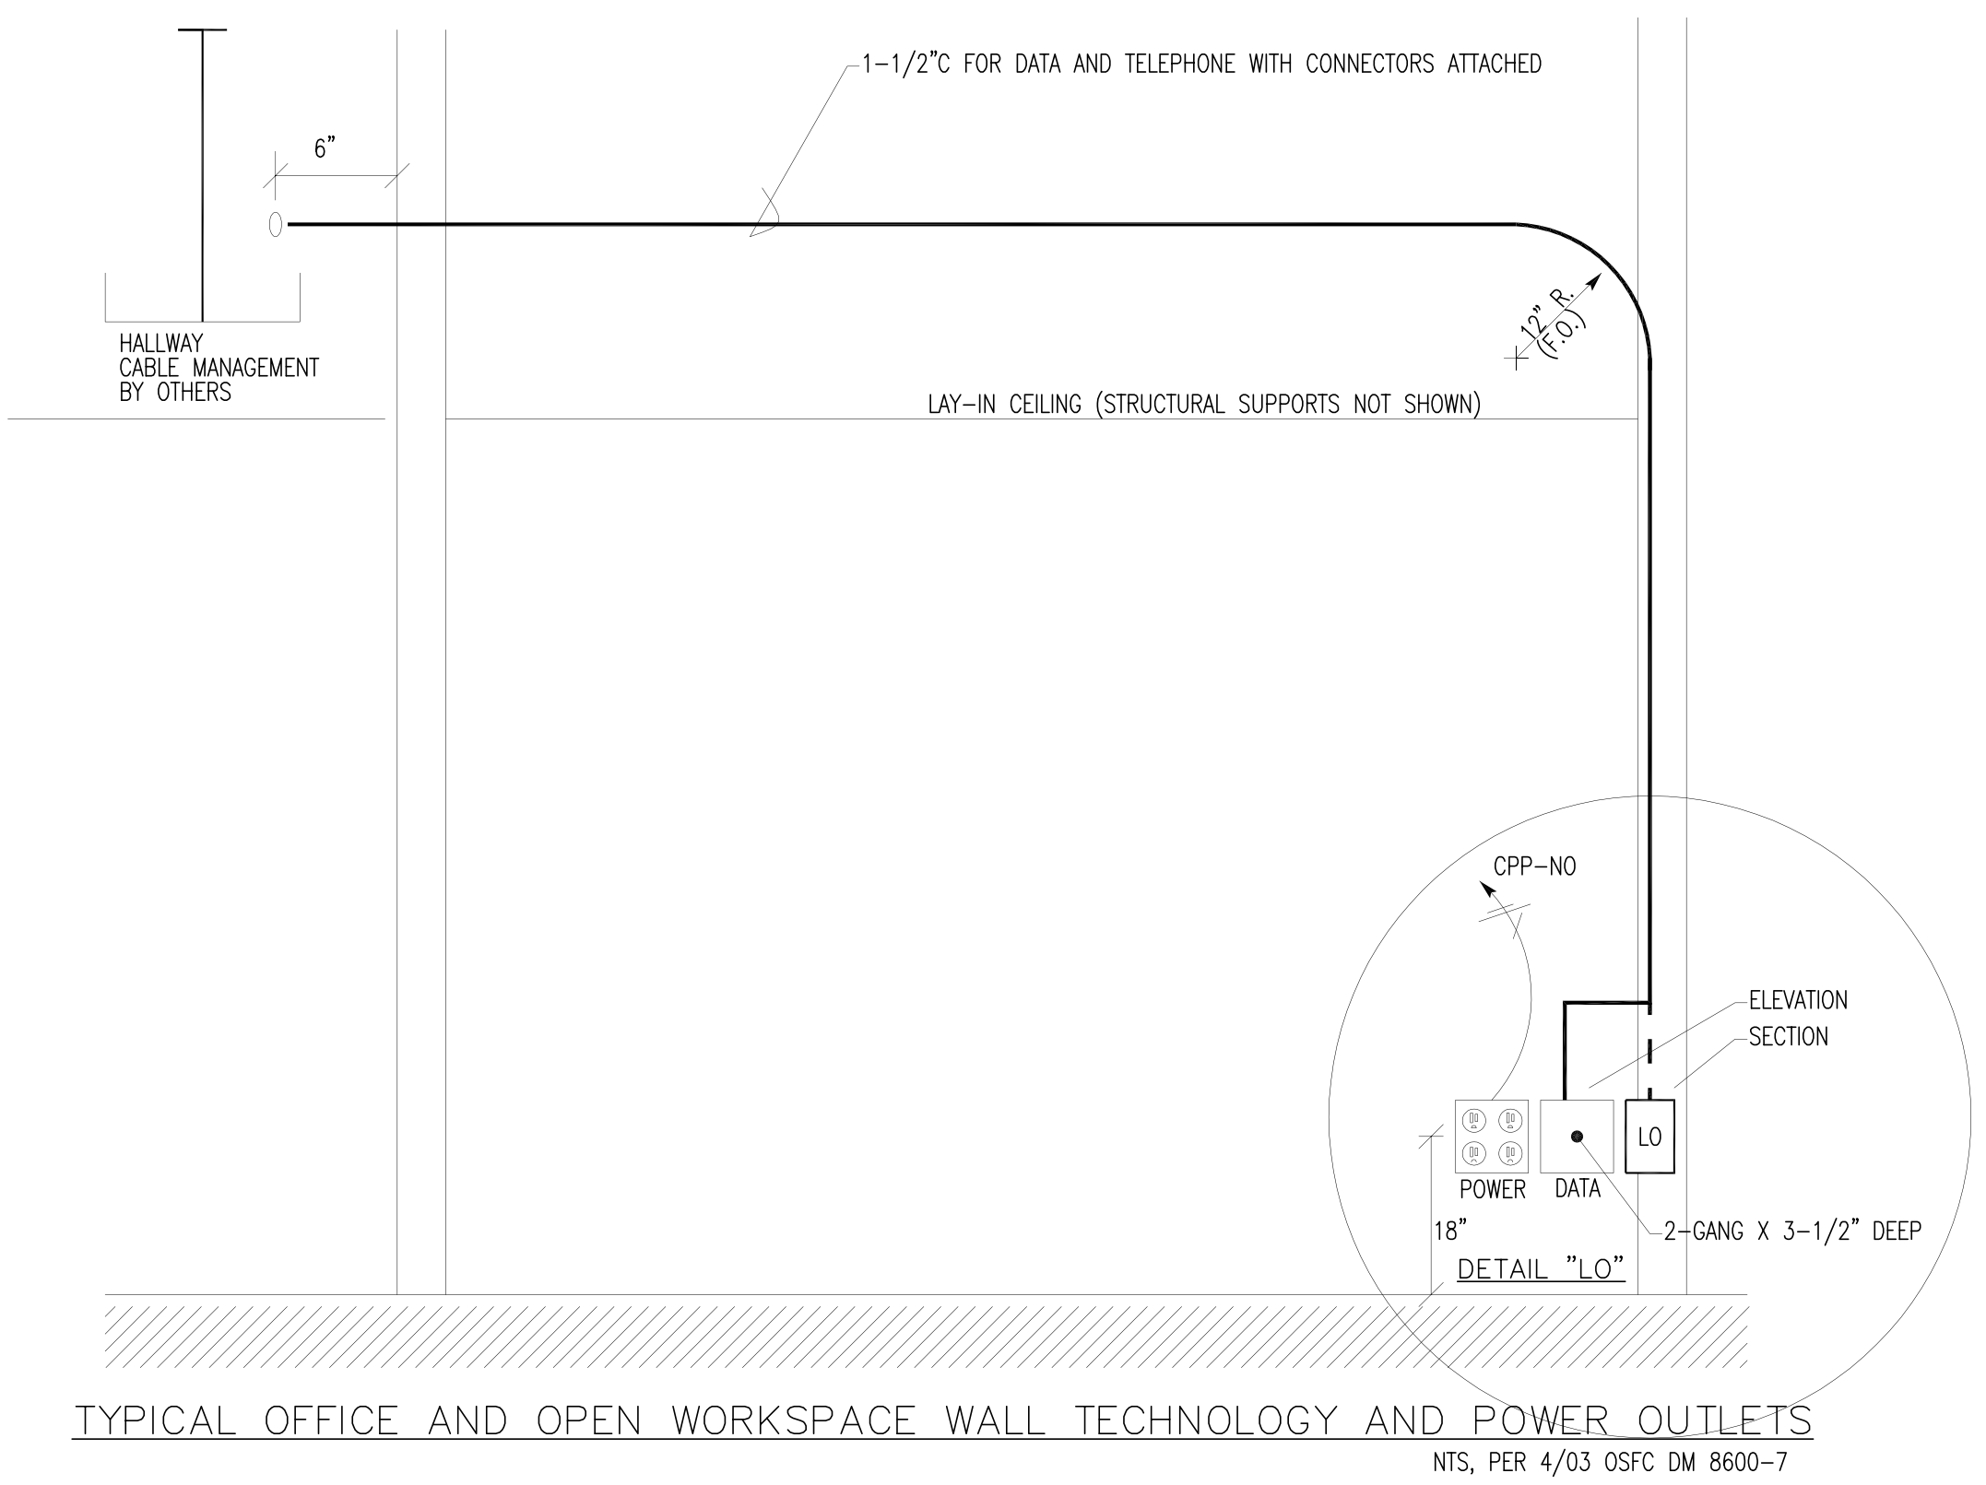

The detail above shows “hallway cable management”. This is basket tray, moderately expensive tray which is supported from the ceiling by a threaded rod in the middle. It is open on both sides to permit running cables without use of pulleys. Ladder tray is much more expensive and harder to use. J-hooks are much less expensive and used on cost-sensitive projects. J-hooks are attached to the side walls instead of running down the center. Some samples are shown below:

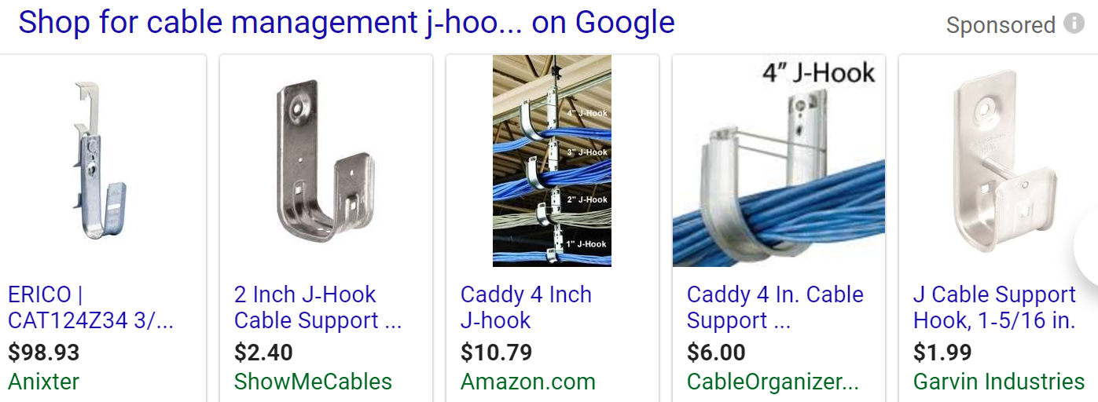

The first item, from Anixter is a ¾-in unit, $99 for a box of 40, or ~$2.50 each, including “universal” mounting. The center illustration, from Amazon, show how capacity can be increased at a later date.

Returning to the Typical … Outlets sketch, there is a grievous error. At the top right, the drafter calls out 12-in radius, to accommodate fiber optic cable without damage. At the bottom right, however, the drafter shows two sharp right-angles leading to the data box. In fact, the vertical conduit run must run straight into the data box, with no bends. Also, required but not shown, is a minimum 6-in loop of data cable in the data box to permit retermination in the future. (The most common problem with data systems is cable terminations.)

Note the use of the 2-gang deep box to permit room for the cable loop.

At one point in time, the State wanted a wall phone, a hanging TV with data connections, interconnection to the teacher’s desk and connections from the teacher and student stations to the central IT room. Loose cable was permitted over the ceiling to the hallway. After I figured it out, I made the following detail to explain it to the installing Contractor:

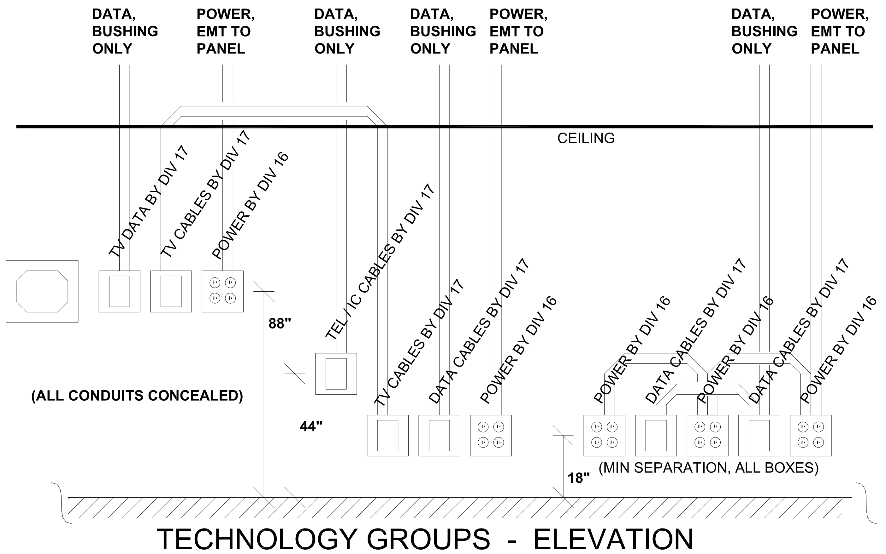

Today, we do not have TV’s in the classroom, but a short-throw video projector directly above the white board. This is demonstrated by the plan below:
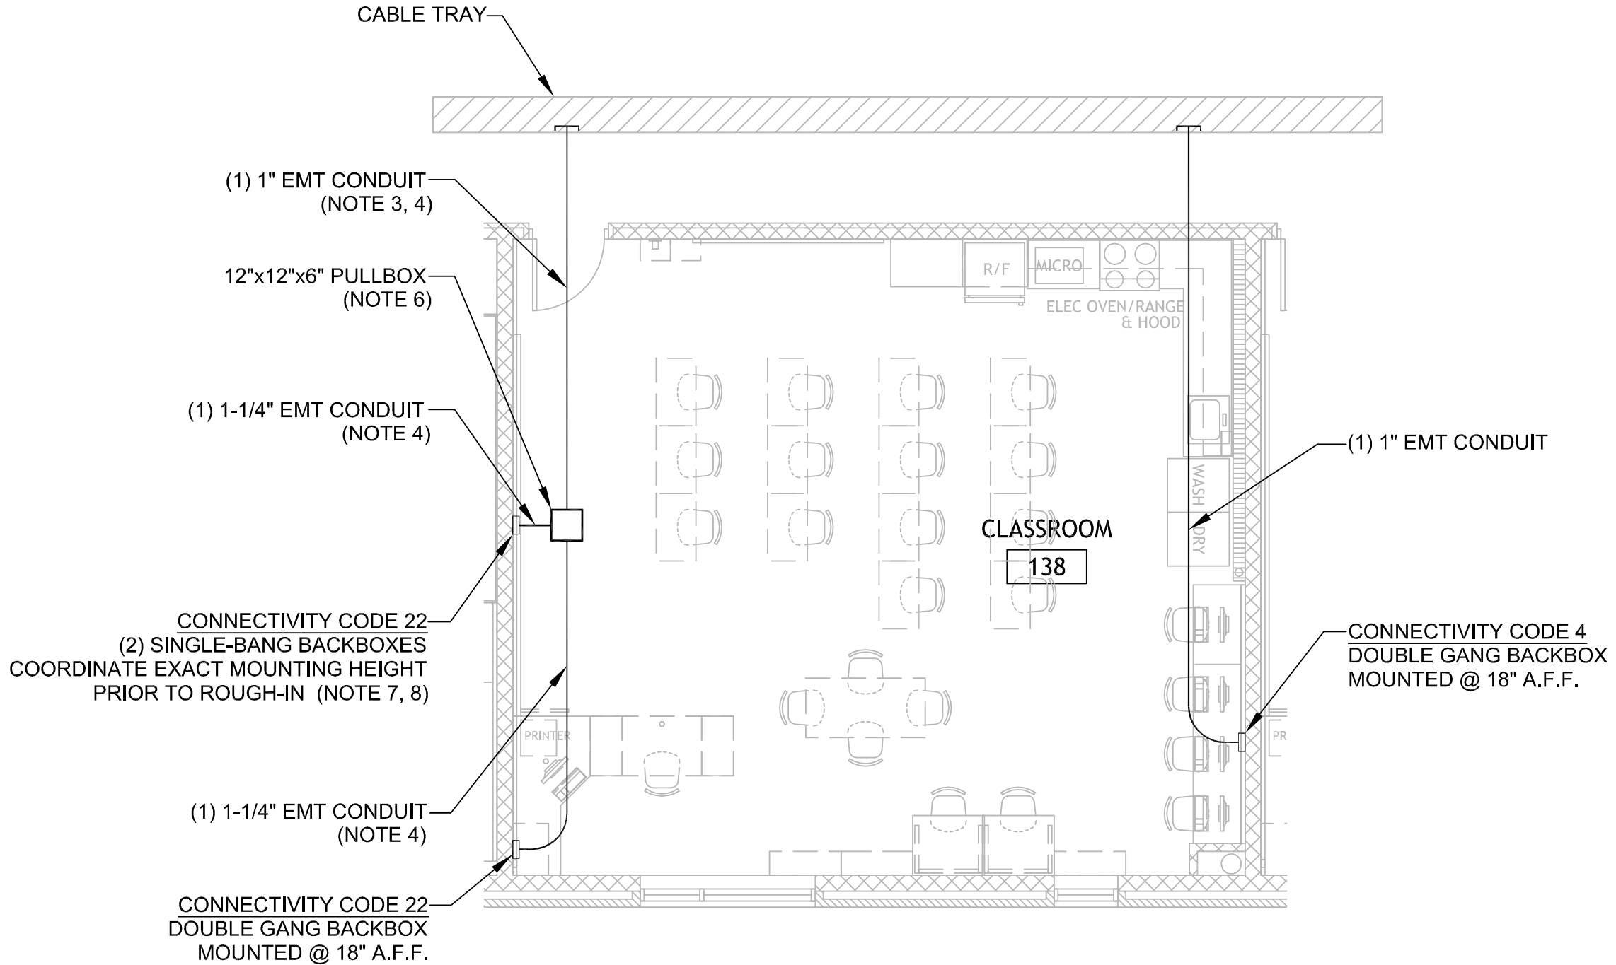
Typical Classroom Rough-In Detail

Note the board wall, oven, range, microwave, refrigerator, sink, washer and dryer. This is one of the combination classrooms, mentioned earlier.
The elevation, below, illustrates the situation more clearly:
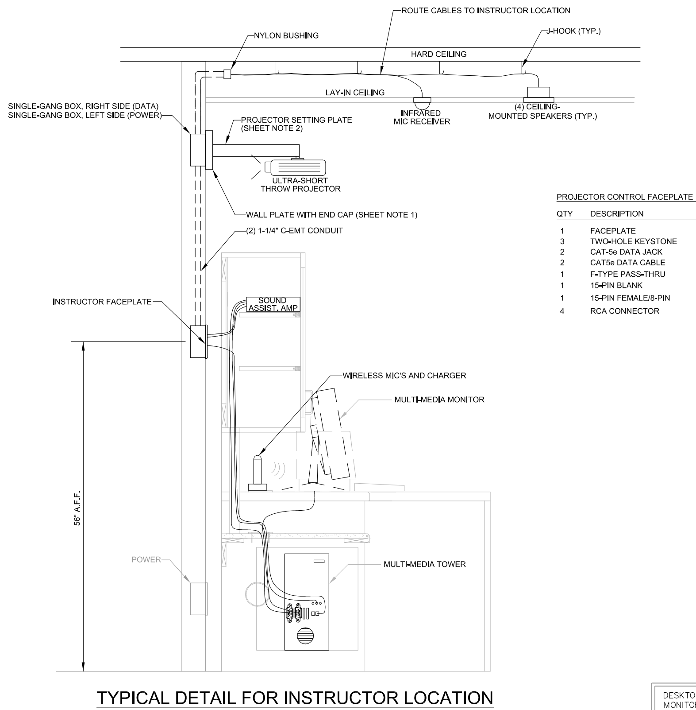

The infrared wireless microphones have been a Godsend for elementary teachers. No shouting.

As mentioned previously, the IT equipment comes from a different budget. The school construction project provides empty racks, cabling and termination to patch panels. Below is one of seven IT rooms from a different school:
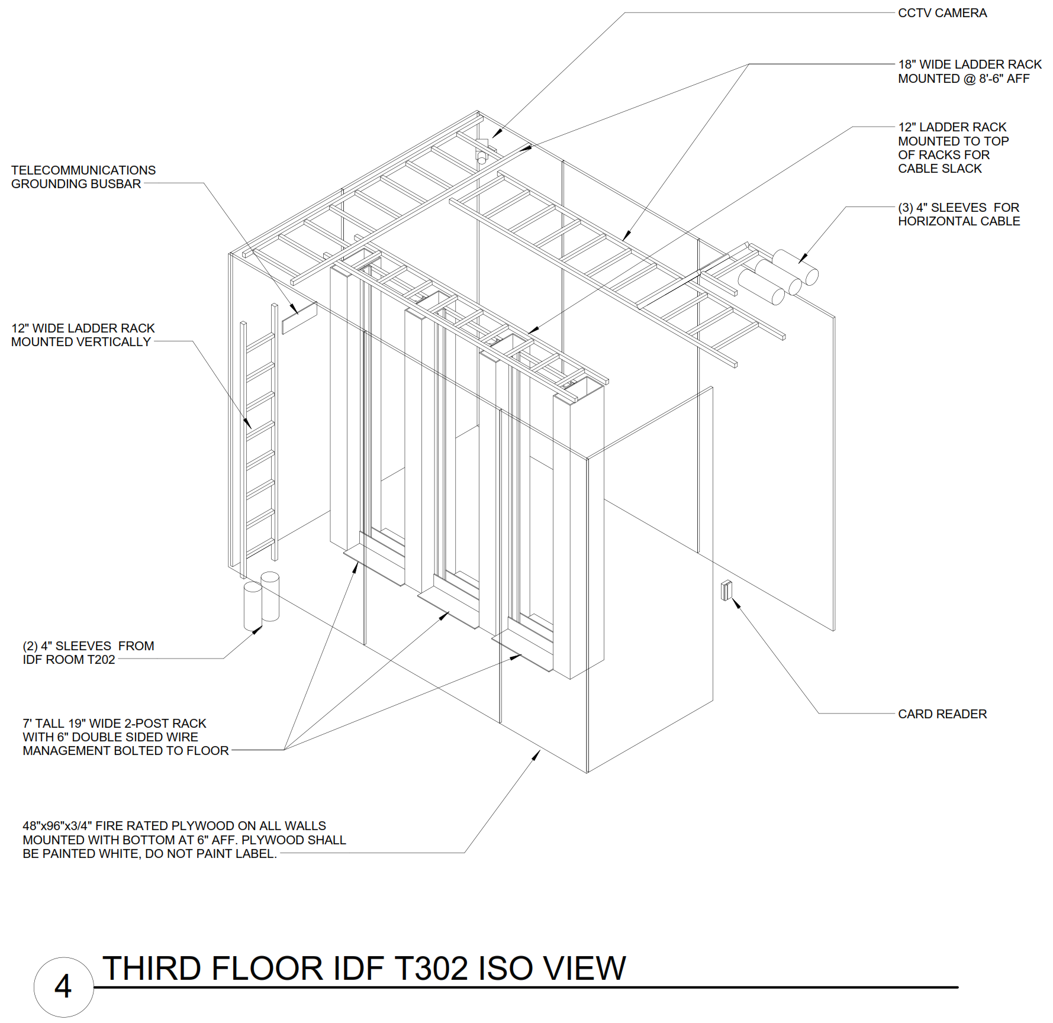
Note security in the form of a CCTV camera and card reader for entry. More important to the electrical designer is the use of cable tray for cable distribution within the room and conduits for cables to classrooms and to other IT rooms. The plywood walls are intended for the mounting of additional devices by the school district. It is common to have central security systems located in the IT room.

Every IT room I have seen has a CRAC, computer room air conditoner. The Standards call for a backup exhaust fan, for the day the CRAC fails. Owners and IT people do not believe the CRAC will fail and prefer to use a box fan, in the door, when they are surprised.

Not indicated on this drawing is the critical firestopping. All wall penetrations must be sealed with an approved material to keep products of combustion from entering or leaving the IT room. Owners and IT people do not like firestopping.

Communications is done when the data installation is complete. Modern telephones are VOIP, meaning they use the data wiring, interchangeably with computers. Data cables use patch cords to connect to data switches. Telephone cables use patch cords to connect to the telephone switch.

The telephone switch can be comlete, locally, connecting to the phone company via a fiber optic cable. Or, it can be a data switch, forwarding all telephone traffic to a central telephone switch at the District Office or Telephone Company Office. Or, it can be a data switch, forwarding all telephone traffice to a central telephone switch located in Augusta, GA. The Augusta, GA, alternative has some advantages, including cost and quality of service. There is a PDHonline course on this subject.

Not mentioned previously are the features of a modern phone or power for the telephone unit on the teacher’s desk. The modern method is POE, when the telephone switch provides low-voltage DC on the same data cables.

Security has four components, physical security, access control, intrusion alarms and CCTV. Physical security is not within the scope of this course, but please be aware of the burglar screens that can be placed on windows and make it almost impossible to enter late at night. Similarly, doors, hinges and window glass can be selected to make late entries almost impossible.

Access control, today, is a distributed service. Locking devices, unlocking devices and a logic box to interpret the keycard are located at the door being protected. A central logic box is where new keycards are added, old keycards are removed and the event log is stored. The detail below illustrates some field components which can be used:
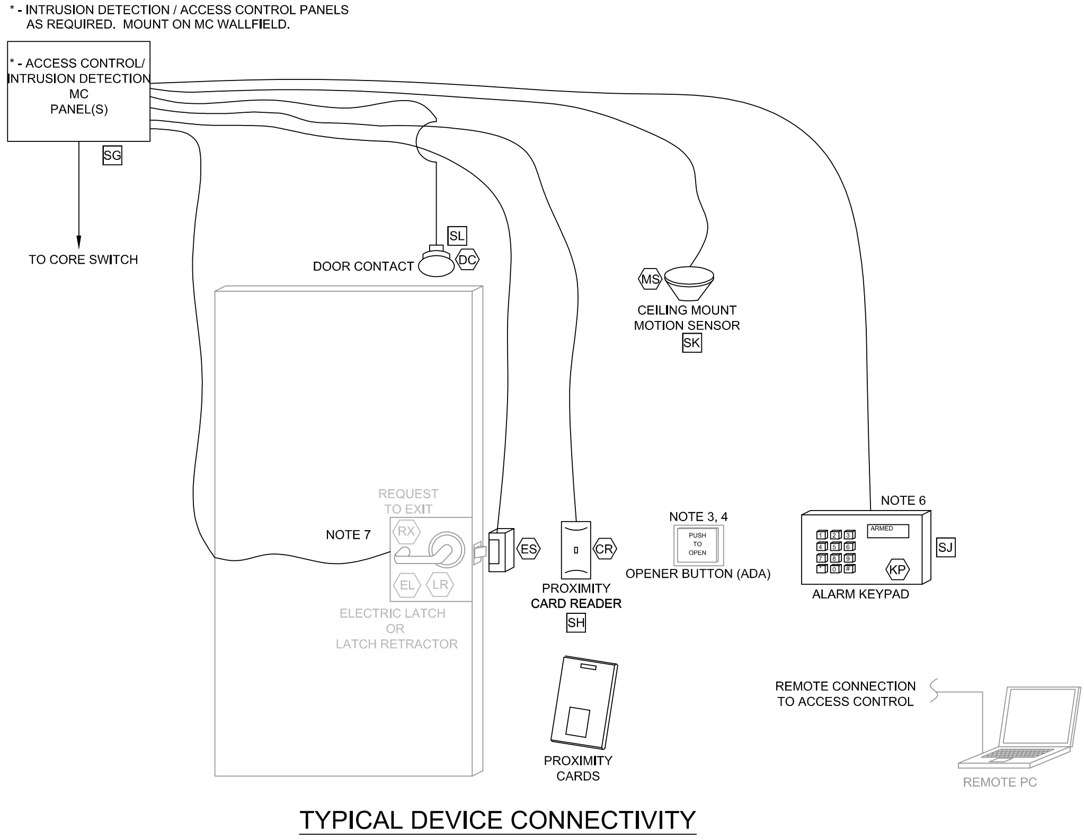
I don’t like this detail, for a number of reasons, as follows:

    - It is of critical importance to require all security wiring be protected, in rigid conduit or flexible conduit.

    - I don’t like magnetic door contacts. I much prefer door position switches located in a hinge.

    - I don’t like electric strike or electric bolt retractor. I prefer magnetic locks.

    - The Opener Button is illegal. ADA has rules that most people, handicapped or not, have trouble finding that button in a panic situation. The law requires a panic bar with a switch that directly releases the lock (not through logic).

    - System vendors like proximity cards, key fobs and magnetic stripe cards. They are consumable items which form a revenue stream for many years. A keypad is almost as good and only requires replacement periodically.

    - There are two ways to buy access control system - fail-locked or fail-unlocked (probably using different words). Fail-closed means that when the power fails or the logic fails, the the door is locked. Fail-open means that when the power fails or the logic fails, the door is unlocked. Owners and IT people prefer fail-closed. Most safety persons prefer fail-open.

Below is a similar detail which I prepared for an apartment house:

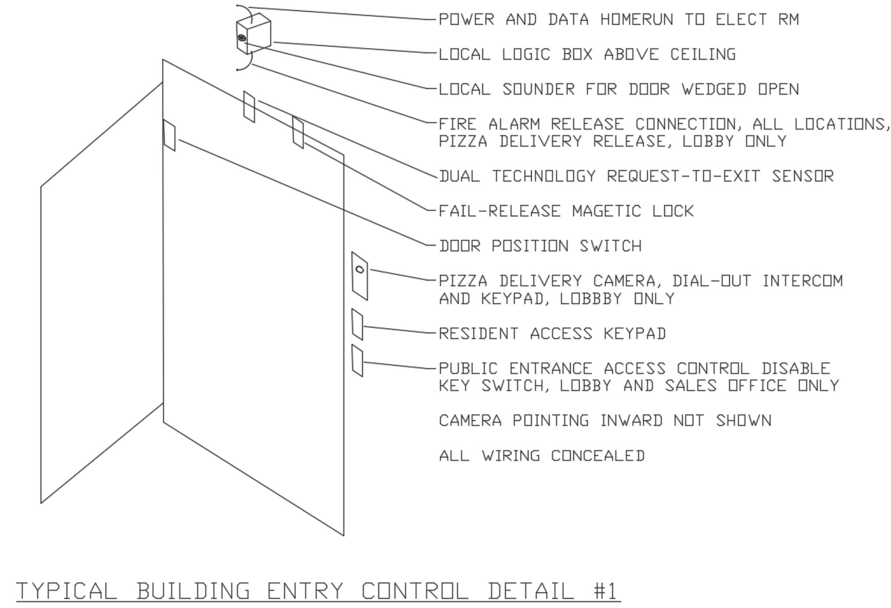

I don’t like intrusion alarms. I install them when the Owner an Architect insist - motion detectors, glass break switches, door position switches and a box which records all events. I much prefer CCTV. Modern CCTV cameras record images on local memory cards, along with a central recorder and permit authorized persons anywhere to view what is happening in real time and from archives.

I design weatherproof, POE, IP-TV cameras with fixed 4-mm lens, memory card slot and 90-ft infrared illuminator. These cost ~$90 at Amazon. I am not recommending buying security cameras for your next commercial project from Amazon. I am recommending that you question your security vendor what additional features his product provides. The Amazon unit is pictured below:

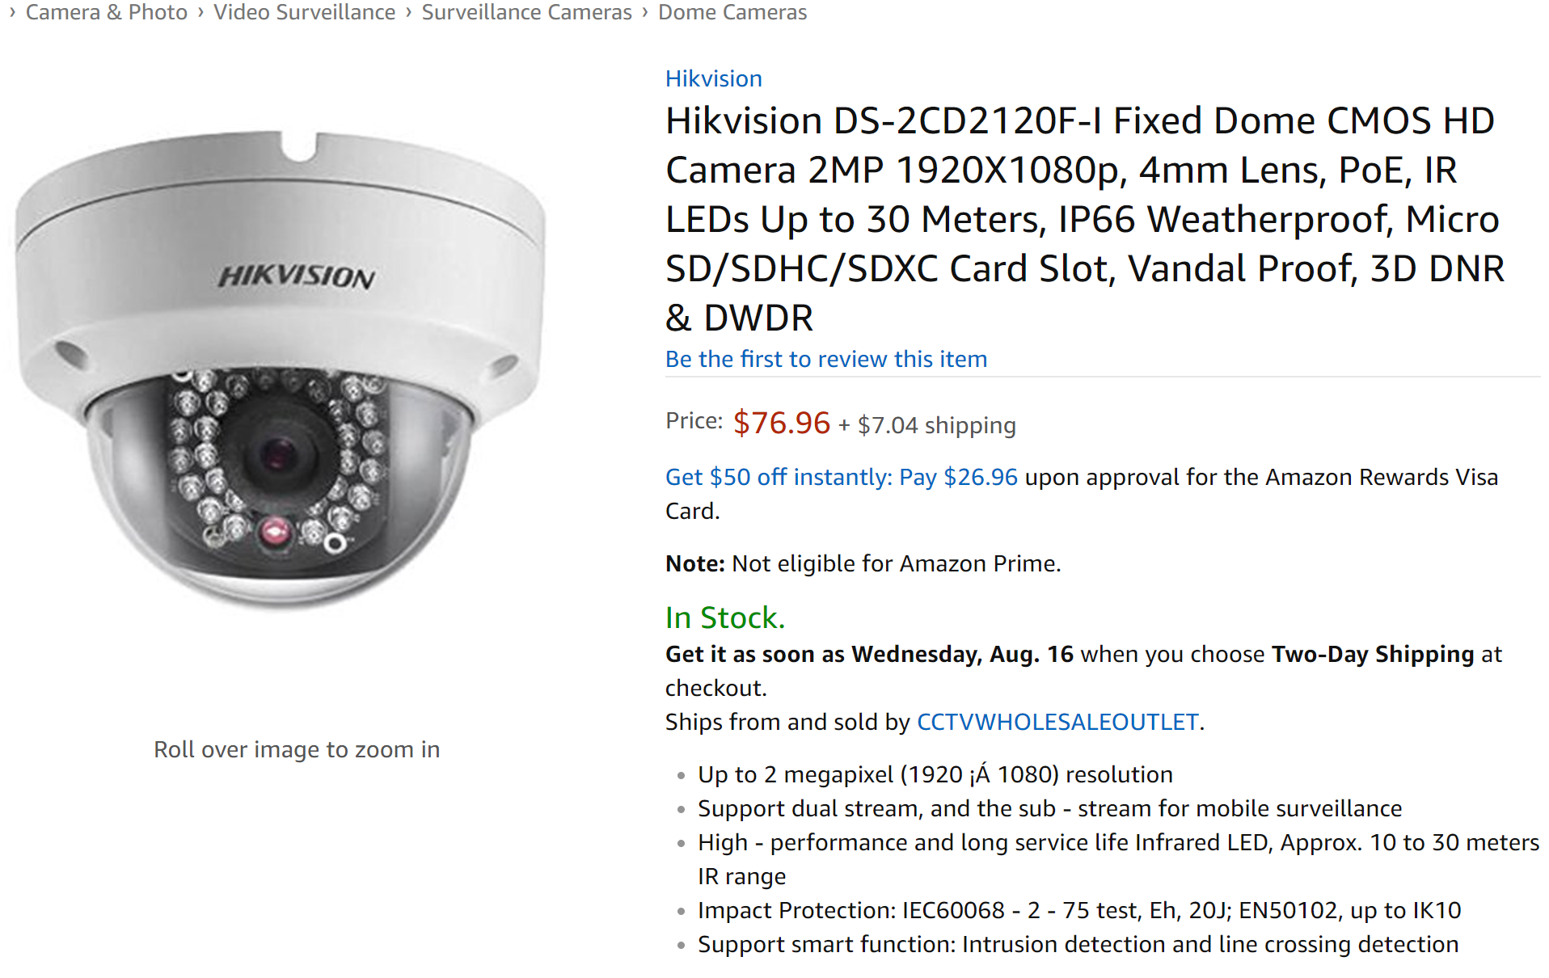
The key fact regarding a 1920x1080 camera is that it provides facial identification or license plate recognition over a 40-ft field of view. The 4-mm lens provides a 90-degree field of view, placing that 40-ft range about 30-ft in front of the camera. Everything closer is good enough to give to a policeman or to a judge.

As my detail indicates, I place the cameras at each door, facing inwards. I am trying to capture someone carrying something out. The camera will story the time and date of the event and take individual pictures for three years, if you put in a 64GB memory card (~$18, free shipping, from Amazon).

Be warned that if you try to take this CCTV idea to a non-school job, you are likely to encounter trouble from the IT people. For commercial and industrial jobs, I often install a totally independent local area network (LAN) to avoid these problems. As an interesting aside, Fire Alarm design is now transitioning over to LAN and wi-fi connectivity. They requie completely independent LAN, as well. It must be locked away from the IT people.

The detailed electrical designer might use the attached plan and SECURITY toolkit to do his job:

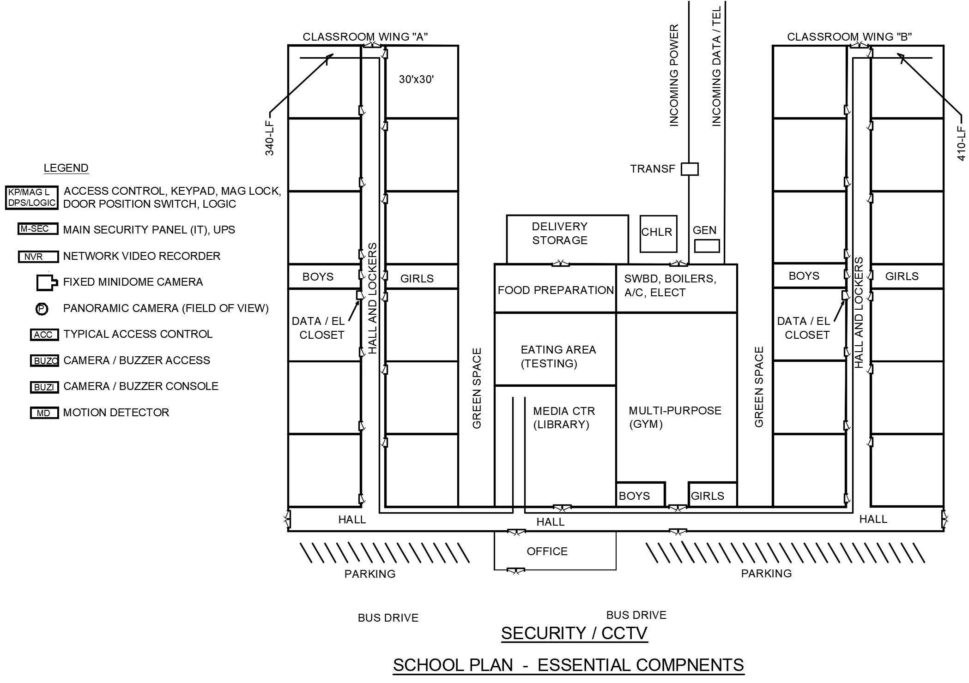
The panoramic camera is included because schools demand them. They provide a record of everything that happens outside, if mounted on a corner of the building, or inside, if mounted in the center of the lobby, gym, cafetorium or gym. They are identical to three or four 90-degree minidomes mounted in a common enclosure. Schools also like pan-tilt-zoom (P-T-Z) cameras. I refuse to show these until my arm is twisted around two or three times. A P-T-Z camera is guaranteed to be looking at something other that the event of interest - 359 wrong directions. A fixed wide-angle is guaranteed to be looking at the event, along with everything else.

The buzzer system is shown because it is very important, now that all outside doors are locked during the day. The Administrative Office lets in partents and late students this way. Food delivery and the boiler room are normally unlocked. It is important to show a camera pointing at the meat storage facility. Meat theft is even more common than theft of computers. It would be a good idea to have a camera pointed at the Vault, since standardized tests and their keys are stored there.

This plan calls out the longest data runs in the school, 340-ft and 410-ft. The data designer has to consider these cable runs and ends up requesting the intermediate data closets. Exactly the same reasoning applies to CCTV cameras which are operated off the central LAN or off and independent LAN. The 300-ft limit applies, unless fiber optic is used. It is common today to place minidome cameras on light poles in the parking lot to record drug deals. Fiber optic is used in these cases.

Fiber optic is almost identical to copper for LAN use. A $50 media converter changes from copper to fiber and proper terminations on each are required. It is important to route low-voltage DC power from the network video recorder to the camera, along the fiber optic pathway. This keeps the remote camera operating during emergencies, when Utility power may be interrupted. Two sketches showing this follow:

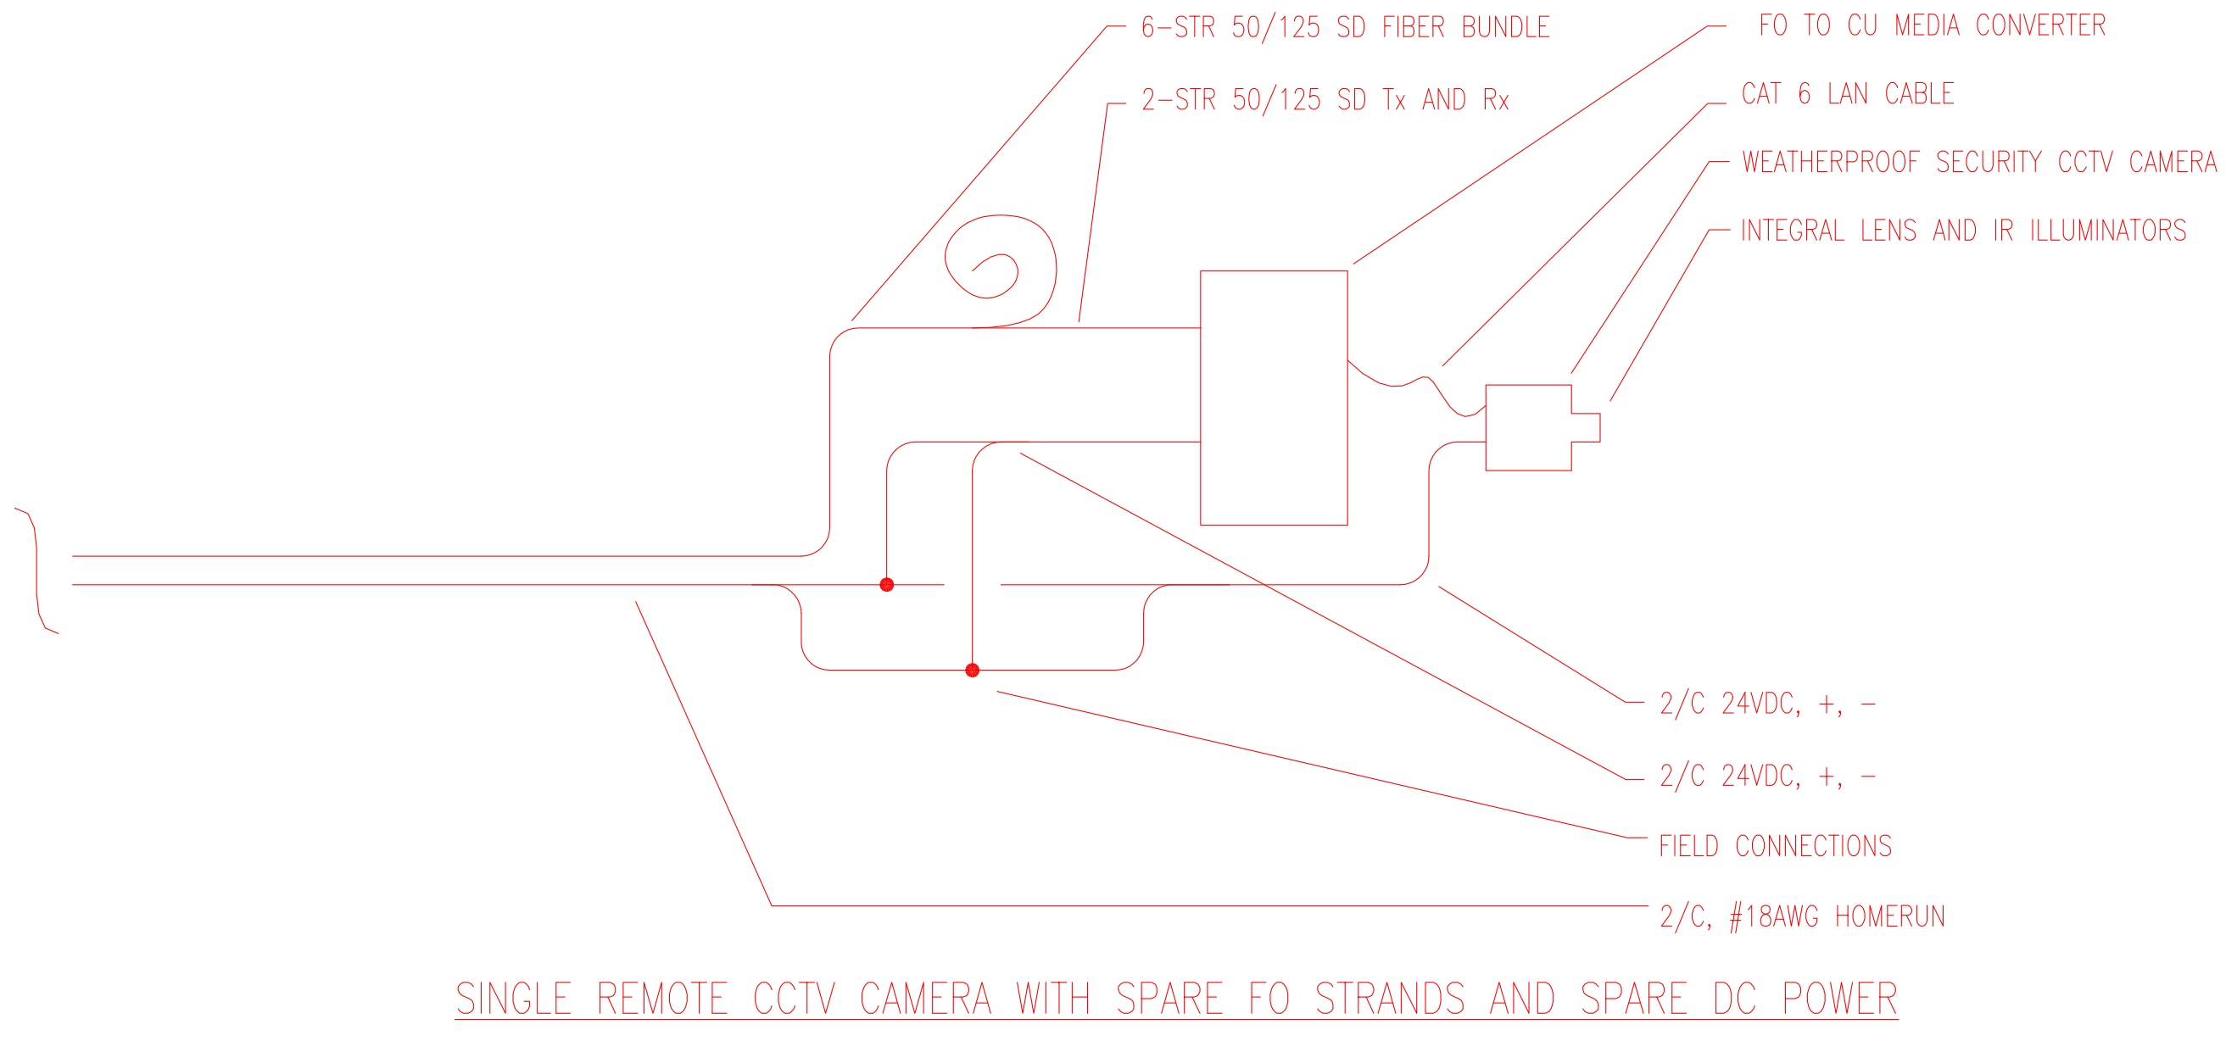
This detail was produced in response to a webinar student’s questions and to validate prices for the components. Media converters and fiber optic cable are very economic in 50/125 SD form. Other forms are also satisfactory. The DC voltage supplied must match the camera and media converter.

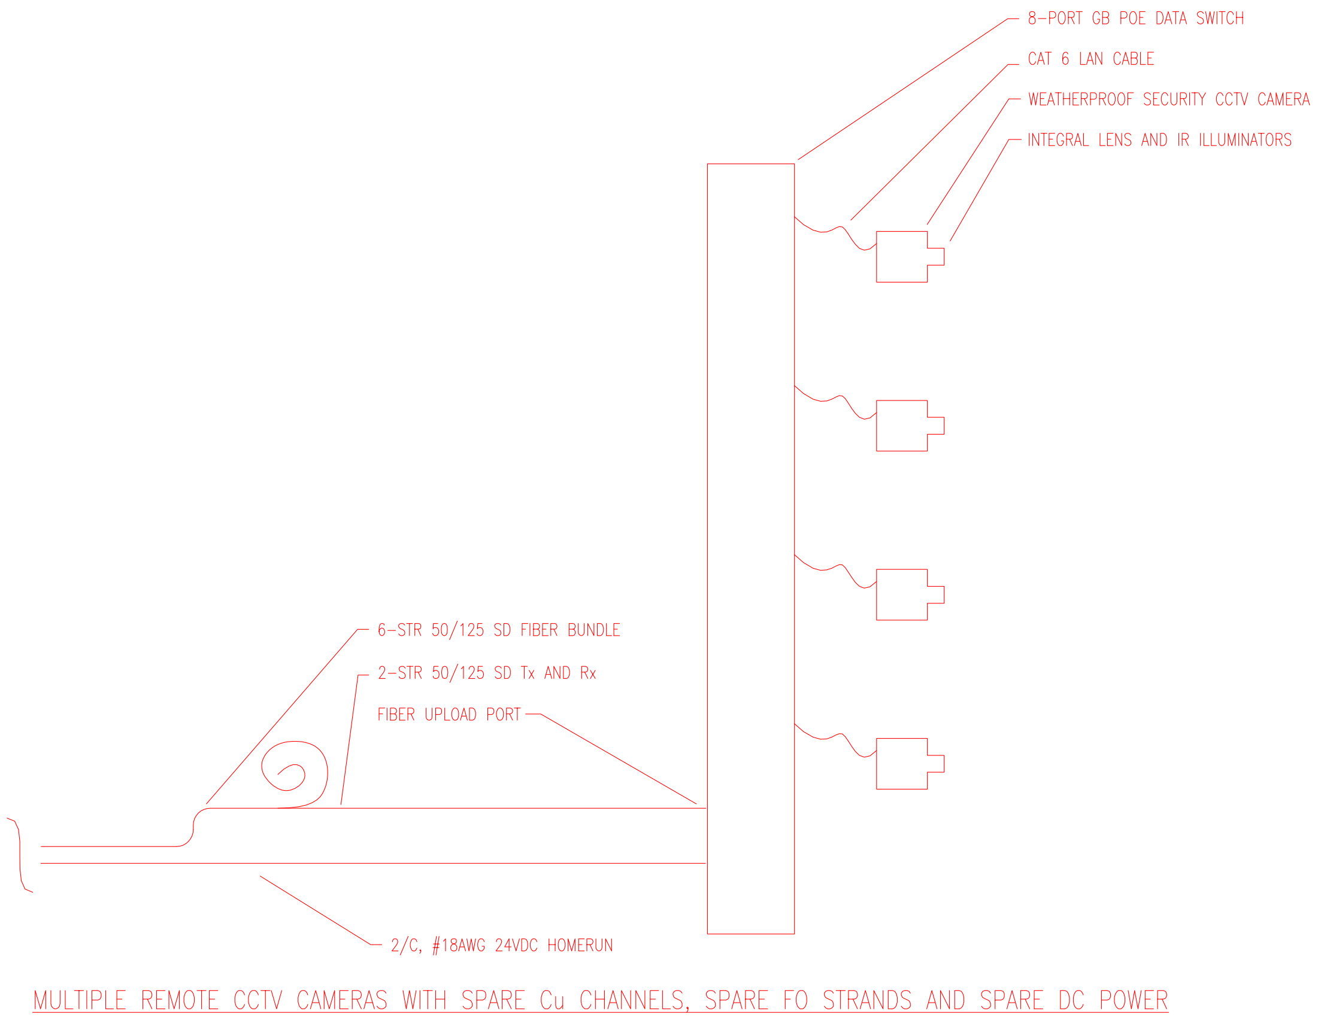
Again, the voltage provided must match the data switch. The data switch provides the power for the POE cameras.

[End of File]

