PDH Course R211F

Florida Laws and Rules
Emphasizing MTS
for
Professional Surveyors and Mappers

Jonathan Terry, P.L.S. (PA)

2010

PDH Online | PDH Center

5272 Meadow Estates Drive
Fairfax, VA 22030-6658
Phone & Fax: 703-988-0088
www.PDHonline.org
www.PDHcenter.com
Florida Administrative Code, Chapter 5J-17

COURSE CONTENT

FLORIDA MTS COURSE OVERVIEW:

While studying for the Florida state portion of the PLS exam in the early 1990’s (the fifth of eight states in which I obtained registration as a land surveyor), I was impressed with the degree of thought and care that went into establishing the laws and rules that govern land surveying in the state of Florida. Many Florida Surveyors and Mappers have not been exposed to the standards governing surveying in numerous states, as I have. Through my comparison of many states’ rules, laws and standards, I continue to be impressed with the thoroughness, clarity and practical usefulness of Florida laws and rules that govern the profession and practice of land surveying and mapping.

The intent and requirements of the Florida Laws and Rules are so unambiguous that little explanation or clarification of them is necessary. However, knowing them and remembering them is essential to the practicing Florida Professional Land Surveyor and Mapper, both to protect the public’s welfare and also to avoid disciplinary action for failing to meet Florida’s requirements governing the practice of professional surveying and mapping.

The primary purpose of this course is to assist you, a Florida Professional Surveyor and Mapper, in reviewing with a fresh set of eyes Florida’s MTS requirements, to refresh your memory – so that you don’t inadvertently fall short of your obligation to the public or in satisfying Florida's requirements for your noble profession.

To achieve this objective we will review numerous aspects of laws and rules governing the practice of our profession, primarily as they relate to the day-to-day practice of land surveying and mapping. Since this is our focus, we’ll not deal with things like how many members are on the Board or what the procedure is for renewing an expired license. These are questions you might find on the local portion of the PSM exam, but a decade or a lifetime can easily pass without your needing to know that information. However, being thoroughly acquainted with the Minimum Technical Standards that govern the daily practice of your profession is critical to your success.

The Board wisely mandates that you study the laws and rules of the Board periodically as a requirement for renewing your license to practice as a Professional Surveyor and Mapper. We’ll consider some laws that govern your work as a surveyor and mapper, but this course will focus almost exclusively on the Minimum Technical Standards of your profession, Chapters 5J-17.050 through 5J-17.052 of the Florida Administrative Code.

Let’s get started.

PREPARATION: GATHERING OF MATERIALS

In preparing this course material, the process I used is the same one I employed when first studying for the Florida PLS exam in 1991. It's a technique I've used with slight variation when studying for surveying licenses in several other states, and it always serves me well.

- First, I obtained printed copies of current Florida Rules and Laws (this time downloading them from the Internet), specifically the Florida Statutes, Chapters 177 and 472 and the Florida Administrative Code Chapter 5J-17. (Links to these and other sources of important information are provided in the following pages with this course material.)
- These documents were placed in a 3-ring binder and separated by tabs identifying various sections of these documents.
- Next, I read them all – as if I'd never studied them before – word for word, highlighting in various colors the information contained in them.

While studying these resources, very few handwritten notes were needed. Again, this is a tribute to the care taken in creating and updating these Laws and Rules.

May I suggest that you do the same as I did – obtain fresh copies and then study the Laws and Rules as if you've never seen them before in your life? And, devote special attention to the MTS (Chapter 5J-17.050, 5J-17.051 and 5J-17.052, F.A.C.) in preparing for this course’s Question-and-Answer/Discussion Section and also for the Course Quiz.

If you will do that, the Question-and-Answer/Discussion Section of this course combined with the Course Quiz will serve as aids to cement in your consciousness the Minimum Technical Standards of your profession plus other matters covered in this course that impact the daily practice of your chosen field of public service. And, you'll gain the peace of mind that comes from knowing you're meeting the requirements set forth by those who oversee and govern your profession.

WHAT IS THE QUESTION-AND-ANSWER/DISCUSSION SECTION?

It's important to stress up front that a very large part of this course, and the learning you receive, will come from the thought processes and analysis you apply while studying the Question-and-Answer/Discussion Section of this course. PLEASE, do not skip over this important section! This section requires critical thinking and careful analysis. Often, inadvertent and unintended violations of MTS can be avoided through such attention to the details within the rather large body of Laws and Rules that dictate the requirements of your practice. The Question-and-Answer/Discussion Section in this course and the Course Quiz are designed as integral and inseparable parts of the study process itself.

The Question-and-Answer/Discussion Section has been structured with three important purposes and benefits in mind:

- To focus your thoughts on the Laws and Rules themselves,
- To assist you in remembering what you must know and do to satisfy the requirements that govern your profession, and
- To help you avoid painful, costly and humiliating disciplinary actions that could potentially result from the plague of our human tendency toward forgetfulness.

It would be senseless, if not damaging, for me to develop course material rephrasing the wording of the Rules and Statutes in order to generate "course material." Your course study-material already exists in the Rules and Statutes, and that material is thoughtfully conceived, carefully worded, and logically presented.

Your obligation to your clients, the public and your fellow professionals is twofold:
- know what that material requires of you, and
- obey what it says.

Unless you’ve spent lots and lots of time in the MTS, you’ll have to keep your nose in Chapter 5J-17.050, 5J-17.051 and 5J-17.052, F.A.C. to make a profitable study of this material and to pass the quiz. Neither the Question-and-Answer/Discussion Section nor the Quiz is overly hard. How can they be? They’re both ‘open book’ activities, and they mostly tend to follow the sequence presented in the F.A.C. But, they do require that you devote your attention to detail and careful, concentrated thought.

YOUR INSTRUCTOR’S TEACHING STYLE:

Now, there is one thing you need to understand about this presentation and my teaching methods in general. This course consists of original material created by me and material that is not original. Of necessity the not-original material consists of the Rules of the Board plus occasional references to Statute Law. Please be careful to distinguish between original material (my writing and opinions) and not-original material (the Rules and Laws).

While many course authors write in a, "Thus saith the Author..." style, I believe a more beneficial presentation results from conveying information more in the tone and flavor of a live seminar. In other words, I present written, original material in a conversational, informal manner, much as you might experience in a live seminar or even during a round-table discussion. That doesn't mean I'm without opinions, or that you won't have to endure hearing some of them. After four-plus decades of surveying in a wide variety of assignments, climates and situations while serving the disciplines of architecture, transportation, bridge building, property surveying, large-scale commercial development, residential development, civil engineering and construction management, I believe that you'll find at least a few things that I share to be beneficial and thought provoking.

I will present my impressions, interpretations, experiences, and advice with the sincere hope and purpose that some of this information will bring new thoughts to you – things you’ll ponder and evaluate and patiently draw your own conclusions about. This doesn't mean that if you and I disagree on some interpretation or application of the Rules of the Board, that I am right and you are wrong. I believe that writing in an informal, conversational style promotes mutual respect between you and me, and it involves you in the process of bringing your own fresh eyes to this material.

DISCLAIMERS

If I were presenting two-plus-two-equals-four, I could state that such-and-such is true, and that if you disagree, you’re wrong and I'm right. But this course deals with Rules of the Board, which in essence have the effect of Law. And, Law is subject to interpretation more often than any of us would like. Also, Law is subject to dispute. If this were not so, we would have no need of lawyers or appeal procedures. Thankfully, though, most of the MTS are straightforward and clear in their meaning and intended application.

I am not a lawyer! The opinions represented in this course do NOT represent legal advice. I am not a member of your Board, nor am I telling you how the Board views the MTS. The opinions presented are those of a person who began his surveying career in 1963 and since then obtained registration as a surveyor in eight eastern states. I do have a lot of experience through an unusually diverse body of experience. But, this doesn't mean that I'm right and you're wrong if our interpretation of the Rules should differ.

You are responsible for deciding if you feel my impressions are correct or not, just as you alone will determine your interpretation of the MTS as applied to your daily practice of your profession.

WRITING STYLE


As noted above, I try to fashion written course material in a way that creates the feel of a live seminar. Why? To engage productively your imagination and independent thought. If this were a live seminar, then I would not be judged overly harshly should I present an opinion that the majority of my listeners found disagreeable. During live seminars, discussion forms a large part of the learning process, and the experience and expertise that both presenter and participants bring to the forum contributes to everyone's learning experience. In this correspondence course format, our give-and-take personal interaction is necessarily limited.
But, it's my intention and hope that you will interact with me in several ways, much as you would in a live presentation:
- You will use your creative imagination to view this course material as a live presentation. You’ll feel free to disagree with what's being presented and to raise your objection or your correction, or share from the wealth of your own experience and knowledge. (Of course, no one is actually listening to you, but that’s how it is in most of your life anyway, right?)
- A benefit that the correspondence course format offers over a live presentation is you actually have time to research and investigate any matter brought forth during the instruction that you disagree with or that you want to research more fully. You won't take everything that's written here as gospel. Rather, you will dig into the MTS and other Rules and Laws (or other sources of authoritative information) and confirm for yourself what the Rules and Laws are saying to you. After all, your career will live or die based on your interpretations and choices, not mine.
- You will offer feedback to me, your course instructor, through the provision made on the website for this interaction. I will appreciate your feedback, whether critical or confirming, and I will personally answer any correspondence you initiate. For more in-depth correspondence, feel free to email me at JonTerryNEC@yahoo.com. To protect my server, I do not open forwarded email as a rule. If you feel I’m flat out wrong on some point(s), please do let me know.
- The Question-and-Answer/Discussion Section of this course material will be very beneficial to you if you allow it to be. It's designed to provoke critical thinking and analysis of the MTS section of the Rules and to draw your attention to points that might "trip you up" in the daily practice of professional surveying and mapping. You should plan to spend some dedicated time in the Question-and-Answer/Discussion Section which, combined with the Course Quiz, will lead you through almost every matter covered in the MTS. Your diligence is critical to fulfilling the purpose of this course and getting the most out of it.

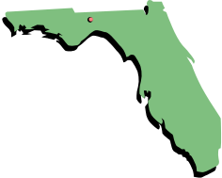

This course focuses primarily on:

CHAPTER 5J-17.050, 5J-17.051 and 5J-17.052, F.A.C.
MINIMUM TECHNICAL STANDARDS

A fundamental premise in the creation of this course is that it’s designed expressly for the Florida Professional Land Surveyor and Mapper fulfilling the obligations of required continuing education.

What does this tell us?
- You've already studied the Minimum Technical Standards in order to prepare for your exam for licensure.
- Florida's MTS governing professional surveying and mapping are not new to you.
- Surveying is not new to you.

So why the continuing education requirement to study the Laws and Rules again and again? Why this course? To keep these requirements fresh in your mind, and so you'll notice changes made in the Rules (particularly the MTS) since you last studied them. Changes do occur frequently!

This course material is essentially a refresher course, not an introductory course. Chapter 5J-17 is a dynamic document. Its frequent revisions dictate that it must be re-studied and reviewed periodically. In truth, the Florida PSM should habitually check with sources that provide news regarding updates and changes to the documents that govern our profession. More detail on how to do this is provided in this course.

Successful completion of this course consists of these essential ingredients:
- you obtain current copies of the Florida Administrative Code - Chapter 5J-17 plus Florida Statutes Chapter 472 and Chapter 177,
- you review and diligently study the current MTS (Chapter 5J-17.050, 5J-17.051 and 5J-17.052 of the Florida Administrative Code) and various other relevant Laws and Rules of the Board,
- you carefully study this original course material in its entirety, and
- you pass the Quiz that accompanies this course – taking the Quiz with your fresh (not an old) copy of the MTS and other Laws and Rules in hand. The quiz is an open-book exam required for your continuing education obligations, and it’s also an aid to your memorization of the study material.

GATHERING YOUR RESOURCE MATERIALS

PLEASE, even if you have recent copies of the MTS and Laws, would you gather fresh, unmarked copies of the resources below for use during the study of this course material?

Some things have changed and necessitated this update of the Florida MTS course. May I suggest you periodically go to http://www.leg.state.fl.us/Statutes/ and spend a little time exploring. For example, if you type “surveyors and mappers” in the search box, thus:

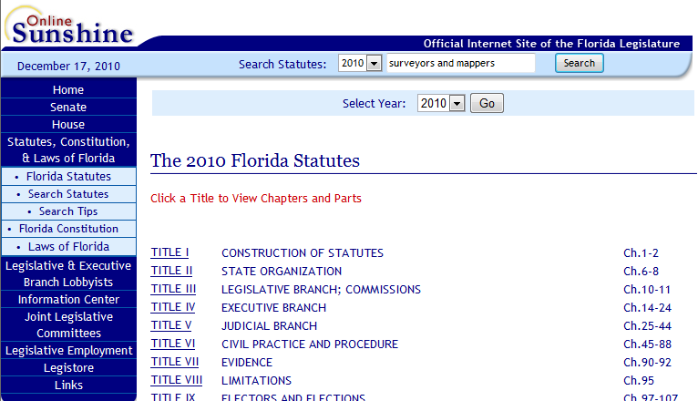

… Then click: and you get (turn to next page)…

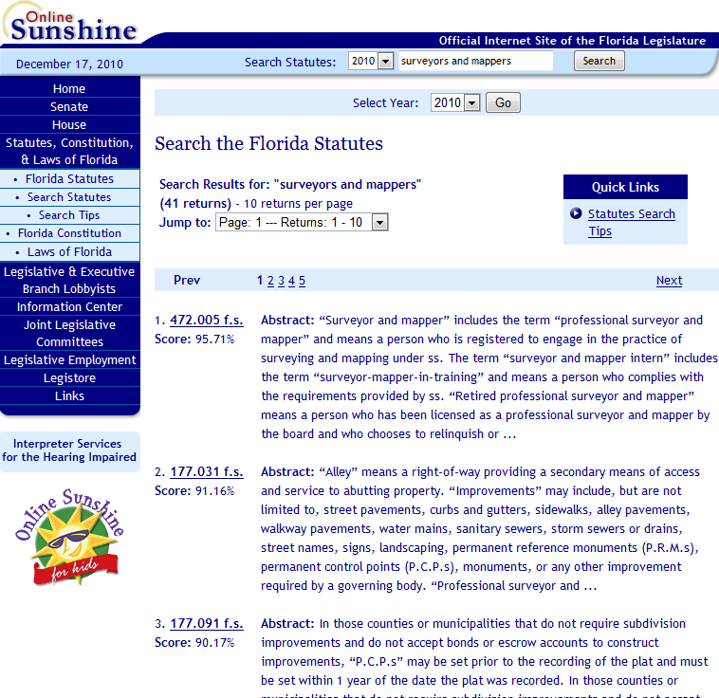

This particular search netted your course author 41 hits, some of which were very interesting. Some provided insights and information I wouldn’t have known about otherwise. Some even generated some marketing ideas.

I digress, which is easy to do when surfing the Internet!

Clicking “Florida Statutes” in the light blue, upper left portion of the above web site page yields a listing of the Florida Statutes as shown on the following page:

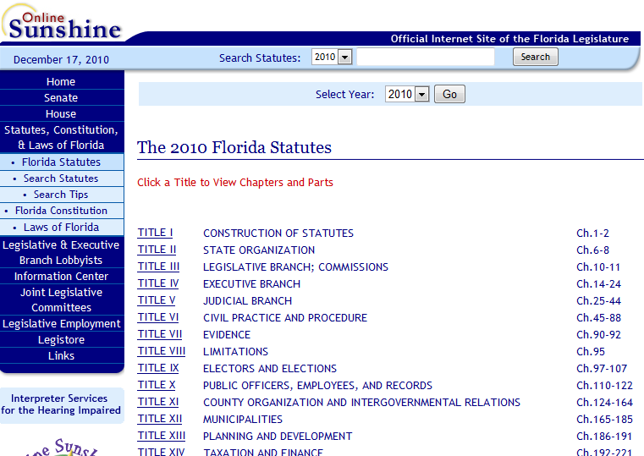

Clicking on “TITLE XII MUNICIPALITIES
Ch. 165-185” we find, as shown on the following page:

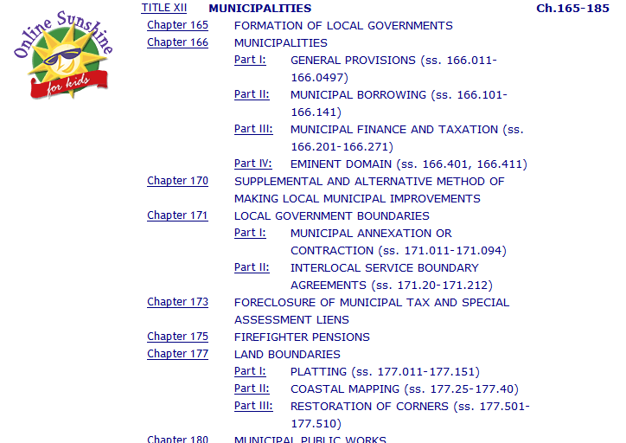

Clicking on “Chapter 177” brings us to a chapter we want to capture:

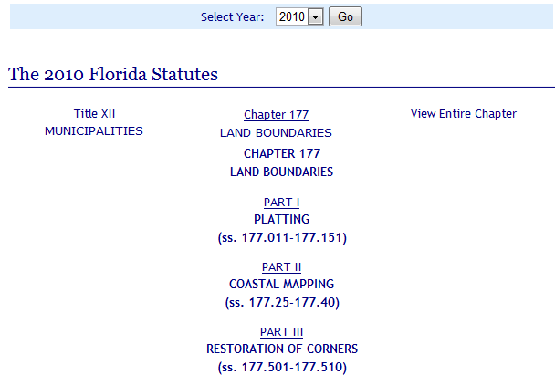

Clicking on “View Entire Chapter” opens just what we’re looking to harvest!
Here’s a tip, should you need it. Right-clicking in the web page that displays the contents of Chapter 177 (or any other web page for that matter) brings up a Context Menu that includes a PRINT option. If you prefer to harvest a PDF file, rather than a paper copy of the document, and if you lack a method to do so, here’s one option. A wonderful utility called CutePDF will behave, in your dialog boxes, as if it’s a printer. But instead of printing to physical paper it will create a PDF file that you may open in the free, downloadable program Adobe Reader.

Go to http://www.cutepdf.com/products/cutepdf/writer.asp and click “Free Download.”

CutePDF has worked well for me in the past, although at present I generally use Adobe Acrobat (not a free program) for most of my work with PDF files.

At the time of this course update, the following links provided copies in PDF format of the following resources:

Chapter 5J-17, F.A.C. http://www.800helpfla.com/psm/pdfs/5J17.pdf
An MTS Checklist http://www.800helpfla.com/psm/psm.html
Chapter 177, F. S. http://www.800helpfla.com/psm/pdfs/Chapter177.pdf
Chapter 472, F. S. http://www.800helpfla.com/psm/pdfs/Chapter472.pdf
Chapter 120 F. S. http://www.800helpfla.com/psm/pdfs/Chapter120.pdf

Your Board’s home page: http://www.800helpfla.com/psm/psm.html

Also, as of the time of this update, the following links may be of interest to you regarding recent (July 1, 2010) changes to Florida Condominium Law:

From Cyber Citizens for Justice site:
http://www.ccfjedu.net/condo718statutes.html
From a familiar site:
http://www.leg.state.fl.us/Statutes/index.cfm?App_mode=Display_Statute&URL=0700-0799/0718/0718ContentsIndex.html&StatuteYear=2010&Title=-%3E2010-%3EChapter%20718
From the Florida Senate:
http://www.flsenate.gov/statutes/index.cfm?App_mode=Display_Statute&URL=0700-0799/0718/0718ContentsIndex.html&StatuteYear=2010&Title=-%3E2010-%3EChapter%20718
From Lexology.com
http://www.lexology.com/library/detail.aspx?g=66450e40-c3be-49a9-9ba1-6f9c9a3af928
From Kaye & Bender P.L.
http://www.rkayelaw.com/legal_morsels/18/summary-of-significant-changes-to-the-condominium-act-chapter-718-f-s

I’ve included the above Condominium Law links to provide just a sampling of the information available at our fingertips on the Internet. The problem with providing links in a course such as this is that available Internet resources come and go and change Internet addresses VERY often. I really don’t like providing any at all, but I do so knowing that some may cease to function and frustrate my reader. I apologize, but I simply can’t keep watch on the many links in the various courses I generate. I trust you’ll understand and that you’ll have to Google to find what you’re seeking as links become extinct.

So, when you click on a link that yields something like this…

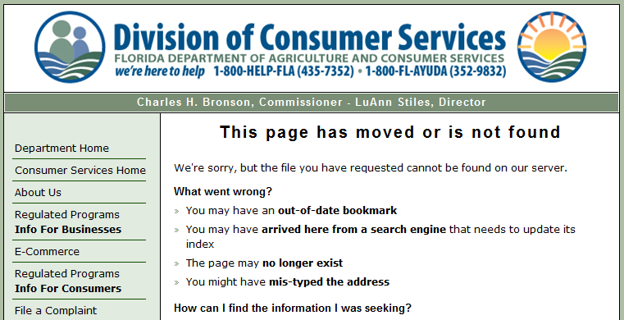

…dear friend, you’re on your own.

-------------------------

Anyway, I’m going to assume that you’ve now gathered your resource materials for this course from the Internet and/or you’ve obtained hard copies.

YOUR COURSE INSTRUCTOR’S PERSONAL APPROACH

Here's what I've done for my own study purposes, and it’s served me well.

Repeating that time-honored saying, “CLASSIFICATION IS THE KEY TO LEARNING,” I’ve created a Chapter 5J-17 spreadsheet. (See the following two pages.)

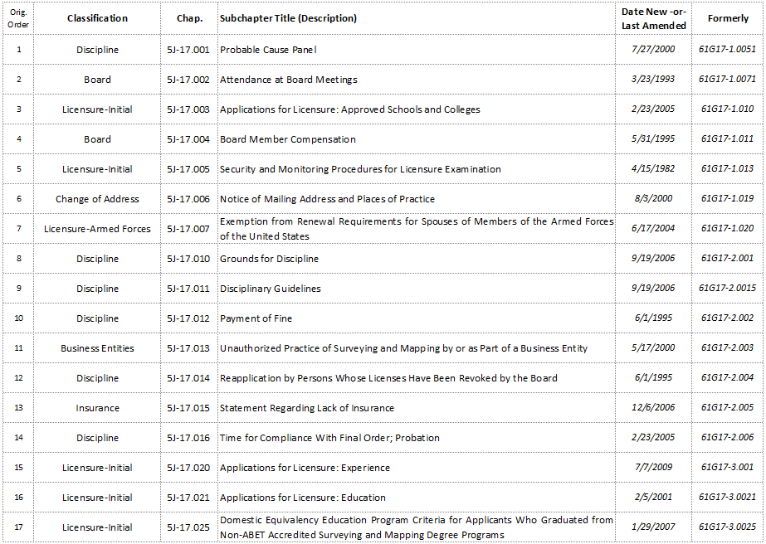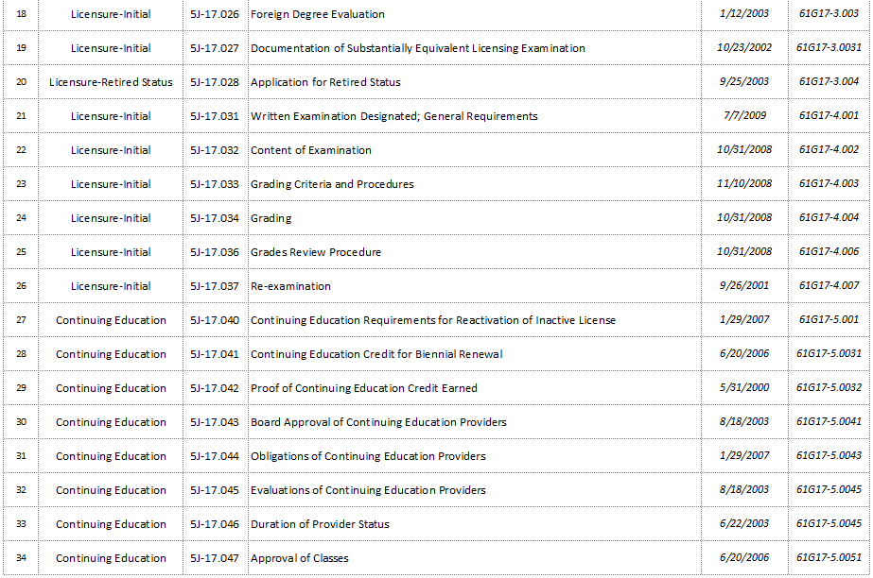
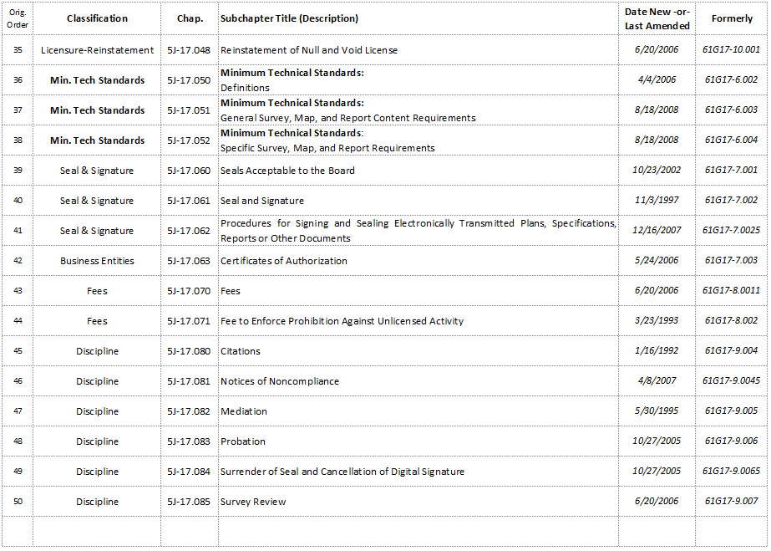

You may notice, as I have, that there appears to be a lack of logic in the flow of the subchapter number sequence. Therefore, I’ve created a column headed, “Classification.”

There are several reasons I’ve taken the time to create the above pictured spreadsheet. As I explain what I did, my reasons become obvious.

- In Microsoft excel, I created a new spreadsheet having six columns with Headings as they appear above.
- I saved the spreadsheet – including in its filename the date that the spreadsheet’s data were downloaded. (Future updates to the spreadsheet will be saved under a new filename, with appropriate new download dates in their new filenames.)
- The initial sheet within the spreadsheet file was named, “Orig Order,” meaning that sheet’s subchapter numbering is sequenced just as it appears in Chapter 5J-17.
- Once all the data were harvested from Chapter 5J-17, I assigned logical CLASSIFICATIONS appropriate for the content of each subchapter’s title.

- Next, I made a copy of the original sheet.
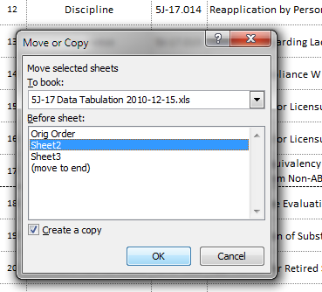

- The copied sheet was renamed, “Classification Sort” (and I decided to rename the first sheet from “Orig Order” to “Orig Sort” for consistency, as shown below).
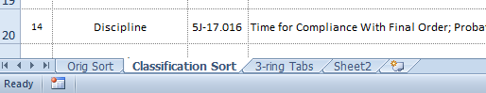

- Sheet “Classification Sort” was then sorted by columns B and C.
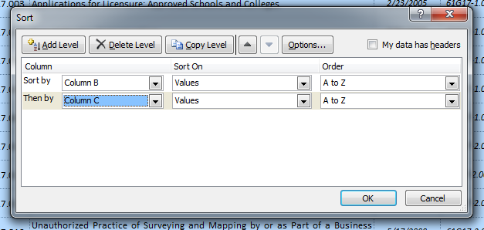

The resulting data, SORTED by CLASSIFICATION, is more logical than the unintuitive sequence in which Chapter 5J-17 was originally crafted.

- I then performed cutting and pasting in my MS Word copy of Chapter 5J-17 and reassembled my Chapter 5J-17 in the order dictated by the spreadsheet’s new “Classification Sort.” At the end of each grouping by classification in my MS Word file, I inserted a page break.

- Then, I printed the logically ordered MS Word file version of Chapter 5J-17. The manually inserted page breaks between Classifications allow me to place the work in a 3-ring binder with tabs separating and identifying each logical classification, (i.e., Board, Business Entities, Change of Address, Continuing Education, Discipline, Fees, Insurance, etc.) as illustrated on the following two pages.

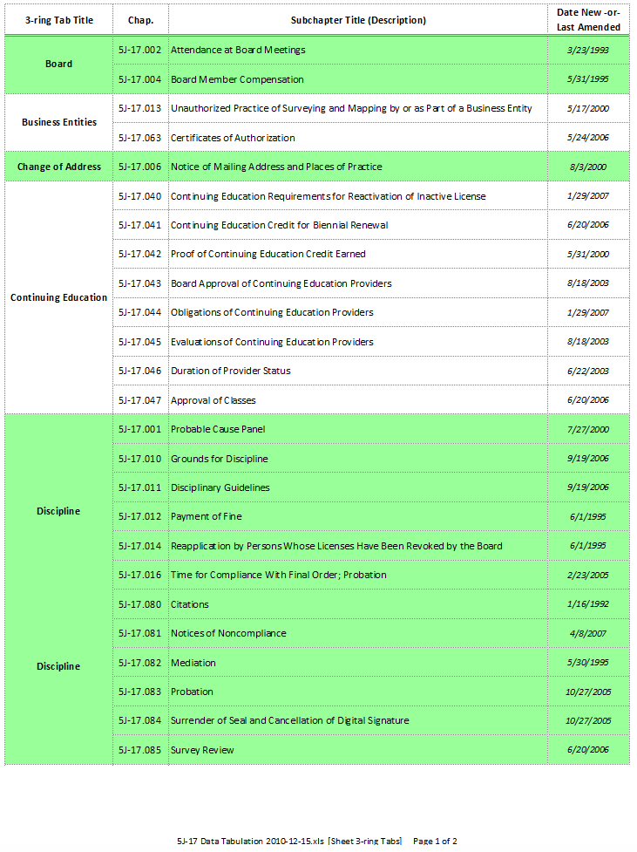
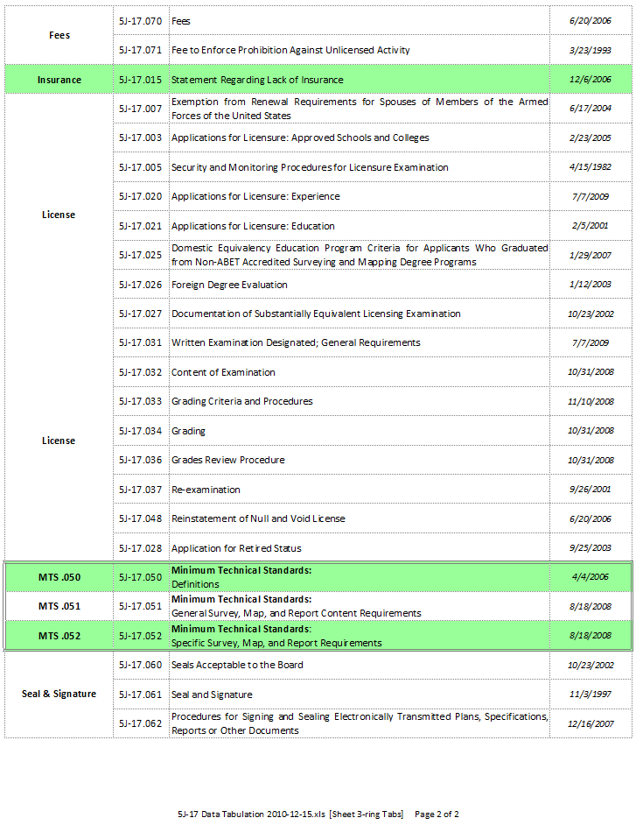

My personal choice is to print the above two sheets to serve as an index, placing them in my 3-ring binder, at the beginning of my 3-ring binder that I’ve titled:
MINIMUM TECHNICAL STANDARDS

“Send this guy to the ARF,” you shout? (That’s short for Anal Retentive Farm.)

Here’s my point, and it has some validity, you’ll have to admit:

- As a Florida Professional Surveyor and Mapper, you have a large body of Laws and Rules to study often and obey consistently.

- These do change over time. (Too often, for your or my taste!)
- You have a moral and professional obligation to keep yourself current.
- Some system (any system that works) is necessary to achieve this purpose.
- Therefore, you need a system that will actually work.
- The one I’m suggesting isn’t that bad… if you have basic competency using Microsoft Excel.
So… if you do have basic familiarity with MS Excel, I doubt that you can find a more foolproof, efficient and convenient way to track changes to the Rules of the Board than through using the spreadsheet approach I’ve created and shared with you in this course.

If you will just make periodic reviews using fresh copies of Chapter 5J-17 looking carefully at the end of each subchapter, where you see something like this…
…you’ll very quickly and efficiently discover the latest amendments (or new Rules). When you determine an update has occurred, you update to the new or revised Rule(s), making certain you understand its application to your practice, and you carry on without fearing some change to the Rules might sneak up on you without your knowledge.

I’ve created 12 tabbed sections in my 5J-17 3-ring binder, the tabs named per the left hand column of the above two pages of the spreadsheet.

For you seasoned professionals who think this approach is just plain “over the top” or a waste of your time, please just remember this material and share it with those you’re mentoring and especially with folks studying and preparing for their PSM exam. Having a CLASSIFICATION system like the one I’ve described will save many precious minutes when taking the exam, and a few saved minutes often make the difference between pass and fail. Thoughtful classification leads to rapid retrieval of laws and rules.

Also, such a system might just make the difference between you keeping yourself current with changes in the Rules and slipping into those troubled waters of not-being-current, that can lead to disciplinary action. The ancient wisdom reminds us…
Ignorance of the law is no excuse!

THE "S" IN MTS DOESN'T STAND FOR "SUGGESTIONS!"

Notice as you review Chapter 472, that 472.027 (Minimum Technical Standards for Surveying and Mapping) is the statute requiring the Board to adopt Rules (often referred to as “Rules of the Board”). These are the Rules that we’re studying in Chapter 5J-17 of the Florida Administrative Code. These Rules, of course, have the force of Law. They are not “Suggestions of the Board” or “things you might want to consider following.” Disobeying or failing to observe the MTS can thus lead to severe consequences!

Notice one person’s consequences as published in the Board’s Summer 2006 Newsletter:

Alberto Lorenzo-Luaces
Miami
DBPR case # 2002-009661
License # LS 3087
Violation: Section 455.227(1)(q) F.S., Multiple MTS violations of Rules 61G17-6.003(1)(b), 61G17-6.003(1)(e), 61G17-6.003(2)(f), 61G17-6.003(2)(i)(2), 61G17-6.003(1)(b), 61G17-6.0031 (1)(f)(1), 61G17-6.0031(1)(f)(2), 61G17-6.0031(1)(f)(4), 61G17-6.0031(2)(b), 61G17-6.0031 (2)(d), 61G17-6.0031(3)(c), 61G17-6.0031(4)(c), 61G17-6.003(1)(c), 61G17-6.004(1), 61G17-6.0031(1)(b),F.A.C.
Penalty: Fine of $3,500.00, costs of $1,273.13, probation and MTS training within 90 days of final order.

From: Minutes Board of Professional Surveyors & Mappers,
Probation Review Committee Meeting of January 10, 2007:

Alberto Lorenzo-Luaces License # 3087
Mr. Lorenzo-Luaces was present and not represented by counsel.
Ms. Nobles reported that she reviewed exhibit numbers three and four and found both surveys not in compliance.
Mr. Lebron reported that he reviewed exhibit numbers five and six and found both surveys not in compliance.
Ms. Clodfelter reported that she reviewed exhibit numbers one and two and found both surveys not in compliance.
After discussion the following motion was made:
MOTION: Ms. Nobles made a motion to have Mr. Lorenzo-Luaces submit a full set of surveys and backup materials.
SECOND: Mr. Lebron seconded and the motion passed unanimously.

Another consequence, as shown in the above examples, is having one's difficulties published for the entire world to see. In our modern information age, a Google search for the above named person returns several hits for that individual, leading one directly to Mr. Lorenzo-Luaces’s encounters with the Board.

This means that Mr. Lorenzo-Luaces is in a sense “branded” well into the future, even if his performance as a PSM became exemplary following his encounters with the Board. Would you like an Internet search for your name to turn up a disciplinary action? What if you apply for a position and your future employer Googles you? What will be found?

There are moments or events or actions in each of our lives that we would prefer not to have shared openly with the whole world – things we wish had never happened; things we wish we’d never done or said. If your view of yourself is objective, I think you'll agree with this statement. (Those who know you best are already aware of this, so you may as well agree!)

The information age in which we live raises the curtains on our lives and lets the world look in to see how we've done. If you are disciplined by the Board, this unfortunate circumstance becomes quite public now and in the future - even if you repent of your less-than-perfect ways and become the model surveyor and mapper you always meant to be in your heart of hearts.

ALWAYS KEEP YOURSELF CURRENT!

Finally a word of caution: Because the Florida Administrative Code and statutes change frequently, you MUST obtain current copies of same when you study this course. You can't use your old copy, even though you've marked it up in four colors with hi-lighters and made copious notes in the margins. You need a nice, white, clean, fresh, unmarked copy of Chapter 5J-17.

There is no practical way that this course can be instantly revised with each and every change to the Laws and Rules. I will keep an eye on changes to the Rules and update this course periodically. Should you find any significant error or outdated material in this course, this should be reported to your course author through the Internet continuing education provider. Your course author will be MOST appreciative and will promptly correct the course material and quiz to reflect any substantive changes made to the Rules or any errors that may have crept into this course material.

Also, NOTHING in this original course material has the force of law. The information in this course is intended to be current at the time the course was created or last updated. Of necessity, changes in the statutes or Rules must occur prior to a course update, and that guarantees that at some point in time, some material presented herein will not be current. As a wise man once said, “There ain’t nothin’ ah kin do ‘bout dat.”

Always guide your professional practice based on current material obtainable on the World Wide Web, materials available and distributed by the Board, by various interested parties, and/or by your professional society. Determine for yourself what or who is the definitive source of the most current information and do what’s necessary to keep a close eye on changes impacting the practice of your profession.

Whether or not you’re a member of FSMS (Florida Surveying and Mapping Society), be certain to stop frequently at their web site: http://www.fsms.org plus the Board's site at http://www.800helpfla.com/psm/psm.html.

Finally, you’ll likely find the occasional (though pretty rare) typo in the Laws and Rules. In the version I harvested off the Internet in December 2010, for example, the downloaded version of the MTS, in 5J-17.052(3)(b)1.e., references “sub-subparagraph 5J-17.052(3)(b) 2., F.A.C.” As far as I can see, the referenced sub-subparagraph does not exist. Based on the former 61G-17 wording, I think the reference should be, “5J-17.052(3)(b) 1.a., F.A.C.”

In 2007, the FSMS site placed this announcement:
RULE 61G17-6, F.A.C., Minimum Technical Standards
The DBPR BPSM's new MTS rules were recently adopted and took effect on Tuesday, April 4. One item in the revised MTS language was inadvertently left in the text during the editing process:
Item 6.003 (3) (p) “Map Accuracy. The expected accuracies of features shown on a survey map must be stated.”
At its April 13 meeting, the DBPR BPSM voted to remove the language and noted that this particular item will not be enforced.
Things like that do happen, in that humans are involved in the process.

On the whole though, the Florida Statutes and Rules of the Board are amazingly coherent, consistent in relationship to each other, and nearly free from typos and incorrect or expired references. If only we could trust all the available Internet downloads to reflect the truly most current changes and most current dates…

DON’T BUY MILK THAT’S PAST THE LAST SALE DATE!

Stuff exists on the Internet’s “shelves” that is past its ‘last sale date.’ Beware of information that looks like it’s what you’re seeking – but isn’t current.

If you click https://www.flrules.org/gateway/ChapterHome.asp?Chapter=61G17-6, as of the date of this course update, you’ll be taken to the site on the following page:
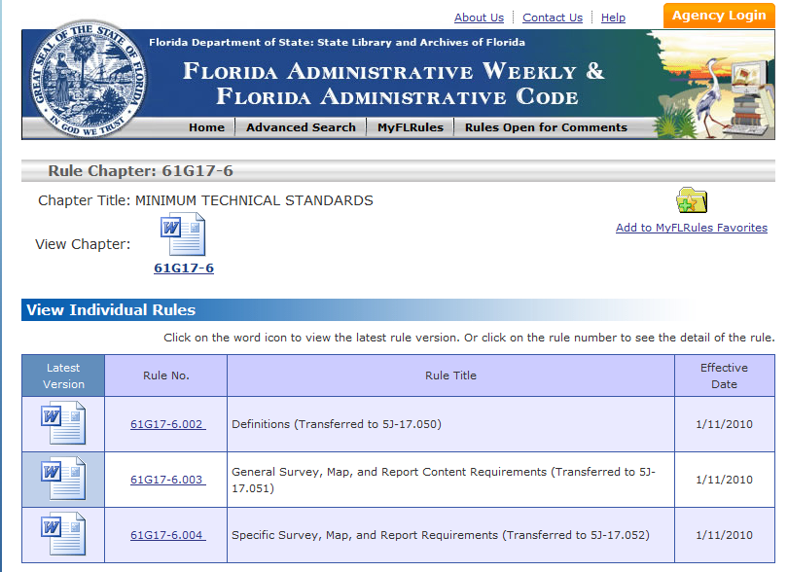

But, as the site shows, the Minimum Technical Standards have been transferred.

Some Internet searches will lead you to places you shouldn’t be looking for the information you’re seeeking, because the information on leftover pages simply is not current. This is just one example of how the unwary surfer may stumble into places that at first glance may look like they serve up the right stuff, but the particular web page may not be where you really need to be.

Here’s a suggestion: (following page)

On the Internet, go to https://www.flrules.org/ and click on MyFLRules:

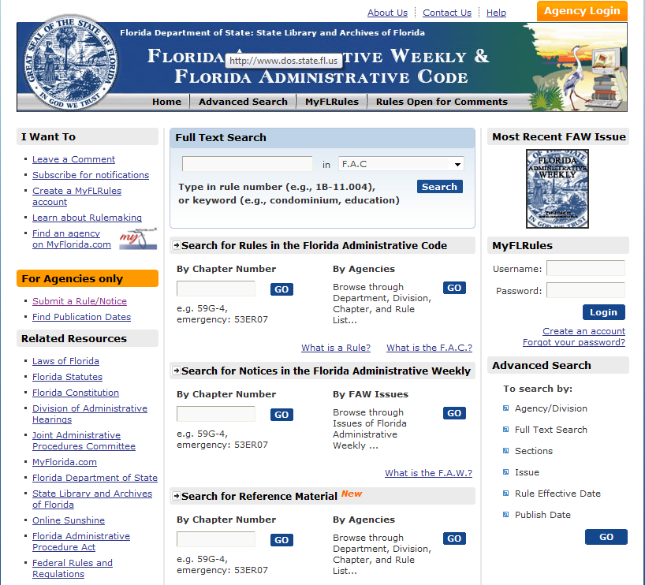

And then on signup near the center on the web page:

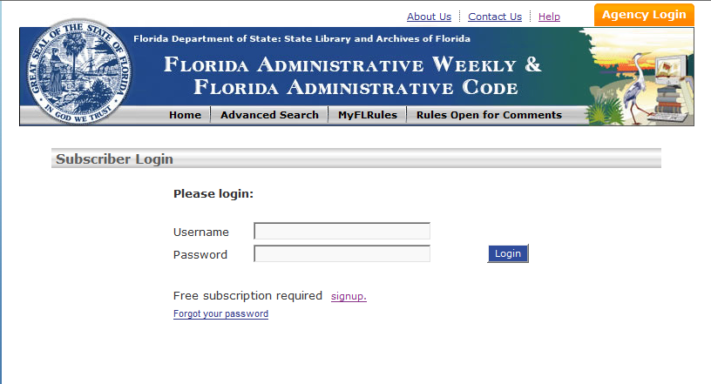

The following page comes up:

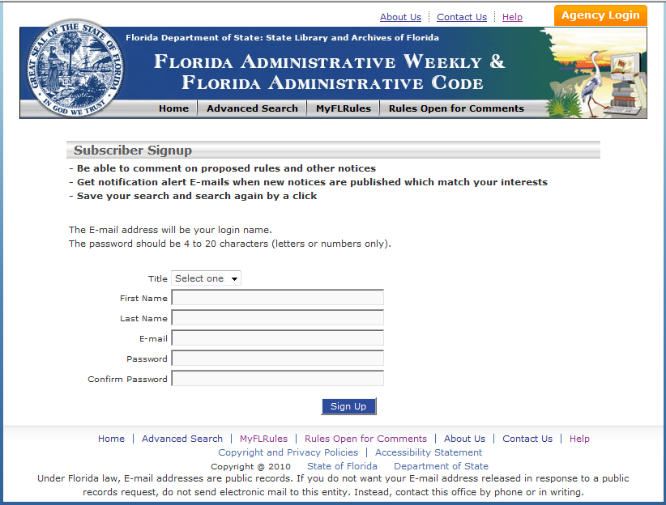

Fill in the blanks on the web page above and click Sign Up.

Next, perform an Advanced Search:


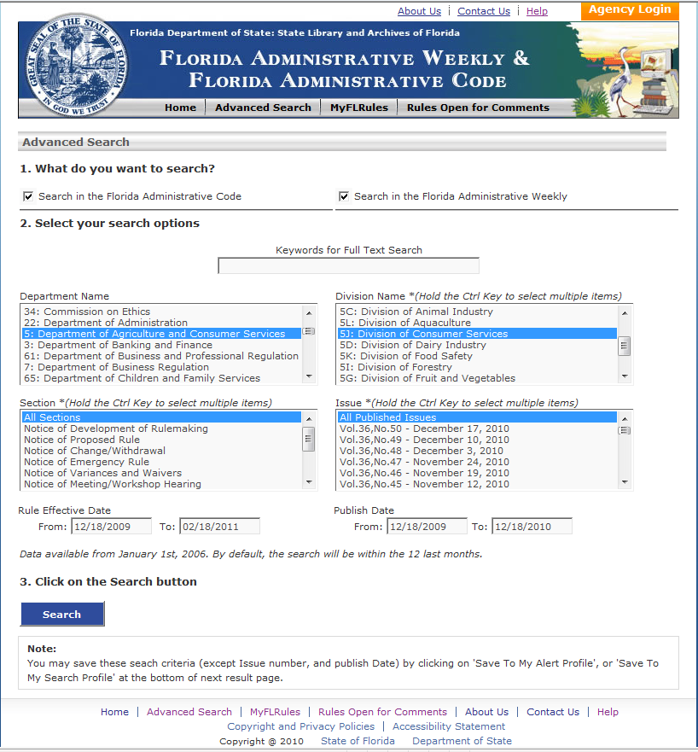

See note for options to save your searches for future use when logging in another time.

My search, made on December 18, 2010 turned up a number of interesting finds.

WHY FREQUENT SEARCHING OF THE SITE IS BENEFICIAL

On December 18, 2010, my search netted some interesting information:

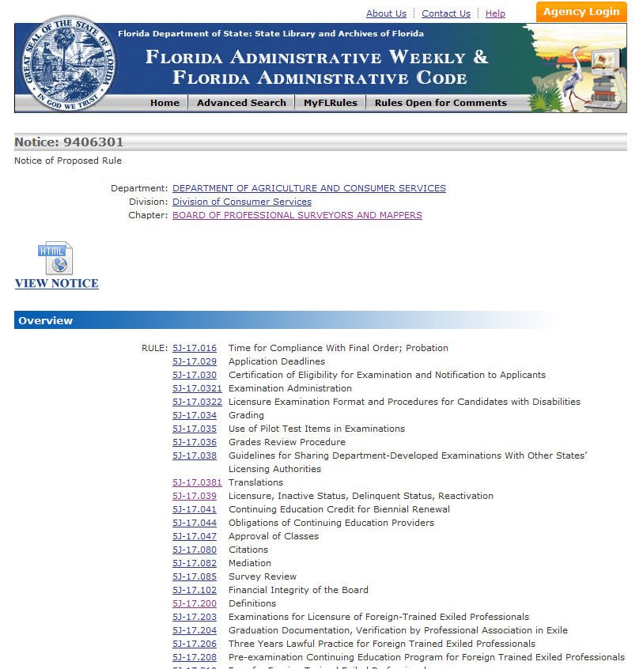

Scrolling down to the bottom of that page (See next page in this course.), we see:

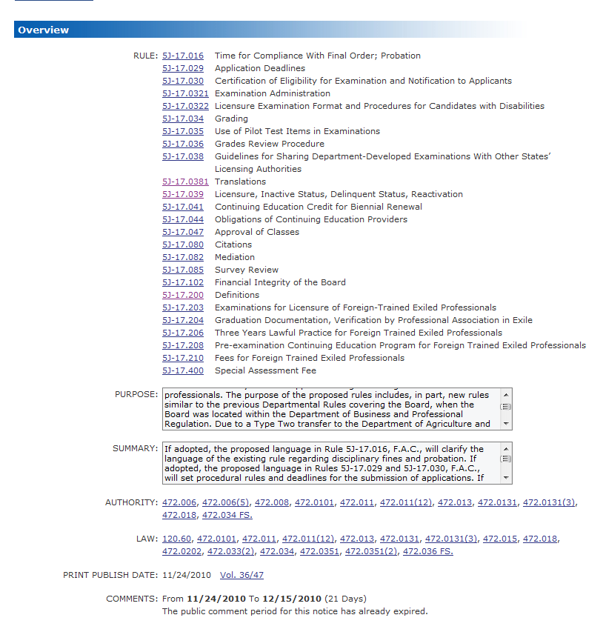

As of the date of my search, the 21-day public comment period had just expired.

Scrolling in the “SUMMARY:” box on the above web page, I learned the following:

If adopted, the proposed language in Rule 5J-17.016, F.A.C., will clarify the language of the existing rule regarding disciplinary fines and probation.

If adopted, the proposed language in Rules 5J-17.029 and 5J-17.030, F.A.C., will set procedural rules and deadlines for the submission of applications.

If adopted, the proposed rules in Rules 5J-17.0321 through 5J-17.0381, F.A.C., as referenced above, will address the administration of exams.

If adopted, the proposed language in Rule 5J-17.039, F.A.C., will further define licensure status and the biennial renewal of a license.

If adopted, the proposed language in Rules 5J-17.041 through 5J-17.047, F.A.C., as referenced above, will change existing rules regarding continuing education, including instructor credit, course length, course submission, and the requirement that instructors be approved by the Board.

If adopted, the proposed language in Rules 5J-17.080 through 5J-17.085, F.A.C., as referenced above, would change existing rules regarding citations, mediation, and probation, establish procedures for the issuing of citations, establish citation fine amounts for unlicensed persons, establish procedures for the mediation of discipline cases, repeal certain offenses from eligibility for mediation, and clarify when probationers must submit surveys for review by the Board.

If adopted, the proposed language in Rule 5J-17.102, F.A.C., will define certain terms regarding the financial integrity of the Board, creates procedures for the Department to follow when reporting to the Board that the Board no longer has a reasonable cash balance on hand, establishes procedures for the Board to follow if requesting a loan from the Department, and prohibiting loans that extend beyond two years by the Department to the Board.

If adopted, the proposed language in Rules 5J-17.200 through 5J-17.210, F.A.C., as referenced above, will establish licensure and examination procedures for certain foreign exiled professionals.

If adopted, the proposed language in Rule 5J-17.400, F.A.C., will require certain licensees to pay a one-time fee to contribute in part to the financial integrity of the Board

Something caught my eye on this same web page:

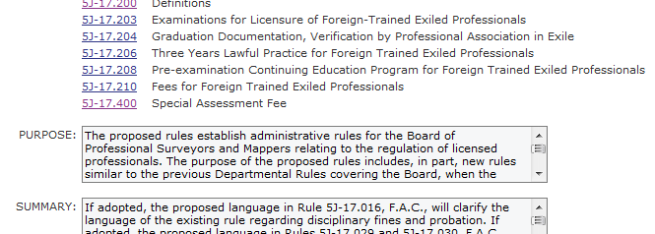

So, I clicked on the link for 5J-17.400 Special Assessment Fee.

What I got was NOT 5J-17.400. Instead, I saw:

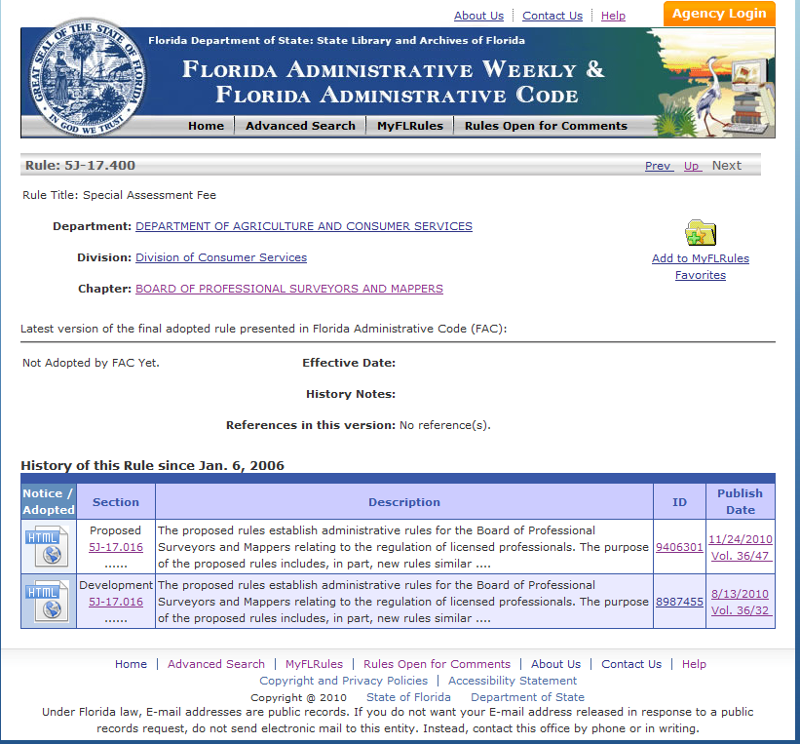

So, I next clicked on all six links circled above.

Not one of these six clicks took me directly to 5J-17.400 Special Assessment Fee, the thing I really wanted to see.

Next, I backtracked to a page I was at earlier – the one shown on the next page of this course.

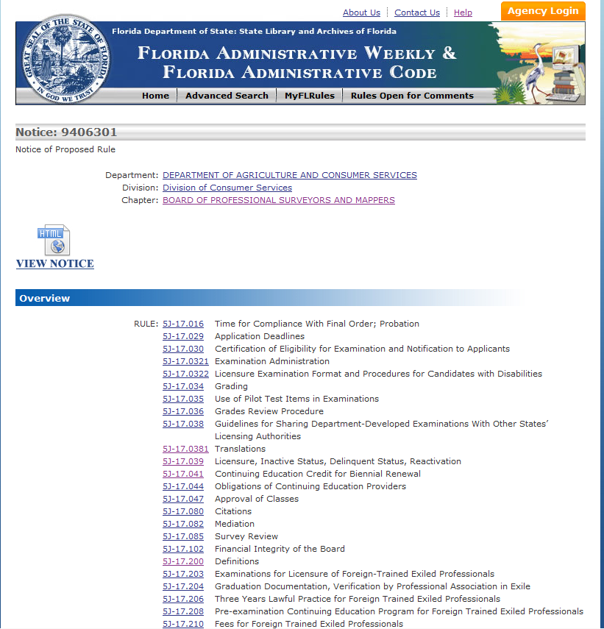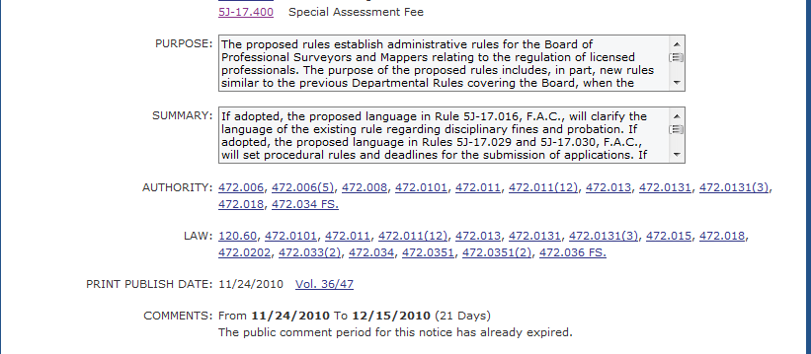

I finally got to what I wanted to see by clicking
 on that page.

The “Notice of Proposed Rules” listed all the involved Rules, and I finally got to see what this was going to cost PSMs.

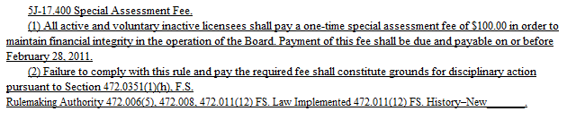

Remember my use of the word, “classification” earlier in the course? In the Board's Summer 2006 Newsletter, the Board gives us the key to classification of the MTS back then in the days of 61G17-6 as follows:

Organization – The standards are now divided into three major sections: definitions; requirements common to all surveying and mapping activities; and requirements for specific types of survey activities.

SIMPLE AS 1-2-3

Do you see it? In the above quote, the Board reveals the format of changes made in the MTS. The revised MTS are broken into three (3) major categories:

  - Definitions
  - Requirements common to all surveying and mapping activities
  - Requirements for specific types of survey activities

Because of the format that the predecessor (Chapter 61G17) to the current MTS came off the press (or from the Internet), it was not clear to my eye exactly where the breaks in the subject matter took place. They basically ran together.

Fortunately, the recent moving of these Rules from 61G17 to 5J-17 has made clearer the classification breaks through the new and revised subchapter numbering scheme.

The three subchapter numbers now are:

- 5J-17.050 Minimum Technical Standards: Definitions
- 5J-17.051 Minimum Technical Standards: General Survey, Map, and Report Content Requirements
- 5J-17.052 Minimum Technical Standards: Specific Survey, Map, and Report Requirements

The MTS first spell out the TERMS; next, GENERAL requirements related to surveys, maps and report contents are presented and finally, SPECIFIC requirements are stated.

This makes good sense and studying within these three, broad classifications is expedited.

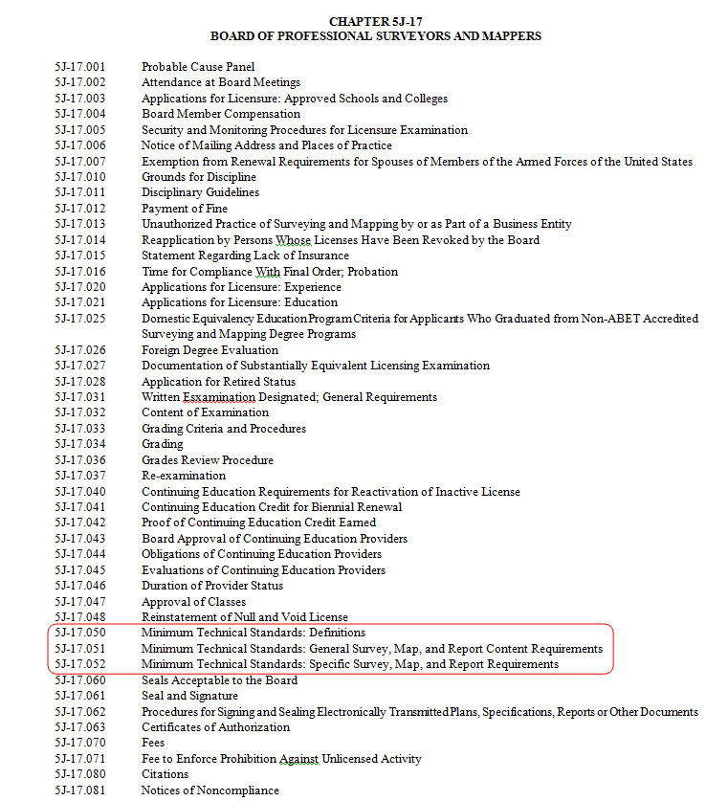

HI-LITE COLORING AND HAND-WRITTEN NOTATIONS

The MTS frequently refer to other portions of 5J-17 by reference. I've found it helpful in my own study to note at the top of each page exactly where I'm at in the MTS. For example in my print out, at the top of one page I’ve written:

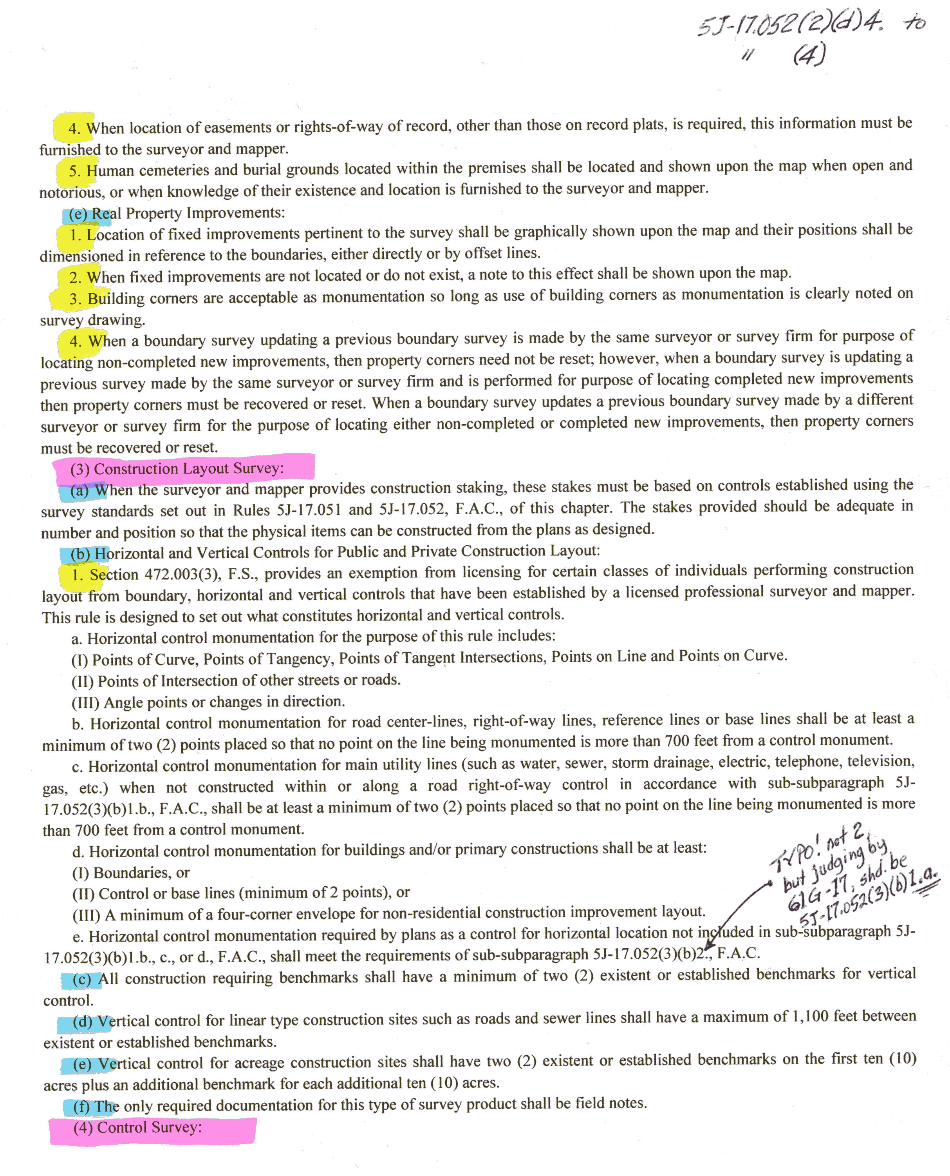

With the hand-written note combined with the hi-lite coloring scheme, I don’t lose my bearings in all the sub-subparagraphs that can obscure the true context of the content.
On the last page, you’ll notice that the major classifications of content are hi-lited in pink. This hierarchical level within 5J-17 is always indicated by numerals within parentheses.

Next level down in the classification hierarchy, we find lower-case letters within parentheses. I’ve hi-lited these in blue.

After this comes numerals without parentheses but followed by a period. These, I hi-lited in yellow.

Items lower in the hierarchy I don’t bother to hi-light, as it is not too difficult to follow the logic of the MTS hierarchy once I get to the level of yellow hi-lighted points.

In my experience, most people who don’t work frequently with the MTS’s hierarchical format find it well worth the time it takes to mark their printouts with hi-lited coding.

Had I not employed this method, I probably would have overlooked the apparent typo that I noted on that page. Locating a particular reference elsewhere in the document is made so much easier through this simple and efficient hi-lite scheme. Truth is, if one location in 5J-17 references me to 5J-17.052-6.004(3)(b)1.b., c., or d. (as the page depicted above does), I probably wouldn’t even bother to follow the trail back to that point if it were not for the aid of the hand notations at the top of the pages and the hi-liting.

Noting by hand where I am in the document on the top of each page (as in the illustration on the previous page) helps me to not only keep clear-headed about the relevance of what I'm reading, but it also facilitates searching for some sub-subparagraph referenced by another sub-subparagraph (like the one we’ve just mentioned) that may direct me to yet another place in the MTS, for example to “sub-subparagraph 5J-.052(3)(b)1.b., c., or d.” When making a study of the MTS, and also when researching or reviewing them later, those hand-written notes save me more time than I spend making them.

I include the above tips realizing fully that some of my more gifted readers will find these methods completely unnecessary. But there exist among us many souls like me, who will find this approach, or some similar method, beneficial for studying, understanding, reviewing and remembering any written material that’s structured in complex ways.

MAJOR MTS CLASSIFICATION #1 OF 3 – DEFINITIONS

5J-17.050 Minimum Technical Standards: Definitions.

The Florida Professional Surveyor and Mapper may, at first glance, look at the words defined in this section and say, “Yeah, yeah, yeah, blah, blah, blah. Nothing new here.”

Just pause for a moment in your busy day and consider the clarity that’s represented in these definitions, and consider the beauty and simplicity that comes from stating something concisely and effectively. The MTS are for the most part clear, concise and require no explanation. You may say, “Well, of course. Aren’t the MTS supposed to be easily understood?”

For the sake of contrast consider for just a moment my personal experience with laws passed in Connecticut. It may make you appreciate Florida’s!


Connecticut’s standards were conceived with the noble intention of making it possible for nonprofessional purchasers of professional land surveying services to know exactly what type of survey they were ordering and exactly what they would get when they used those specific terms defined in Connecticut’s statutes to commission various types of surveys.

This body of law is published in a single volume consisting of one portion printed on white pages and a second portion on blue pages. The white pages simply present the laws governing surveying as they exist without comment. The blue pages attempt to explain what's written in the white section. And even this did not suffice to clarify the intention of the law. For example, the Connecticut Board found it needful to further explain the law in written communications to their licensed surveyors who needed to be told under what circumstances an As-built Survey should not be titled "As-built Survey," but rather an "Improvement Location Survey." Some surveyors were titling their maps incorrectly, even after studying both the white pages and the blue pages intended to clarify the white pages.

Florida Professional Surveyors and Mapper's rejoice! Your 3-ring binder containing Chapters of statute law and the Rules may be thicker than what’s necessary for most other states in which I’ve become licensed. But at least you don't need a second binder with blue pages explaining what's written in Florida's Administrative Codes and Statutes.

Nevertheless, diligent study is required to assure that you learn, remember, and fulfill the requirements of the Florida statutes and rules that govern your profession.

The framers of Florida’s Minimum Technical Standards should be praised for the simplicity and understandability of these definitions. Most of the MTS definitions require no comment or clarification.

Whether or not it is wise to create standards covering so many aspects of professional practice as Florida has is a matter of opinion. Does it take the governmental charge to protect the public health, safety and welfare to unreasonable limits and effectively micro-manage the profession? Some no doubt feel this is the case. I personally appreciate the MTS, because I’ve seen enough sunrises and sunsets to know that surveyors need this regulation. Sad, but true. Now, neither you nor I need it; we know that. But, there are unfortunately many surveyors who don’t do what they’re supposed to do without the threat of discipline.

So, if we’re going to be regulated to the degree Florida has done so, let’s at least do a thorough and thoughtful job of it. In my opinion, Florida has, and I applaud the effort and praise the hard labor behind the MTS.

A LOOK AT SPECIFIC DEFINITIONS

Let's look at definitions and illustrate some important points.

Benchmark – Perhaps you’re aware that a benchmark in some circles can be a reference point for either horizontal or vertical location. Since the Tower of Babel, we’ve confused one another by using the same word to mean different things. I’m glad the MTS has decreed that in Florida, benchmarks reference elevation.

Record Survey – Record Survey is a term occasionally confused in the minds of some surveyors. In at least a few geographical locations, surveyors have produced maps titled, "Record Surveys," that are actually "office surveys" compiled from record documents – in other words, they’re actually compilation maps made without benefit of any field survey whatsoever. The definitions within the Minimum Technical Standards make it clear that the terms, “As-built Survey” and “Record Survey” are interchangeable and mean exactly the same thing.

Corner – A point on a land boundary that designates a change in direction, for example: points of curvature, points of tangency, points of compound curvature and so forth.

Remembering the exact definition of “corner” is important as it relates to monumentation requirements.

Monument - an artificial or natural object that is permanent or semi-permanent, and used or presumed to occupy any real property corner, point on a boundary line, or reference point.

Reflect on these two interrelated definitions in the context of Florida's statutes and Rules of the Board. Considering “corners” and “monuments” together presents an excellent opportunity to illustrate the need for studying minimum technical standards along with other Rules and laws that govern the following:
- specifications for monuments (minimum diameter, length; material)
- sufficiency of monumentation (maximum distance between monuments; certain points requiring monumentation)
- different types of monumentation such as P.R.M., P.C.P. or boundary monument, as used in 5J-17.052(2)(b)
- additional definitions for both "corner" and "monument" as used elsewhere in the body of laws governing the practice of surveying and mapping in Florida (Chapter 177 and also in Chapter 472, for example.)

Also, note the requirements for monumentation in Boundary Monuments, which reads in part, “…bearing either the Florida license number of the surveyor and mapper in responsible charge.” Do you have any idea how many states allow surveyors to place unmarked monuments as a matter of course? Isn’t it great when you know who actually is responsible for setting the monument you discover?

We used to read in the earlier incarnation of MTS at 61G17-6.004(2)(b):

“REGULATORY OBJECTIVE: in order to prevent boundary conflicts, the public must have assurance that the corners of accurately located real property boundaries as found by a survey are durably marked with survey monuments that may be identified on the ground with the aid of the survey map. In meeting this objective, surveyors and mappers must meet the following minimum standards of accuracy, completeness, and quality…”

I confess, I miss that specific language.

The new language says:

“REGULATORY OBJECTIVE: The public must be able to rely on the accuracy of measurements and maps produced by a surveyor and mapper.”
and
“REGULATORY OBJECTIVE: In order to avoid misuse of a survey and map, the surveyor and mapper must adequately communicate the survey results to the public through a map, report, or report with an attached map. Any survey map or report must identify the responsible surveyor and mapper and contain standard content.”

What the land owner cares about is WHERE his or her land is – where it begins and ends. They care less about hair-splitting accuracy than durability, visibility and permanence. That’s why I miss the older statement regarding the regulatory objective.

The words to an old song say, “Love and marriage, love and marriage – go together like a horse and carriage.” So it is with corners and monuments.

My point? Glad you asked. A tendency may exist to overlook the "definitions" sections of statutes and the administrative code. Definitions are important! A review of the MTS is never complete without giving attention to the Definitions section.

MAJOR MTS CLASSIFICATION #2 OF 3 – GENERAL SURVEY, MAP AND REPORT CONTENT REQUIREMENT

BASIS of BEARINGS – Please review 5J-17.051(3)(b)8-10.

Not long ago, I heard a young, licensed surveyor complain to his technician, "This north arrow says, ‘See note 1.’ Just put the deed’s book and page number on the north arrow. Make it simple for crying out loud!"

Before that young surveyor had flexed his recently appointed supervisor muscles, ‘Note 1’ of that survey map had specified a particular course of the referenced deed that served as the basis of bearings in the new survey. The young surveyor felt he was simplifying things by just noting a recording reference to the deed itself on the North arrow, and in his uniquely offensive mix of ignorance and arrogance, he’d referred to the semi-retired surveyor who’d crafted that map with the north arrow reference note as “a jerk.”

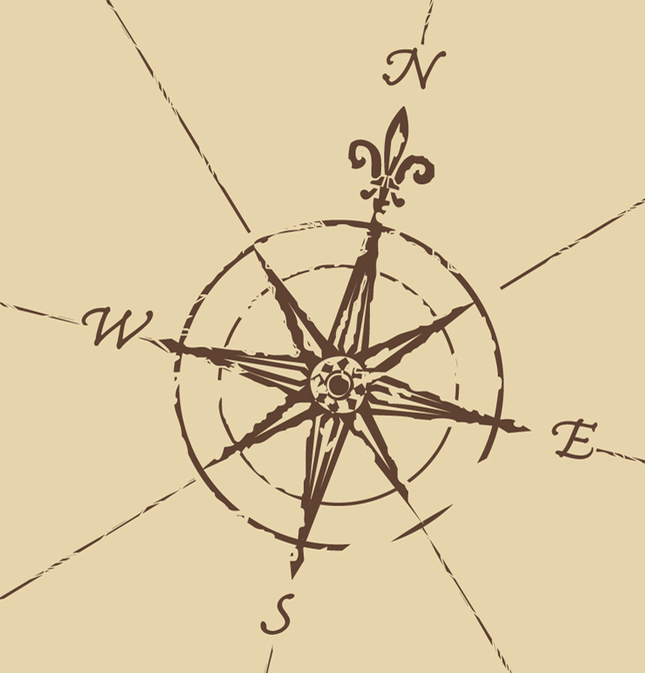
This younger surveyor hadn’t ever learned what's wrong with just noting a book and page reference of a deed on a north arrow. In most cases when the basis of bearings is related to a deed, it is referenced to a single line in a deed that is held in the current survey, not every line in that deed. Citing the recording reference to the deed does NOT specify which line in the deed description is the basis of bearings for the new survey. Note that one of the options that may be used as a reference to bearings shown on a survey map per the MTS is, "a Deed Call for a particular line." Thank you Florida for not overlooking this important distinction, something the young surveyor in this example clearly did not consider.

PROVISIONS THAT MUST NEVER BE USED AS ESCAPE CLAUSES:

Let’s review certain portions of the General Survey, Map, and Report Content Requirement. I'd like to talk for a moment about the "Specific or Special Purpose Survey" and "Special Conditions" related to a survey of another classification, one that is NOT a Specific or Special Purpose Survey.

5J-17.051(3)(b) states the following:

When special conditions exist that effectively prevent the survey from meeting these minimum standards, the special conditions and any necessary deviation from the standards shall be noted upon the map or report.

Also, take note that use of the "Specific or Special Purpose Survey" defined in 5J-17.050(10)(j) is clarified in the wording of 5J-17.052(11) :

Surveys which are performed for a purpose other than the purposes encompassed by the definitions in paragraphs 5J-17.050(10)(a)-(i) or (k), F.A.C., shall be permitted only where unusual conditions make impracticable or impossible the performance of one of the types of surveys defined in paragraphs 5J-17.050(10)(a)-(i) or (k), F.A.C.

Neither the “Special Purpose” survey classification nor the “special conditions” create opportunities for the PSM to escape the more usual requirements of the MTS without a good reason. Unlike the laws and Rules in many states, Florida's MTS do reasonably recognize those rare occasions when the MTS cannot be met for some good reason – some really good reason.

Florida has wisely recognized (at least I hope Florida has) that surveyors are also among the most qualified mappers. Many states actually hamstring professional surveyors from functioning as mappers and from accepting mapping assignments because those states’ technical standards make no provision whatever for projects that are essentially mapping efforts – that is, projects that create mapping products that would better be called "Specific Purpose" surveys or not be titled as surveys at all.

Even though Florida provides some measure of latitude, if I were a Florida surveyor producing mapping products or surveys bearing the title, "Specific Purpose Survey," I would write to the Board requesting guidelines regarding the notations, titling and sealing (or not sealing) of my mapping products. This is the surest way I know of to avoid inadvertently stepping over some invisible line that causes my mapping products to fall under the scrutiny of the Board as deficient surveying products.

My personal opinion is that the MTS fail to define "mapping" as contrasted with "surveying" or to properly regulate the Professional Surveyor and Mapper who offers mapping in his or her range of professional services. Why call somebody a “surveyor and mapper” and not address this issue more clearly?

In my not-so-humble opinion, the MTS should define exactly what mapping is and is not, and should empower the professional surveyor and mapper to perform mapping that is not ever held to the same standard as surveying. Personally, I cannot find this needed clarification and guidance anywhere in the MTS.

REQUEST THE BOARD’S OFFICIAL INTERPRETATION

Abuse of the MTS constitutes grounds for discipline! When one doesn't understand exactly what the MTS is requiring in a specific circumstance, it is wise to make inquiry of the Board, requesting an official interpretation. After all, it would be very unlikely that the Board would discipline you for following their own interpretation of the Rules or their own written guidelines or clarifications.

OPEN AND NOTORIOUS EVIDENCE OF BOUNDARY LINES

True story: A licensed surveyor in another state, a person with about 10 years of experience, who had earned an Associate Degree in surveying from a respected institution, performed a field survey under my direction. As I reviewed the survey map he produced, I asked (having walked the boundary myself in the field), "Isn't there a fence along this line; I seem to remember one?"
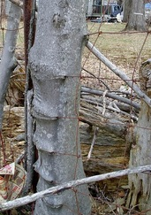
He replied, "Yes, but I didn't locate it because there were monuments at each end of that 500 foot line."

This same licensed surveyor, accompanied by a party chief with over 20 years of experience, went to another site, specifically charged with the responsibility of locating any evidence of property lines along a large commercial property that adjoined a number of residential parcels of land as well as the smaller commercial parcel that was the subject of our current survey.

With over 30 years of experience between them, these two individuals overlooked hundreds of feet of barbed-wire fence remains hanging from positions embedded deeply into mature trees along most of the length of that property line. And that very line with the fence remains was the subject of our uncertainty as to the correct location of a property line for the parcel we were surveying. The express purpose of the crew’s return trip to the site they’d field-surveyed earlier was to recover evidence along this particular line.

They ignored the barbed wire fence remains, but they located a relatively new and also clearly disturbed fence corner located about 800 feet distant from the subject parcel. They also located a metal object that could possibly have been a pipe, or part of a pipe, located at the first “ring” the magnetic locator indicated in a grassy rear yard behind a residence. They didn’t rough tape (measure) to determine where in that back yard to begin their search for a certain corner, and as a result, they overlooked entirely the true corner monument located later just 15 feet from the piece of metal junk they found, located and coded simply as “IPF” in their data collector, thinking they’d found a corner monument. That piece of junk metal was neither an iron pipe nor an iron pin – nor was it a corner monument. But, it was steel, and it did make the magnetic locator sing a song.

Did Florida get too picky in stating the obvious – like, "Hey dude, don’t forget to locate the fences?" Based on the above story and so many others not told here, I don't think so! I only wish they’d added, “and ancient remains of fences.”

I've heard Florida surveyors complain of the sheer volume and “picky” detail in Florida's MTS, but I can't tell you how much I wish states that I've practiced in had patterned their standards after Florida's – with just one exception. I’ll talk about that next.

MAJOR MTS CLASSIFICATION #3 OF 3 – SPECIFIC SURVEY, MAP AND REPORT REQUIREMENTS

RECORDS RESEARCH REQUIREMENTS – SAY WHAT?

Before you read on, please take a moment to review the specific requirements in the MTS pertaining to records research. Look for some requirement specific to what constitutes adequate research. Find what sources of records you’re expected to examine at a minimum.

If you had trouble finding them, you’re not alone. How can this be?

If you've worked in numerous states spanning a wide geographical area, as I have, and studied the standards and laws of different states, Florida's provisions are strangely silent as regards requirements for records research. Florida stands in stark contrast to the records research requirements of other states. For some reason, Florida appears to ignore what’s generally considered an essential function of professional land surveying:
- thorough records research,
- skilled analysis of records (NOT just of the latest deed), and
- the relationship of records to evidence located in the field.

Florida's MTS addresses records research only in passing through vague phrases nested here and there in places that are easy to overlook. I believe the absence of any standard in reference to research lays the Florida Surveyor and Mapper open for criticism, discipline and litigation and provides no “standard of care” safeguard.

The former incarnation of MTS formerly stated in 61G17-6.004(2)(c)1.

REGULATORY OBJECTIVE: In order to protect and enhance stability of property location and title, the public must have assurance that potential boundary inconsistencies are adequately researched and disclosed.
[Emphasis mine.]

I once called this a "sleeper" research requirement of the MTS. But, it evidently died in its sleep!

The current version of the MTS has deleted this language entirely. And, I mourn its loss.


Appropriate and adequate records research has always been an integral function when performing boundary surveying, and I just can’t understand why records research has been overlooked in these written MTS.

Obviously, we cannot locate or disclose on a survey drawing any conflicts between records and field evidence that we’ve failed to discover for lack of research. The "potential" for undiscovered, non-visible boundary inconsistencies often lurks deeply in the recorded history of adjacent parcels (not just the parcel we’re surveying). This is one of the more fearful aspects of our otherwise enjoyable, professional careers. Many, many times, my records research has unearthed matters that required location in the field, notations on maps and sometimes legal remedies. Most often, these legal remedies were the cooperative efforts of adjoining neighbors, accomplished PRIOR to some day in the future when an adversarial relationship might have prompted an expensive and emotionally draining legal battle. By removing the REGULATORY OBJECTIVE, I fear the Board has reduced what little emphasis the MTS once had on the need for “adequate research.”

Also, I’ve never lost in court, and this is largely due to the fact that I’ve out-researched the other surveyor.

The Florida Professional Surveyor and Mapper should exercise caution, professional business acumen, and ethical discernment regarding the following questions:

- What exactly is the role of the Professional Surveyor and Mapper, when it comes to his or her direct responsibility for performing thorough records research on parcels being surveyed, adjacent parcels, and sometimes even parcels beyond that may impact a professional decision as to boundary location and property rights?

- How should I, a PSM, structure the language of my contract with my clients related to the records research I’ll perform?

I dare not even try to answer these questions for you, but I do request that you consider them seriously. It makes me very sad when a surveyor is bitten in the backside by a dog that approached without warning. The lack of specificity in Florida’s MTS regarding records research does, to my thinking, create a situation that bites the backside of a surveyor without first issuing a warning bark. I speak, of course, of a complaint before the Board brought by a client who simply doesn’t want to pay your bill. Or you’re slapped with a law suit that claims you neglected to discover something in the records that you felt was beyond your duty to investigate and/or beyond the standard of care typical for surveyors in your area performing similar services.

Enough said on this point.

But, as deeply and sincerely as I feel about the issue of the MTS failing to address or even seriously mention records research related to property surveying, I want to close this section by praising again the MTS for what they do cover. I’m sure some consider the MTS as meddling and micro-managing their practice. I for one appreciate the thoughtfulness, thoroughness and clarity of the Florida MTS, and I wish more states would adopt most or all of what Florida has mandated. If government feels the need to regulate, it’s good sense and good business to do so adequately. Some states have erred in creating loose and irrelevant standards. I find the Florida MTS to be neither of those things. Having been exposed to the standards of numerous eastern states from Maine to Florida, I have a few favorites that I’d add to Florida’s MTS if I had the power. But, mostly I’d impose much of Florida’s standards on other states’ surveyors. It would be an improvement. And, both the profession and the public would be better off.

THE MTS, QUESTION-AND-ANSWER/DISCUSSION SECTION

As noted repeatedly throughout this course, Florida's MTS speak for themselves – and the MTS instruct in a clear voice (stating what they mean to say more directly and understandably than the standards of most states’ in which I've become licensed as a surveyor), so you don't have to wonder in most situations what's required of you to fulfill the letter of the law.

Be grateful for this as you proceed to the following material, and enjoy the personal and professional security that comes from knowing and obeying the laws that govern and bring honor to you as you practice your profession.

Test your knowledge by answering the following multiple-choice questions before going to the answer key and the Discussion portion that follows this Question-and-Answer Section.



GET YOUR MONEY’S WORTH!

You’ll reap the greatest benefit from this course only if you do the following:

- Study the remainder of this course material in the order its presented.
- Take the PRE-TEST with your copy of the MTS and Laws in hand.
- If you’re uncertain of any pre-test answer, DON’T GUESS; look up the answer.

Once you’ve completed the PRE-TEST, follow along carefully in the DISCUSSION section as we discuss the PRE-TEST.

PRE-TEST YOUR KNOWLEDGE OF THE MTS

1. MTS Definition: “Benchmark: a relatively permanent material object, natural or artificial, whose elevation above or below an adopted data datum plane is known.”
Question: What's missing from this definition?
a. being visible and above ground
b. bearing a marked point
c. on NAVD88 datum
d. listed with the NOAA database
e. The definition is complete as stated.

2. Per definitions in 5J-17.050(2), a corner is a point on a land boundary that designates a change in direction of over 5° in any straight line, points of curvature, points of tangency, points of compound curvature and so forth.
a. True
b. False

3. Per Florida's Minimum Technical Standards definitions the title, “Survey Map” [select the answer below that completes the sentence INCORRECTLY.]
a. is a graphical or digital depiction of the facts of size, shape, identity, geodetic location, or legal location determined by a survey.
b. may never mean a Sketch of a Survey.
c. may be a plat of survey.
d. is sometimes referred to as “a map” or “the map.”

4. In Florida, a PSM is allowed to prepare a Boundary Survey without the necessity to prepare a map.
a. True
b. False

5. A Boundary Survey is a survey
a. the primary purpose of which is to document the perimeter of a parcel of land.
b. made to establish or reestablish corners, monuments, and boundary lines.
c. locating fixed improvements on the land or dividing a parcel of land.
d. made for platting.
e. per the MTS definitions, any (or all) of the above.

6. Select from the following, the definition of “Reference Point” that most closely agrees with the MTS definition.
a. Any monumented point set to establish a defined position in reference to another specific, defined position.
b. Any defined position of a monument that is or can be established in relation to another defined position.
c. Any calculated point that by means of coordinates, bearings and distances, or angles and distances, can be used to reestablish the position of another known point.
d. Any defined position that is or can be established in relation to another defined position.

7. A Specific Purpose Survey or Special Purpose Survey is
a. a survey that would fit under any of the other types of surveys defined in the MTS, but which does not satisfy the accuracy or other requirements of those types of surveys.
b. a survey that meets the requirements of any other type of survey, but the preparer of the survey specifically limits the use or application of the survey to certain, well-defined criteria.
c. a survey performed for a purpose other than the purposes detailed in paragraphs (10)(a)-(i) or (k) of the MTS “Survey” definitions.
d. none of the above.

8. By MTS definition, a “Survey and Map Report” is
a. a report of the issues or matters relative to a specific survey that further clarifies matters depicted on the survey plan, plat, or map.
b. a written document that details methods used, measurements and computations made, and accuracies obtained in the course of performing a survey.
c. a report accompanying a survey and map that expands upon matters noted or depicted on a survey plan, plat, or map.
d. a written document, sometimes referred to as "a report" or "the report," detailing methods used, measurements and computations made, accuracies obtained, and information obtained or developed by surveying and mapping techniques.
e. None of the above.

9. Per Chapter 177, a “P.R.M.” means a permanent reference monument which must consist of a metal rod having
a. a minimum length of 18 inches and a minimum cross-section area of material of 0.2 square inches.
b. a minimum length of 24 inches and a minimum cross-section area of material of 0.25 square inches.
c. a minimum length of 12 inches and a minimum cross-section area of 0.2 square inches.
d. a minimum length of 18 inches and a minimum cross-section area of 0.25 square inches.

10. Per Chapter 177, a “P.C.P.” set in pervious surfaces must consist of a metal rod having
a. a minimum length of 18 inches and a minimum cross-section area of material of 0.2 square inches.
b. a minimum length of 24 inches and a minimum cross-section area of material of 0.25 square inches.
c. a minimum length of 12 inches and a minimum cross-section area of 0.2 square inches.
d. a minimum length of 18 inches and a minimum cross-section area of 0.25 square inches.

11. Per Chapter 177, a “P.C.P.” must also be identified with a durable marker or cap having the following:
a. the Florida registration number of the professional surveyor and mapper in responsible charge or the certificate of authorization number of the legal entity.
b. a number preceded by LS or LB, as applicable and the letters, “P.C.P.”
c. a and b.
d. a marked point of reference.
e. a, b and d.

12. All measurements on a survey must be in accordance with the international foot or meters.
a. True
b. False

13. Measurement and computation records must
a. be dated.
b. contain sufficient data to substantiate the survey map.
c. be sufficient to ensure that the accuracy portion of the standards has been met.
d. a, b and c.

14. The Board may not enforce through the disciplinary process any standards set forth by federal, state, or local governmental agencies, if those standards are more stringent than those set forth in the Minimum Technical Standards of Chapter 5J-17.050 through 5J-17.052.
a. True
b. False

15. All survey maps and reports must
a. bear the name, certificate of authorization number, and street and mailing address of the business entity issuing the map and report, along with the name and license number and address of the surveyor and mapper in responsible charge.
b. show the name, license number, and street and mailing address of a surveyor and mapper practicing independent of any business entity.
c. bear the name, certificate of authorization number, and street and mailing address of the business entity issuing the map and report, along with the name and license number of the surveyor and mapper in responsible charge.
d. either a or b.
e. either b or c.

16. The survey date on all survey maps is
a. the date the survey map actually receives its rubber-stamp, inked seal and the original surveyor and mapper's signature.
b. the date the survey map actually receives its impression-type, raised seal and surveyor and mapper's original or electronic signature.
c. the date of data acquisition.
d. none of the above.

17. All computed data or plotted features and all bearings distances, coordinates, and elevations shown on survey maps
a. must be compiled or taken from survey measurements under the direct supervision of a licensed surveyor and mapper.
b. must have as their source either accurate field survey measurements or topography supplied by a licensed photogrammetrist.
c. must be supported or substantiated by accurate survey measurements unless clearly stated otherwise.
d. a or b.

18. Magnetic North should be avoided as a basis of bearings except in cases where a comparison is necessitated by a deed call.
a. True
b. False

19. Which of the following contains abbreviations which must be noted in a legend if used on a survey drawing?
a. E NE +/- P.O.B. AC
b. NW SW BLDG
c. SE Sq Ft MON
d. a, b and c
e. b and c.
20. Horizontal control measurements shall achieve the following closures:
a. Commercial/High Risk Linear: 1 foot in 10,000 feet; Suburban Linear: 1 foot in 8,000 feet; or Rural Linear: 1 foot in 6,000 feet; Farm or Large Acreage: 1 foot in 1,000 feet.
b. Commercial/High Risk Linear: 1 foot in 10,000 feet; Suburban Linear: 1 foot in 7,500 feet; or Rural Linear: 1 foot in 5,000 feet.
c. Commercial/High Risk Linear: 1 foot in 15,000 feet; Suburban Linear: 1 foot in 10,000 feet; or Rural Linear: 1 foot in 5,000 feet.
d. Commercial/High Risk Linear: 1 foot in 20,000 feet; Suburban Linear: 1 foot in 15,000 feet; or Rural Linear: 1 foot in 10,000 feet.

21. When statistical procedures are used to calculate survey accuracies, the maximum acceptable positional tolerance, at the 95% confidence level
a. must be +/- 0.07 feet.
b. must be +/- 0.05 feet.
c. must be +/- 0.10 feet.
d. should meet the same equivalent relative distance standards as set forth in subparagraphs of the F.A.C. specifying accuracies verified through redundant measurements or traverse closures.

22. All maps or reports of surveys produced and delivered with digital coordinate files must contain a statement to the effect of: "This map is intended to be displayed at a scale of 1/__ or smaller."
a. True
b. False

23. An individual surveyor and mapper or the surveying and mapping business entity must maintain records of measurements made in the survey for a period of
a. 10 years
b. 15 years
c. 20 years
d. 12 years
e. length of time not specified in the MTS

24. When a real property description or other recorded document referenced on the boundary map specifies by deflection angle a change in direction between two property lines
a. the survey map must also show the change in direction by deflection angle.
b. the survey map should show the change in direction by azimuths or by bearings of the two lines.
c. the survey map should show the turned angle to the right between the back and forward lines.
d. the change in direction must be indicated consistent with the other changes in direction on the map.

25. Curved lines (with circular curves) on a boundary map shall show
a. radii, arc distances, chord distances and chord bearings.
b. radii, arc distances and central angles.
c. radii, arc distances, central angles, chord distances and chord bearings.
d. radii, arc and tangent distances plus central angles.
e. at a minimum, a or b.

26. Surveys of all or part of a lot(s) which is part of a recorded subdivision shall show the following upon the map:
a. the lot(s) and block number(s) or other designations of the subject parcel and of adjoining lots.
b. When field measured directions and distances and recorded directions and distances vary, a comparison must be shown.
c. When one part of a lot is included within the description the dimensioned remaining portion of a lot(s) shall be shown.
d. a comparison between the recorded directions and distances with field measured directions and distances to the nearest street intersection, right-of-way intersection or other identifiable reference point.
e. All of the above.

27. Surveys of parcels described by metes and bounds should show the following upon the map:
a. The most current abutting recorded instrument or recorded plat either known by the surveyor and mapper or furnished to the surveyor and mapper.
b. All information called for in the property description, such as point of commencement, course bearings and distances, and point of beginning.
c. A comparison between recorded directions and distances and field measured directions and distances on the boundary when they vary.
d. The relationship of the parcel(s) to at least one established identifiable real property corner.
e. All of the above.

28. The MTS require the following concerning monuments:
a. Whether monuments are or are not set in the course of performing a survey is a matter to be determined by the contract between the property owner or owner’s representative and the professional surveyor and mapper responsible for the survey.
b. Monuments as defined in the MTS shall be set unless monuments already exist or cannot be set due to physical obstructions at such corners or unless a water boundary has been located in approximate position.
c. Monuments shall be composed of a durable material, have a minimal length of 18 inches, and be detectable with conventional instruments for finding ferrous or magnetic objects.
d. Monuments shall be identified with a durable marker or cap bearing either the Florida license number of the surveyor and mapper in responsible charge, the certificate of authorization number of the business entity; or name of the business entity.
e. b, c and d.

29. The description of all monuments on the survey map shall state:
a. the size of the monument.
b. the material the monument is made of.
c. the cap identification of the monument.
d. whether the monument was found or set in the course of the survey.
e. All of the above.

30. Regarding boundary inconsistencies, the Regulatory Objective of the Rules states the following: “In order to protect and enhance stability of property location and title, the public must have assurance that potential boundary inconsistencies are adequately researched and disclosed.” To this end,
a. all survey maps should present the factual basis of potential boundary inconsistencies in a clear fashion.
b. all potential boundary inconsistencies that the survey process did NOT attempt to detect shall be clearly indicated and explained on the survey map or in the report.
c. where evidence of boundary inconsistency is found, the nature of the inconsistency shall be shown upon the survey map.
d. boundary inconsistencies are primarily determined by a title report and are not the surveyor and mapper's responsibility.
e. a, b and c.

31. Boundary inconsistencies consist of matters such as,
a. conflicting boundary lines or monuments; doubt as to the location on the ground of survey lines or property rights.
b. overlapping descriptions or hiatuses; excess or deficiency.
c. descriptions that mix units of measure; interior and exterior angles; or bearings and azimuths, etc.
d. open and notorious evidence of boundary lines such as fences, walls, buildings, monuments, etc.
e. a, b and d.

32. All of the apparent physical use onto or from adjoining property must be indicated with the extent of such use shown or noted upon the map.
a. True
b. False

33. In cases where foundations may violate deed or easement lines and are beneath the surface,
a. the surveyor and mapper must obtain design drawings indicating the extent to which such foundations may extend beyond structures visible on the surface, and show or note with dimensions the extent of possible encroachments.
b. failure to determine their location shall be noted upon the map or report.
c. a test pit or probe should be made in critical areas to determine the actual, physical position of underground structural elements.
d. None of the above.

34. Regarding rights of way, easements, and other real property concerns,
a. the surveyor and mapper is required to perform research regarding human cemeteries that may not be visible on the property being surveyed.
b. the surveyor and mapper is required to perform research to determine if record plats indicate easements or rights-of-way of record.
c. when streets or street rights-of-way abutting the land surveyed are physically closed to travel, a note to this effect shall be shown on the map.
d. easements and all recorded public and private rights-of-way shown on applicable recorded plats adjoining or across the land being surveyed shall be located and shown upon the map as well as open and notorious evidence of easements or rights-of-way on or across the land being surveyed.
e. b, c and d.

35. Regarding real property improvements
a. Location of fixed improvements pertinent to the survey within 10 feet of a boundary line being surveyed shall be graphically shown upon the map in their position and shall be dimensioned in reference to the boundaries, either directly or by offset lines.
b. When fixed improvements are not located or do not exist, a note to this effect shall be shown upon the map.
c. Building corners must not be used as monumentation, because they do not meet the definition of monuments or requirements set forth in other portions of the MTS.
d. When a boundary survey updating a previous boundary survey is made by the same surveyor or survey firm for purpose of locating non-completed new improvements, then property corners need not be reset; however, when a boundary survey is updating a previous survey made by the same surveyor or survey firm and is performed for the purpose of locating completed new improvements, then property corners must be recovered or reset. When a boundary survey updates a previous boundary survey made by a different surveyor or survey firm for the purpose of locating either non-completed or completed new improvements, then property corners must be recovered or reset.
e. b and d.

36. When the surveyor and mapper provides construction staking,
a. the stakes provided should be adequate in number and position so that the physical items can be constructed from the plans as designed.
b. the stakes must be set no more than 50 feet apart.
c. the stakes must be based on controls established using the survey standards set out in Rules 5J-17.051 and 5J-17.052, F.A.C.
d. a and b.
e. a and c.

37. Horizontal control monumentation for buildings and/or primary constructions shall be at least:
a. boundaries.
b. control or baselines (minimum of 2 points).
c. a minimum of a four-corner envelope for non-residential construction improvement layout.
d. a b and c.
e. a or b or c.

38. The laws and rules governing the professional practice of the surveyor and mapper allow that under certain circumstances a contractor may “fill in” control provided by a surveyor and mapper. Many contractors have this capability.

Assume that you, as a professional surveyor and mapper, are asked by your general contractor-client to stake the two major corners of a commercial building to be constructed on a site being developed. The client tells you this "baseline" is all he wants staked (just two major building corners), and that he will offset the two stakes you set, and he’ll stake any other building corners or offsets as needed.

While your client is not a licensed surveyor and mapper and does not employ a licensed surveyor and mapper, you feel certain from your long relationship with this client that his firm has the layout skills, knowledge, equipment, staff, experience and capability to successfully stake from just the requested, two-building-corner baseline. Per the “letter” of the MTS, under which of the following circumstances may you agree to your client's request?

a. The proposed building is a simple, rectangular, pre-engineered, combination warehouse/office building measuring 25 x 80 feet, to be constructed on a concrete slab.
b. The proposed building is an upscale, 4,500 square foot, private residence having three major sections, each with 10-degree deflections in exterior walls, an attached three-car garage set at a 30° angle to one end section of the house. The home is supported by a poured concrete exterior foundation with full basement and an intricate pattern of unevenly-spaced steel columns.
c. The proposed structure is a church building to be constructed by a firm that designs and builds several standard models of basically rectangular, worship buildings featuring laminated wooden beams. It sits near the middle of a 40-acre tract, with no wetlands or other sensitive considerations. It’s positioned well away from any zoning setbacks or restrictions of any kind. In other words, the proposed building’s location on the site is not critical.
d. any of the above.
e. a or c.

39. All construction requiring benchmarks shall have
a. at least one benchmark placed centrally on the site to be developed.
b. benchmarks placed typically at the four corners of the site to be developed.
c. at least one, but as many benchmarks as the client requests.
d. a minimum of two (2) existent or established benchmarks for vertical control.

40. For Topographic Surveys, a minimum of how many site benchmarks shall be indicated upon the survey map?
a. One.
b. Two, regardless of acreage.
c. Three.
d. Four.
e. Two for the first 10 acres, plus one for every additional 10 acres.

41. Regarding the intended topographic features shown on a topographic survey,
a. Abbreviations, and the symbols, line-types, etc. shown on the survey map shall be explained and/or defined in a legend.
b. The surveyor and mapper shall devise a method of reporting which topographic features were intended to be surveyed and mapped, the style of cartographic representation employed for each, and the degree of intended completeness in the surveying and mapping of each feature.
c. The selected scale of the map, when provided in hardcopy, shall be sufficient to accurately and clearly show the results of the survey.
d. Features in obscured areas, where the desired points or surfaces being mapped are not clearly visible on source images, shall be clearly labeled on the map as "interpolated" or "estimated" through the use of notes and shall be depicted graphically clearly different from other surveyed features.
e. All of the above.

42. Any depiction of property lines on a topographic map
a. shall be accompanied by a Boundary Survey.
b. shall be clearly indicated as "approximate" through symbols, notes and/or references on the topographic survey.
c. shall be accompanied with a statement as to the source of the property lines shown.
d. b or c.


CONGRATULATIONS!

HAVE YOU FINISHED SELECTING THE CORRECT ANSWERS?

Okay! The above section has provided you with a chance to think about a significant portion of the MTS and in many cases to distinguish some of the "fine points" - things that might possibly trip you up in your daily practice. The course quiz will focus on additional topics.

In the next section, we’ll look at the correct answers and discuss them together. I'll tell you what I think and share my opinions with you, and you can talk to the wall. All right, I admit it's a little one-sided, but it really can be delightful to have a discussion with yourself. For one thing you'll seldom find disagreement. You'll not think yourself an idiot for holding the position you do and defending it.

Seriously though, if you want to get the most from this course be certain that you do go through the preceding section answering the questions to the best of your knowledge, ability and understanding.

Then go through the next section hearing what I have to say about each of these questions. I think you'll find it thought-provoking and make this course a cut above the typical, correspondence course experience. At least I hope that it will be.

THE DISCUSSION SECTION

Don't knock it till you've tried it! I hope and firmly believe you'll find the following section interesting, informative and most important, educational.

Question number 1. The correct answer is:
b. bearing a marked point.

How many benchmarks have you set in your life that fail to meet this criteria? Does a railroad spike driven into a tree meet the criteria? How about the top nut of a hydrant? What about a Rebar driven in the ground? Suppose a wooden hub is driven in the ground, at a slight angle so that one of its four corners is higher than the other three. Would you be in violation of this Rule if you don't physically mark the highest corner of the four? What is the marked point for each of these objects?

Personally, I can't imagine the Board citing you for employing any of these objects as a benchmark and not physically marking some point to aid the user in knowing where he or she should place the rod or prism pole. Nevertheless, I personally would advise finding some way to "mark" the high point of your benchmarks.

Question number 2. The correct answer is:
b. False.

Per definitions in 5J-17.050(2), a corner is (among other things) "a change in direction." The change is not quantified. Therefore we must assume that a rear property line 300 feet long that has three minor deflections in between its two ends actually has five "corners" (one corner at each end where the rear line joins the sidelines, plus three corners - one for each minor deflection.

Question number 3. The correct answer is:
b. may never mean a Sketch of a Survey.

I confess: this is sort of a trick question. Remember the word INCORRECTLY in the question.

Per 5J-17.050(4), the term "Survey Map" may refer to a Sketch of a Survey. Per this definition, the Florida surveyor and mapper should take care in preparing a Sketch of a Survey, because it follows per 5J-17.052(5)(b) that a Sketch accompanying a property description “shall show all information referenced in the description.”

For a sketch to really meet that requirement, it would basically become a Survey Map, would it not? So what is it – a sketch or a survey map? At what point does a sketch become detailed to the extent it risks being judged by the criteria for a survey and found seriously wanting?

My opinion: The MTS missed the boat on this point. A sketch should purposefully NOT contain any more information than the minimum required to (hopefully) make apparent and achieve the purpose of that sketch and/or the document(s) it references or depicts. I feel strongly that a “sketch” should never be thought of or called a “survey map.” This is NOT the Florida Rule of course; it is my opinion.

ILLUSTRATION (also a true story):

I once coordinated a five-party boundary line agreement associated with the resurvey of a 20-acre tract in Marion County, Florida. The original owners of five contiguous parcels within this 20 acre subdivision of a section had hastily divided the tract into five parcels and built homes and barns and made other improvements to their individual tracts.

These five owners were all close friends of commonly held religious beliefs who all got along well, and they didn’t pay much attention to property lines. In fact, they didn’t know where the lines they’d crudely described and recorded for convenience actually fell on the ground. They didn’t care. After all, they were all good friends who wanted to live together on the land, and breaking the 20 acres into five parcels facilitated their home-building activities on the previously undeveloped land. They ascribed to the loving philosophy, “NO fences make good friendships.”

Many years passed.

Then, one of the five owners of an interior lot fell out of agreement with the other four parties and sold his tract. The new owner commissioned a survey that revealed multiple encroachments of improvements and driveways across every one of the five properties (but fortunately, these problems did not involve the perimeter of the 20 acre parent tract.) Two of the five parcels had no legal access.

To remedy the numerous encroachments impacting every one of the five parcels while creating legal access and also maintaining the originally deeded acreage of each parcel required creating some pretty unusual jigs and jogs in the property lines. One of the five tracts, a three acre parcel, required 26 calls in its new description! Any person reading this new description in the future would be dumbfounded. A 26-corner, three acre tract?

The survey map depicting the five-party boundary agreement made the descriptions of the 5 parcels make sense. That survey map showed drives, fences and buildings plus original property lines overlaid with the new property lines – enough detail to make clear what was going on and why. Without benefit of the map, the new descriptions were sure to be dizzying to their readers. But, Marion County would not allow the recording of surveys – only of approved subdivisions, which this survey was not.

Since we could not record the survey map itself, it was prudent to record along with the boundary line adjustment’s five descriptions a sketch depicting the 5 contiguous parcels, and of course we did make reference to the survey map in those descriptions – but, the County would not allow us to record the survey map unless we obtained subdivision approval. And, this was NOT a subdivision. In case you’re wondering, we did hire an attorney to steer this delicate matter of getting five different land owners to agree to adjust the lines dividing their parcels to eliminate the many encroachments.

How this went down and how long it took to accomplish is an interesting tale too long to relate here. Suffice it to say, negotiations were not entirely emotion-free, but in the end, five parties avoided litigation and settled their boundaries. I consider this one of the more notable accomplishments of my surveying career.

Here’s the Catch 22. Were my sketch to meet the letter of 5J-17.050(5)(b), it would have to “show all information referenced in the description.” What exactly is meant by this? What is the framers’ intent?

The sketch I prepared and recorded certainly failed the letter of the law in that it was not intended to, nor did it, show “all the information referenced in the description.” It would have been physically impossible to do so on one letter-size piece of paper depicting five parcels within the 20 acre parent tract.

Even if it had been possible, the sketch would then have become cluttered with virtually all the same information as the survey map itself, obscuring the true purpose of the sketch with matters unrelated to what made the sketch necessary in the first place.

This one thing I did: My sketch boldly proclaimed,

“THIS SKETCH IS NOT A SURVEY.”

Question number 4. The correct answer is:
b. False.

What if the client requests you to mark one of his property lines so that he may install a fence between his parcel and the one next door? In my not-so-humble opinion, there is no such thing as a one-line survey. How can you determine the location of only one property line of the parcel without knowing its position and relationship to all the other boundary lines of that parcel? I suppose one answer is that, for one reason or another, you have faith in a prior survey, and you also have faith in the position of some control points or monuments in the vicinity of the line your client wants marked. For purposes of discussion, let's just assume this is the case. By marking that one line physically in the field, are you (per the MTS) "preparing a boundary survey?" Review what the MTS defines as a Boundary Survey. If your service is defined in the MTS as a “Boundary Survey”, you MUST prepare a map.

All boundary surveys SHALL result in a map. (emphasis mine) See 5J-17.052(2)(a)2.

Question number 5. The correct answer is:
e. per the MTS definitions, any (or all) of the above.

A Boundary Survey includes all of the purposes in answers a. through d. of Question 5. Notice that answer b. includes, "made to establish or reestablish corners, monuments, and boundary lines." Reflect on this definition in relation to Question number 4, above.

Question number 6. The correct answer is:
d. Any defined position that is or can be established in relation to another defined position.

A "Reference Point" enjoys a very broad definition with the term, "ANY defined position that is or CAN BE established in relation to another defined position." [Emphasis mine]

Question number 7. The correct answer is:
c. a survey performed for a purpose other than the purposes detailed in paragraphs (10)(a)-(i) or (k) of the MTS “Survey” definitions.

A Specific Purpose Survey or Special Purpose Survey CANNOT be one of the survey's detailed in paragraphs (10)(a)-(i) or (k) of the MTS “Survey” definitions. If a client requests a sloppy topographic survey for some sloppy purpose of his or hers, can you produce a Specific Purpose Topographic Survey for this client? Per the MTS, a Topographic Survey is a survey of selected natural and artificial features of a part of the earth's surface to determine horizontal and vertical spatial relations. If this is what you produce for your client, you've created a Topographic Survey, not a Specific Purpose Survey. See also 5J-17.052(12). My advice is that you be very careful what you call a Specific Purpose Survey, and when in doubt – ask the Board for guidance regarding your intentions.

Question number 8. The correct answer is:
d. a written document, sometimes referred to as "a report" or "the report," detailing methods used, measurements and computations made, accuracies obtained, and information obtained or developed by surveying and mapping techniques.

Note carefully that a Survey and Map Report details the following:
- methods used
- methods and computations made
- accuracies obtained
- information obtained or developed by surveying and mapping techniques

Be certain that your Report delivered to a client contains at a minimum these four items. Although your decision to create a Report may be based on a desire to convey other information, to satisfy the requirements of the MTS your Report must also include methods used, methods and computations made, accuracies obtained, and information obtained or developed by surveying and mapping techniques. Then, having satisfied the MTS, go ahead and satisfy yourself and tell your client whatever else you want to.

Questions 9 and 10. The correct answer to both questions is:
a. a minimum length of 18 inches and a minimum cross-section area of material of 0.2 square inches.

Per Chapter 177, both P.C.P.’s set in pervious surfaces and P.R.M.’s have a minimum requirement regarding both their length and their cross-sectional area. Minimum length of both must be 18 inches, and minimum cross-section of material for both is 0.2 square inches. (See 177.031(13)(b)1. And 177.031(15)(a)1.

Question number 11. The correct answer is:
e. a, b, and d.

This is one I really like! I'm convinced of two things. First, ALL monumentation of every kind set by any surveyor should bear that surveyor’s license number or the registration number of the business entity. Why? You guessed it! Other surveyors know who did the work.

You have a reputation; it's either a good one or a bad one. When persons familiar with surveying in your geographical area know that you’ve performed a survey of land they are surveying or tying into with an adjacent survey, they also know whether to have respect for your prior work or to be suspicious of it. You know this is true because it's how you view the surveys of others.

It's of tremendous benefit to future surveyors retracing a survey to know who performed the earlier survey. I also believe that control points, whenever possible (which is almost always), should be identifiable as to who set that control. Chances are that you are willing to share the coordinates of your control points with some (perhaps not all) surveyors in your area. If you trust another surveyor to the extent you're willing to share your control points, he should also take care to help that other surveyor know that they have found a control point that you set, and not someone else. But the sharing of control is not my main point here.

In my experience, I've benfitted greatly (and therefore the public has also benfitted) by surveyors who do two things:

- Identify every point they set so that I know the surveyor responsible for the evidence I recover and locate in the course of my subsequent survey.

- Label clearly on the survey maps they produce an exact description of all evidence set or recovered, honored or not honored as correct, in the course of performing their survey.

A very, very tricky analysis of evidence of monumentation on more than one survey I've encountered has been facilitated by the thorough and careful description of evidence as labeled on a prior survey map. Only a thorough and complete description of evidence is of the greatest benefit to surveyors retracing your footsteps and examining your professional opinions as expressed through your earlier surveys.

On one survey, my crew found a particular pipe driven in the ground and located it. Some survey crews (way too many!) would enter in their data collector something like, "IPF". This is not acceptable to me! My crews MUST tell me the following for every iron pipe or pin they find when performing a field survey:
- the outside diameter of an iron pipe or pin found,
- the height in inches between the ground surface in the top of the pipe,
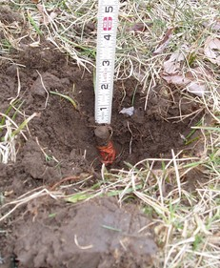
- if leaning, the general direction in which it is leaning (N, NE, E, SW, etc.),
- whether the pipe or pin is solid or loose in the ground,
- ANY indications that the pipe or pin may have been disturbed,
- described indications of age, if any,
- color and condition of any flagging found on the pipe or pin, (faded red, brittle, etc.)
- the top is peeled over or partially broken from driving it in the ground, if so,
- whether the top of a pipe is threaded or plain or pinched (cut by snipping),
- the presence or absence of any wooden stake and stake labeling if any, and
- for leaning pipes or pins, both the base as it enters the ground and its center at the top are located.
- Distinguish between rebars, round rods and square bars. (These are three different types of monuments, and “Iron Pin Found” does not tell the tale.)
- Distinguish between a PK nail and a Mag-nail
- Distinguish between a rail road spike and a dock spike and note the presence of a mark in the top of either to indicate a more precise location of the point
- Note color and engraving or impression in tags or caps and record the complete identification marked on same.

The crew is also required to take a date-stamped, digital photograph of the monument with something in the photo to provide relative scale - such as a portion of the prism pole or rule. In a paper field book a quick sketch is drawn to indicate physical features in the vicinity of the monument (such as walls, fences, significant trees, evidence of occupation, etc. On this sketch, the digital image frame number for the photo is recorded along with an indication of the angle from which the photograph was taken.

Concrete monuments, stone corners, axles, rivets, nails, spikes, drill holes, etc. MUST BE THOROUGHLY DESCRIBED as well, including notation of any marked point and any surveyor identification on the monument –plus notes regarding the size, shape and condition of the monument.

This, dear reader, is normal surveying practice! And, I make no apology whatsoever for making this not-so-humble statement about my not-very-flexible requirements of my field crews.

It never ceases to amaze me that some surveyors roll their eyes at this proclamation of mine that FULL details of found evidence should be labeled or noted on the survey map. Yet, more humble and inquiring minds may ask, "Why?"

Okay, here's why. If you are surveying a parcel and you locate a pipe near the location of the found pipe shown on an earlier survey, it will be easy to tell if it's likely the very same pipe depicted on the earlier survey ONLY IF that pipe is thoroughly described.

Hopefully, none of my readers fail to understand the value of knowing whether a pipe you find, presumed to mark someone's earlier opinion of property location, is the pipe – the VERY SAME pipe – located, identified, and depicted on the earlier survey. The value that you give to the pipe as marking a true corner is your professional decision, but you can't properly evaluate that pipe depicted on the prior survey, if you can't tell whether the pipe you located is the truly the same pipe set during the earlier survey or a pipe set later than the date of that survey.

Okay, now you're asking if I really do show all that detail on my survey map. Whenever practicable, yes, I do! This information can also be included in a survey report (a report referenced on the face of my survey map) in cases where that information has played a significant role in the professional opinion expressed through the survey map delivered to the client. Below is an example of what I’d indicate on the survey map at a minimum:

2” O.D. IPF, LOOSE, LEANS S.E. (UP 15”).

“IPF” is, of course, included in my legend. The level of analysis you apply to evidence found in the course of retracing an earlier survey, as you follow in the footsteps of the earlier surveyor, is impacted by whether or not that prior survey provides full descriptions of evidence located. Full descriptions can make the difference between you being correct or erring in your professional judgment. With benefit of full descriptions, you may be able to confidently conclude:

"That's the same pipe the earlier surveyor found, and he felt this same pipe is actually 1 foot west of the true boundary line.”

— or —

"Per the earlier survey, a pipe existed in or near the pipe I just located. I wonder if the pipe I found is the very same one shown on this earlier survey – or maybe it’s a pipe set by someone since the date of this prior survey.”

Do you see what a huge difference it makes in retracement when the earlier survey provides full descriptions of the evidence depicted on that earlier survey map? This kind of thoroughness on the part of an earlier surveyor has made all the difference in boundary decisions I’ve made when conducting a resurvey. Sadly, very few surveyors take the time and trouble to document thoroughly. Very few party chiefs of our time think beyond a three-letter description code punched into the data collector, and this is a great loss to our profession.

When retracing a survey I’ve produced, you can follow in my footsteps and weigh the value of my professional opinion, only if:
- I indicate on my survey a description sufficient for you to determine whether we have located the very same evidence you’ve recovered, and
- I also indicate where I believe that evidence is physically located in relation to the true boundary line or property corner.


I've taken the effort to make this point thoroughly, and I’ve done it for a good reason. It’s because I’ve personally observed the practices of many young surveyors who boast of their degrees from respected institutions. Yet, they lack the instincts and practical knowledge that once was typically received through years of mentoring. Mentoring was common for our profession decades ago. Often young, educated, yet relatively inexperienced graduate surveyors are placed in responsible charge when they’re fresh out of college, and they don’t yet know what they don't know. Our colleges have created great expections in their minds, and they’re puffed up by what they’ve learned through their education. Please don't over-react to what I've said.

I’m NOT anti-education. Read on.

This is what I am saying, and you may quote me:

Mentoring alone, in most cases, is no longer sufficient to produce today's or tomorrow’s surveyor. Formal education alone, in most cases, has never been, is not now, and never will be sufficient to produce a true professional boundary surveyor. Formal education followed by a few years of experience as a party chief is not sufficient to produce a truly qualified surveyor, either. Formal education followed by or combined with a period of several years of dedicated and purposeful mentoring under a seasoned, experienced, intelligent, ethical, professional surveyor is our profession's best shot at producing the surveyors in our time and the surveyors of the future.

Question 11 does my heart good because it requires the professional surveyor and mapper to do what the professional surveyor and mapper should know enough to do (at a minimum) without being told to do it. And yet, experience tells me that if some surveyors were not told that they must do this, it simply wouldn't be done.

And, this unprofessional tendency within some members of our profession displays itself regarding monumentation of property lines and corners as well. Fortunately, the MTS hasn’t overlooked this reality, this pressing need, as many other states have.

Your boundary survey must be monumented according to the requirements of Chapter 5J-17.052(2)(b). I applaud this diligent effort on the part of the framers and enforcers of the MTS.

Question number 12. The correct answer is:
b. False

See 177.091(19). The difference in 10,000 feet using the International foot rather than the TS required U.S. foot is .02 foot. Not a big difference when performing measurements in the field, but check your data collector settings. Some surveyors collect data for years in International feet without noticing the setting in their data collectors.

However, one surveyor recently lamented the considerable confusion created when a technician converted metric state plane coordinates from metric units to International Feet instead of U.S. Survey Feet.

Question number 13. The correct answer is:
d. a, b, and c.

Be careful! We have a tendency to view our closure data on the computer and not print it out and file it, thereby documenting and preserving records "sufficient to ensure that the accuracy portion of the standards has been met," as required by the MTS.

It's important to maintain some kind of a paper trail to document (in addition to your typical traverse closure data) what took place computationally and analytically in reaching your boundary opinion. In truth, this was easier to do in the days before computers, when your thoughts were placed on paper and your complex computations were made on paper and checked by someone else. Now, all kinds of magic takes place on the computer screen and out comes your control traverse and points plotted in their post-adjusted positions. It's not uncommon for the paper trail of some of our most professional and skilled calculations to be lost, and even the trail in our own memory of how we arrived at the decisions we did. The MTS says that measurements and computation records must contain sufficient data to substantiate the survey map. See that you do it! And don't forget that the MTS says you need to date it, too.

Question number 14. The correct answer is:
b. False

Based on my experience there is a general rule regarding the stringency of standards: When in conflict, the most stringent standard applies. The bottom line is that you could be disciplined by the Board after meeting every single requirement of the MTS, if you fail to meet more stringent standards set forth by some federal, state, or local government agencies that apply to the work you perform.

The MTS standard for error of closure of 1 foot in 10,000 feet, for example, is a fairly lax standard in our time. It's entirely possible that a local jurisdiction could require a higher standard for a boundary survey of the parcel being subdivided. And, the Board could, in my opinion, discipline you for failing to meet the more demanding standard set by the local government. (Consider this in relation to ALTA/ACSM survey requirement, too!)

Be aware though that this is sort of the reverse of a typical problem encountered in many states, namely that surveyors perform surveys that meet the standards of ALTA/ACSM land title surveys, yet fail to meet the records research requirements for surveys in the surveyor’s state. Some surveyors think that they can survey to ALTA/ACSM standards and disregard their state standards. Not so!

The general rule to keep in mind is when surveying to multiple agencies’ regulations is this, whoever issues the most stringent standards wins. Any surveyor who fails to satisfy requirements of the more stringent standards stands to lose.

Question number 15. The correct answer is:
e. either b or c.

An important thing to remember here is that a business entity issuing the map and report must not only provide the name and license number of the surveyor and mapper in responsible charge of the survey but also the business entity’s own certificate of authorization number. Also take note that the Board wants both the street and mailing address of the surveyor and mapper in responsible charge who is practicing independent of any business entity, or the street and mailing address of the business entity. Think of it this way: the Board wants to be able to reach those responsible, either by mail or by walking up and knocking on the door. A post office box number is not a street address! Provide both mailing address AND the street addresses of the business entity issuing the survey or of the surveyor, when a business entity is not issuing the survey.

Question number 16. The correct answer is:
c. the date of data acquisition.

It is my practice to create title blocks having areas for both the issue date of the survey and the date of field survey. The MTS doesn't say why the date of data acquisition is the date to be shown on a survey, but my guess is that this Rule protects you from liability or disciplinary action for not locating and showing on your map features or evidence that did NOT exist on the site until after you concluded your field survey. By stating the date of data acquisition (in most cases the date of field survey), you hopefully avoid responsibility for changes that took place between the time you concluded your data acquisition and the time you're survey product(s) made it out the door.

Under this Rule, it stands to reason that unless you have updated the data acquisition itself, graphical changes to the survey map are noted with a revision date, not a change to the date of the map itself.

Speaking personally, I would want the viewers of the survey map to understand exactly what the date or dates on the map or in the report actually reference. I recommend fulfilling the requirement of this Rule, and also including an issue date for the survey and report. For a typical boundary survey and subdivision plat, the date of data acquisition related to the records research, and the date of data acquisition related to field survey, and the date of data acquisition related to zoning/land development requirements are probably three different dates. I would state what data acquisition was completed on what dates in an attempt to protect myself regarding changes that took place after my completion of each portion of data acquisition pertaining to my project.

Question number 17. The correct answer is:
c. must be supported or substantiated by accurate survey measurements unless clearly stated otherwise.

It is not unusual for the various features or data shown on a survey map to come from different sources of information. Suppose for example, you survey around the boundary of a 300-acre horse farm, obtaining a computed linear error of closure of say 1 foot in 30,000 feet for your traverse., Then you depict interior features such as horse barns, corrals, driveways, workers’ living quarters, open fields, etc. from aerial photos that you’ve scanned in and rescaled based on visible tree lines in certain areas along the perimeter of the boundary. In creating this drawing, you've produced a survey map of widely varying accuracies.

Your property boundary is quite accurate. If your survey falls under a Rural Linear classification, you've obtained six times the required accuracy per the MTS closure requirements. But, your interior features are shown in approximate locations, based on your scanned-in and rescaled aerial photography with all of the accuracy limitations inherent in both your source material and your ability to properly fit this data to your survey.

It’s important to state clearly both the sources of your data and also the expected accuracy of each type of survey data shown on your drawings.

Question number 18. The correct answer is:

a. True

Many surveys in states other than Florida, colonial lands states to be sure, are based on magnetic bearings observed on the date of the current field Survey. Florida would like you to avoid Magnetic North as the basis of bearings except in cases where comparison is necessitated by a deed call.

Question number 19. The correct answer is:
- a, b, and c.

While we surveyors wouldn't trouble ourselves for a minute wondering what the abbreviations listed in answers a., b. and c., members of the general public are given the benefit of the doubt in the MTS regarding abbreviations. Abbreviations common to the general public like Mr., Mrs., Ph.D. are presumably acceptable to include on our survey maps and reports, but P.O.B. is not a term the general public is expected to know, nor is BLDG or MON. MON probably means Monday to the general public, and we all know how the public hates Mondays.

The bottom line? ALL abbreviations NOT listed in the MTS that are not commonly used by the general public MUST be included in a legend on the face of the map or report. Be sure to remember that this applies to reports as well as survey maps. We become so familiar with the terms of our profession that it's easy to forget that members of the general public may not know what we're trying to say or depict.

Again, your instructor applauds the Florida Board. I can't tell you how rarely I see an adequate list of abbreviations included in the legends of surveys in states other than Florida.

Question number 20. The correct answer is:
b. Commercial/High Risk Linear: 1 foot in 10,000 feet; Suburban Linear: 1 foot in 7,500 feet; or Rural Linear: 1 foot in 5,000 feet.

Anyone who has trouble meeting these requirements needs to examine how they go about surveying in our time. They are extremely generous to the surveyor.

Question number 21. The correct answer is:
d. should meet the same equivalent relative distance standards as set forth in subparagraphs of the F.A.C. specifying redundant measurement traverse closures.

Maybe I'm mathematically challenged, but to me this Rule requires that we homogenize oil and water. While we may suspect that our 10,000 foot traverse that yields a 1 foot error of closure represents an error to be distributed more or less equally among the stations (and of course our side shots to corners “float” along with this adjustment made to our main traverse), what proof do we have that the 1 foot error did not occur in just one place or in two or three places, maybe four? What mathematical theory do we use to convert a linear error of closure to a statement of statistical probability at the 95% confidence level?

Question number 22. The correct answer is:
a. True

Legibility of the plotted paper version probably stands behind this Rule.

Question number 23. The correct answer is:
e. length of time not specified in the MTS

Pay special attention to this rule! Since no time limit is specified for the maintenance of survey measurement records, one must assume "forever" is a good guess at the required duration. Forever can be a very long time. Does this mean that if you die you MUST see to it that your measurement records are perpetuated for eternity? Apparently so. I wish the MTS specified a reasonable limit on how long a surveyor must maintain records. Perhaps the time required could be the same as a reasonable limit for the surveyor’s liability!?!

Question number 24. Per 5J-17.052(2)(a)4., the correct answer is:
a. the survey map must also show the change in direction by deflection angle.

When in Rome do as the Romans do. As far as I can tell, this does not preclude you from also showing bearings and distances on the two lines that meet at the deflection angle, but if the written property description states a deflection angle, be certain to also label the deflection angle on the map.

Question number 25. The correct answer is:
e. at a minimum, a or b.

At a minimum, curved lines (that is, arcs) on a boundary map must show at a minimum either radii, arc distances, chord distances and chord bearings -or- radii, arc distances and central angles. I'll bet you can guess my favorite of the two. Yes, it's the first, and I’ll bet you know why.

In many cases, labeling just the radius, arc distance and central angle of a curve does not tell you whether or not the curve is intended to be tangent to whatever connects with that curve at either end. This to my taste is insufficient curve data. If the written description does not reveal whether or not the curve is a tangent curve, or if the math doesn’t work out perfectly, then you cannot calculate the exact mathematical closure of the parcel. If a parcel as labeled or described fails to mathematically close, then not knowing the chord bearing and distance puts you at a strong disadvantage to resolve the amount or the true location of the error.

My personal choice is to label arcs with radii, arc distances, central angles, AND with chord distances and chord bearings. This not only gives the users of your survey map enough information to determine whether or not the curve is tangent or non-tangent, but it also provides redundancy that may allow a user to determine the intended curve geometry in the event of a typo in the the curve data on your map.

The language of any new property description I generate specifies that a curve is either tangent or non-tangent.

Question number 26. The correct answer is:
e. All of the above.

Now here's where I not only applaud the Florida Board, I also rise to my feet in a show of appreciation. It is my policy on every survey to show a distance to the nearest street intersection or reference point. (And by Jonathan Terry's definition, a "reference point" is something physical that can be recovered by a surveyor, and better yet by your average member of the public.)

I also include in written descriptions of parcels that are not part of a recorded subdivision plat, an introductory paragraph stating the general location of the parcel, whenever possible using layman's terms.

Here’s an example: The parcel of land described herein is located generally about one half mile south of the statue of General Harbinger that sits on the green in the center of town and about one quarter mile east of the intersection of Harper Road with SE 142nd Place.

I was sad when the ALTA survey requirements removed the compulsory distance to the nearest street intersection and made that information optional. I personally feel that a boundary survey should tie the surveyed parcel generally to some place on the earth that any sober person familiar with the area could easily identify and locate.

I well remember a survey that I saw in the state of Vermont that depicted a 200' x 200' lot fronting on a particular road in a particular town. That lot was being newly cut out of a larger parcel and was surrounded on all sides by the grantors land. There was absolutely no way looking at the survey to determine where the 200' x 200' lot actually existed. No reference point was given; no distance or reference to any parcel adjoining the grantor’s land was provided; no distance to an intersecting street was indicated. This parcel simply could not be located on the earth, unless perhaps you were the surveyor who prepared this thoroughly deficient map.

Incidentally, my hat's off to Florida for requiring a comparison of recorded directions and distances with field measured directions and distances. In my opinion, this removes a tremendous amount of confusion that only gets worse as the boundary is retraced again and again.

Question number 27. The correct answer is:
e. All of the above.

Now here's where I sit down, put my hat back on and let the palms of my hands cool off. No applauding here. Why?

Because of the wording, "the most current abutting recorded instrument or recorded plat either known by the surveyor and mapper or furnished to the surveyor and mapper."

These words again suggest to me a general lack of clear directives regarding sufficient records research being performed by the surveyor and mapper.

A surveyor in Connecticut once remarked to me, "I could send a monkey to do records research." (It may explain this man a bit if I tell you he was an engineer who also became licensed as a surveyor.)

I replied, "Records research is one of the most professional things we do as boundary surveyors."

As far as I'm concerned, "most recent deed surveying" is not surveying at all but merely measuring. And, the wording of this Rule sounds to me like it comes from the mind of a "most recent deed surveyor." Other wording in the MTS, as noted elsewhere in this course, would seem to hold the surveyor and mapper responsible for anything not discovered during the research phase that is later discovered to impact the surveyed property.

Regarding sufficiency of records research, I find the Florida MTS vague and bordering on contradictory in its intent. The MTS leaves me wondering what is expected of the Florida Professional Surveyor and Mapper as regards the extent of records research required for parcels being surveyed? How does Florida view the role and responsibility of the surveyor when it comes to records research?

Other states do weigh in on this emphatically in their standards. How I wish the MTS were as crystal-clear on this point as they are on so many other important aspects of performing surveys in the state of Florida.

Question number 28. The correct answer is:
e. b, c and d.

Now I'm standing, and my hat is off once again. The palms of my hands are red from obsessive clapping. Many states do not require that monuments must be set in the course of performing a survey. (Can you believe it?) In my travels and practice in other states, I've encountered many survey maps that labeled property corners with the note, "Iron Pin to be set."

Guess what. Those pins “to be set” can’t be found in the field! Perhaps the surveyor meant, “to be set by other surveyors at some unspecified time in the future.”

To be fair, in northern portions of the U.S., winter frost does prevent monuments being set. The earth becomes like steel! Sometimes a client requires a survey that just can’t wait for spring, and a note on the map about future setting of corner monuments is appropriate. But, I’ve seen more than one surveyor who routinely uses that notation and routinely never gets around to setting those “to be set” monuments.

Monumentation of surveyed property corners IS important! Florida's MTS requirement that surveyed property corners MUST be monumented (when the frost has melted) should be a model for all states.

Question number 29. The correct answer is:
e. All of the above.

My soap box has already been used to express my views on this topic. I do believe this Rule states the absolute minimum, acceptable information that any surveyor and mapper should disclose to the users of his or her survey.

But, if you've only worked in Florida, you'd be amazed to discover that the bulk of surveys prepared in states that do not specify this kind of detail in their standards make it impossible to tell whether an iron pipe or an iron pin was found or set and whether or not it has any identification on it.

Question number 30. The correct answer is:
e. a, b and c.

The Regulatory Objective that once appeared in the earlier version of MTS at 61G17-6.004(2)(c)1. stated the following:

REGULATORY OBJECTIVE: In order to protect and enhance stability of property location and title, the public must have assurance that potential boundary inconsistencies are adequately researched and disclosed. [Emphasis mine.]

As stated earlier in this course, this "sleeper" research requirement of the earlier MTS seems to have died in its sleep, and I mourn the loss.

I believe that only through adequate, sometimes extensive research can we HOPE to provide such assurances to the public. Maybe that is why the REGULATORY OBJECTIVE has been removed from this new incarnation of the MTS. Nevertheless, I firmly believe we should be doing this level of research on every survey, and you may be surprised to know that I haven't had much difficulty convincing clients that the extra cost involved in performing such research is both justified and desirable to the client.

In every boundary dispute in which I've participated, provided expert witness testimony or performed research in advance of a session in court, I’ve prevailed over other surveyors precisely because of the amount, thoroughness and quality of records research I’ve performed. (In some cases parol evidence was also a key to prevailing in court. Surveyors have a tendency to neglect the gathering of parol evidence, but that’s another story.)

When a client has heard me out on the importance of performing adequate research, they often wonder if a survey that’s commissioned based solely on a surveyor’s ‘expertise in measurements’ is a product worth having or worth paying for at all. When people call and ask for a survey, in the majority of cases they are not saying, "I’d like to have you come and measure the stuff you find around my property."

What they're really saying is this:

"I want you to show me the limits of my property. I want you to explain to me what a ' bundle of rights' is. I want to know what rights in my property have been given up by my predecessors in title, or that I may have inadvertently given up, or that I may be in danger of forfeiting. I want to

know what rights others have on, over or under the property I have title to. I want to know if you’d advise me to seek legal counsel about any condition related to my property or about possible action I might take to preserve, secure or recover my rights. And, I want you to put enough work into this survey so that if I take your professional opinion into court, and if the judge understands property law, the opinion you express will prevail in court. I'm not interested in you just making precise locations of stuff on my property that looks like corner markers; what I'm really interested in is gaining the greatest sense of security available to me through hiring a surveyor. I want the peace of mind that spending my money in this way brings to me and my family."

Of course, the average client doesn't articulate this, because he or she doesn’t realize it until I explain it to them.

When your phone rings, what you often hear on the other end of the phone is, "What will it cost to have my property surveyed?" Normally, I make a patient explanation to the potential client of what's contained in the above paragraphs. My professional service to my clients begins by my helping callers to better understand what they really should be asking me and what they really should be seeking.

Once I've made a patient explanation to my potential client; once the client comes to realize and appreciate what he or she is really requesting of me, and through our interaction believes that I represent the professional caliber and personal character capable of delivering this --- I generally get hired.

Then I can do work I'm proud to do in exchange for a professional fee worthy of the service I provide. Generally, my fees are much higher than those of other surveyors. Often, I’ve been hired because the caller didn’t understand what he or she was really needing until I explained it.

You’ve all heard the saying, “You get what you pay for.” The problem with $300 surveys is that the client doesn’t even get that! I never cease to be amazed at how many surveyors just don't get it.

I hope you do.

Question number 31. The correct answer is:
e. a, b and d.

Is there ANY way a surveyor and mapper can possibly know about or discover the presence of boundary inconsistencies defined in answers a. or b. without performing adequate research? I don't think you would say that there is. Some surveyors I know honestly believe that their role is merely to serve as an expert in measurement. Those who hold to that belief offer their clients a glorified location service. In the end, they tell their clients, “Your title line is here; your fence is here. The two aren’t in the same place. Go see a lawyer.”

With the technology and equipment we have today, expertise in measurement is not hard to come by. Accurately turning angles and measuring to fences, walls, buildings, and monuments requires little beyond possessing modern equipment and knowing how to use it. Mapping the results to scale is not particularly difficult to teach. And I'm sad to say that I've known a number of firms who turn out measuring-and-mapping products wrongly called, "surveys."

On the other hand, expertise in performing records research, gathering parol evidence, knocking on doors at an hour when people are at home in an attempt to discover unrecorded surveys, researching rights-of-way widths and locations, road vacations or abandonments, recorded and possible prescriptive rights benefiting and burdening the
parcel being surveyed – these are skills gained over time. That sixth sense or instinct that only some mature surveyors possess combined with professional research capability and, oh yes, expertise in measurement are what sets the true professional surveyor and mapper apart from the run-of-the-mill surveyor and mapper.

You may have heard the story about George Washington that goes something like this: George Washington performed a survey for some client, and upon completion of the survey, he presented his client with a bill for $100.

The client was livid! "$100 for setting four pins at my property corners?"

George Washington took his bill back from the man and apologetically said, "I'm sorry. You're right. I'll correct the bill."

The corrected bill that George Washington returned to his client read:

Setting 4 property corners $ 1
Knowing where to set the corners $ 99
-------
Professional fee $100

Question number 32. The correct answer is:
a. True

In question 32, I would like to draw your attention to the words, "all" and "apparent."

Hats off again! The Rule did not use the word, "encroachment." And I suggest that you don't either. Whether or not an apparent physical use is or is not an encroachment is a legal question not a question of fact, and labeling apparent physical use or even the presence of physical objects like sheds or other buildings as "encroachments" is rendering a legal opinion that I believe opens the surveyor and mapper to a world of hurt.

The location of and dimensions related to apparent uses or occupation by parties other than the owner of the parcel you’re surveying should of course be indicated on your survey map and in your report, however you must be careful not to inadvertently offer a legal opinion in such cases. This door swings both ways: You must also indicate your client’s (and/or the subject parcel’s) apparent use onto or from adjoining property.

Question number 33. The correct answer is:
b. failure to determine their location shall be noted upon the map or report.

Surveyors should be aware that foundation wall footings typically extend beyond the foundation wall itself both on the inside and the outside of the building’s foundation wall.

I don’t consider it a “failure” if you don’t locate anything you can’t see or measure because it is beneath the surface of the earth. Many clients and title companies and others have tried to trap surveyors into certifying that they have x-ray eyes. I personally think this feature of the MTS is poorly worded. So, I personally would phrase my note more along the vein of, "Features and improvements not visible beneath the surface of the ground have not been located unless specifically depicted or noted hereon."

As far as I know, this should suffice in fulfilling the spirit of 5J-17.052(2)(c)4. In cases where you are pretty certain underground foundations or improvements of any kind are specifically in question, then a more specific note to that effect would of course be prudent, if not required.
Question number 34. The correct answer is:
b. c and d.

Read 5J-17.052(2)(d)1.-4. carefully, because embedded in this Rule is a research requirement. Notice the word, "all" in the requirement.

This rule makes it imperative that you research all applicable recorded plats adjoining or across the land being surveyed but it doesn't say anything about researching deeds. Once again, the MTS fails to make clear exactly what the Board believes is necessary in the way of records research.

Question number 35. The correct answer is:
e. b and d.

Answer a. is incorrect because the MTS doesn’t say anything about “improvements within 10 feet of the boundary line being surveyed.”

The first correct answer to this question (b.) is quite straightforward. In all cases where improvements exist within the limits of my survey and have not been located, I include a note on the plan that states, "Improvements exist on this site which were not located and are not depicted on this plan." If the purpose of the survey is to determine or certify to some zoning compliance issue, it's quite possible that some sidewalks, patios, driveways, and other improvements may not be relevant to the survey’s purpose. In such cases, it may be prudent to specifically state the improvements or the nature of improvements that have not been located, as the note in the above paragraph could lead the person reviewing the survey to wonder if sufficient locations have been made to adequately assess zoning compliance."

What makes me nervous about 5J-17.052(2)(e)4. is the part about surveyor #2 locating improvements on the parcel surveyed and monumented by surveyor #1. Notice the words, “when a boundary survey updates a previous boundary survey made by a different surveyor or survey firm…”

I’ve always hated that word, “update.” What the heck is an update to someone else’s survey? Isn’t it a new survey, or a re-survey at best? I’ve had people call and tell me, “All I need is an update to another firm’s survey”

What are they really saying? Hasn’t fee negotiation begun, and all I’ve said so far is, “Hello.”

I’m sad that we surveyors have allowed ourselves to adapt this language. My vehement proclamation is that there is no such thing as “an update to someone else’s survey.” Am I somehow absolved of professional liability or the potential for being disciplined by the Board because, “Gosh, you know, I was only doing an update.”

Question number 36. The correct answer is:
e. a and c.

It always bothers me when a state Board tries to regulate construction layout. Many surveyors simply don't know what they don't know about construction layout. Now, I know that statement may ruffle some feathers, but I've had too much real-world experience to feel very humble in my opinion about this.

The "correct" answer to this question is correct as to what the Rule requires, but in my opinion creates more problems than it solves and feeds ammunition to attorneys who may question surveyors in court in the event a surveyor is sued related to construction layout services rendered.

First let's take a look at "correct" answer "a." Think about it. What exactly constitutes, "adequate in number and position?" The answer varies widely depending on the contractor. A very simple example: Consider two different contractors constructing a sewer line, a 300 foot run between two manholes. The first contractor uses a laser to guide his horizontal and vertical alignment of the pipe; the second contractor controls horizontal alignment with the transit and determines the vertical grade of the pipe from offset stakes using a self-leveling level and a stadia rod.

Both contractors would benefit from double offset stakes for each manhole.

The first contractor in this example really needs nothing more from me in the way of stakes. My practice is to give him two more offset stakes, one offset stake at 50 feet and one at 100 feet "upstream" from each manhole, and provide cuts to the flowline of the pipe at those two points, not because the contractor needs them or will even use them, but to cover my own liability (CYA). On the paperwork I deliver to the contractor, usually an abbreviated cut sheet, I advise the contractor to check these stakes at the beginning of the run to verify my stakes at the manhole and the contractor’s equipment settings.

The second contractor gets what the first contractor gets plus an offset stake at every even 50 foot station between manholes along the sewer run.

To me, what determines stakes "adequate in number and position" is a matter between the surveyor and the contractor, and as a person who has personally provided construction layout for hundreds of millions of dollars of commercial construction and a fair amount of residential construction, I fail to see the benefit to anyone in this Rule.

And then there’s the "correct" answer "b." Let me ask you something. Suppose you're staking waterline for blasting or the top and bottom edges of your average, run-of-the-mill detention basin, or clearing limits, or rough grade for an overall site. Should you be constrained to meet the vertical and horizontal closure requirements of Rules 5J-17.051 and 5J-17.052, F.A.C.?

And for thorough construction layout services including larger commercial, institutional, industrial, educational buildings and sites, my experience tells me (and I've had a lot of it) that if I don't have a 1:30,000 traverse closure or better at the start of the project, that my control will haunt me throughout the duration of the project. If I have a 1:10,000 closure I've met the MTS, but I have a lousy start on my construction layout project.

Surveyors who haven’t learned that varying levels of accuracy are required for the different features of construction layout should not be performing construction layout. It’s that simple. Construction layout is a specialty; it's a dynamic, challenging and demanding professional service, and the surveyors who really understand it and are truly qualified to perform it are in the minority.

I highly recommend Florida approved Course L120F, Construction Layout, offered through PDHonline. (That course’s author has expertise in construction layout, and the course is a fun read!)

Question number 37. The correct answer is:
e. a or b or c.

In my career, I've worked in quite a number of firms having various specialties: surveying only, engineering firms that offer surveying, architectural firms with in-house engineering and surveying. It is not an overstatement to say that I've been shocked over and over again by how infrequently professionals in these firms fail to ask their construction layout clients what they desire for layout.

Again and again, survey crews are sent out to lay out something in a manner other than what's really needed or wanted by their clients.

In the past, I've made what any surveyor would probably agree is a great deal of money performing construction layout. One of the keys to my success was the mess other surveyors made of construction layout and the degree of dissatisfaction general contractors and construction managers had with the service other surveyors were providing.

What bothers me most about the Board’s Rules related to construction layout is that I have seen and experienced firsthand the problems surveyors cause for themselves and for their clients when they perform construction layout without really understanding the dynamics involved. And, I don't believe the most common or serious problems are solved through these Rules.

Question number 38. The correct answer is:
b. The proposed building is an upscale, 4,500 square foot, private residence having three major sections, each with 10-degree deflections in exterior walls, an attached three-car garage set at a 30° angle to one end sections of the house. The home is supported by a poured concrete exterior foundation with full basement and an intricate pattern of unevenly-spaced steel columns.

Per the MTS, the most difficult-to-construct and possibly even the most expensive building may legally be laid out with the least required building control provided by a professional surveyor and mapper.

I’ve performed geometric computations and construction layout for an office park zoned for 3,000,000 sq. ft. of office space; also for libraries, schools, shopping centers, multi-story office buildings, medical complexes, parking garages, etc. Yet, one of the more challenging layout projects I’ve computed and staked was an upscale, personal residence for a very wealthy individual – a building very much like the one listed in the "correct" answer to this question.

My point: many commercial projects are quite simple compared to some upscale, single-family residences. Per MTS, the massive, complex residence can be built from "boundaries provided by a surveyor," but a cookie-cutter, prefab church in the wilderness as well as a small, pre-engineered, rectangular warehouse requires more layout than the residence.

Again, it's very hard for me to believe that the public receives much protection from the portion of MTS governing construction layout practices. Because of the MTS, surveyors providing construction layout on a regular basis to talented contractors will on occasion have to tell their clients, "I know what you're asking me to do is exactly what you need. But, it would be illegal for me to do it, and I could be disciplined by the Board for providing you with the most sensible, economical and useful thing. You’ll just have to pay me for doing something you don’t want and don’t need." This is bad business.

Question number 39. The correct answer is:
d. a minimum of two (2) existent or established benchmarks for vertical control.

It has been my policy to ALWAYS place a minimum of two benchmarks whenever I have been asked to provide a vertical control point. In addition to providing the two benchmarks I create a brief correspondence in writing stating that the user of the benchmarks is advised to always check between two benchmarks to verify that the benchmarks have not been disturbed. I will almost never agree to write the elevation of the benchmark on the benchmark or a guard stake nearby.

The reason is this: Site contractors are notorious for disturbing a stake or a control point and then dutifully "putting it back" in what they think was its original position. Or, they remove a stake and reuse it in a different location without making certain the original writing on that stake has been crossed off. I can't tell you how many times I've seen a stake that I set pulled out and used for another purpose by someone working on the site. Seldom if ever do they scratch out my writing, and the worst thing that can happen is that when they're through using that stake they go and put it back as close as possible to where they think it came from. (Believe me, this really happens!) Instead, I label the stake with a point number or “BM#4,” and on paper provide the elevation of the benchmarks with clear descriptions the physical benchmarks.

If you’ve grown up surveying in Florida under MTS, you will be amazed to know that when doing consulting and training work in other states, I often encounter surveyors and party chiefs who think I’m from outer space when I tell them to never set just one bench mark on a site, to always set at least two benchmarks. Even after careful explanation, I often encounter resistance. Hard to believe!

This Rule of the MTS requiring a minimum of two benchmarks is a good Rule!

Question number 40. The correct answer is:
b. Two, regardless of acreage.

This, of course, states a minimum, not a limit of two benchmarks. A 300 acre topo project could probably benefit from having additional benchmarks, but the MTS doesn’t require more.

Note: Incorrect answer e. in question 40 applies to “acreage construction sites, per MTS.”

Question number 41. The correct answer is:
e. All of the above.

Answers a. through d. are all correct.

Regarding answer “a” --- You know one quality that makes a good teacher? It's a person whose familiarity with their subject matter has not made them insensitive to how unfamiliar their students are with the matters being taught. And so, they explain the meaning of terms that are peculiar to their specialty as they introduce them to their students; they'll never use new terms conversationally during their lectures and expect the students to figure out what they mean through usage alone.

Do you know what makes a good mapmaker? Among other things, complete legends.

Regarding answer “b” --- This is a lot like something we discussed earlier. If you fail to locate something and show it within the area included in your survey map, tell the person viewing your map what you haven't located or shown.

Regarding answer “c” --- Have you ever received a half-scale set of plans, and the original detail or text of the full-size drawing was so small that at half scale you can't make out what's presented? Have you wrestled trying to understand maps having an insufficient variety of line types, and the lines cross over each other at narrow angles, and symbols overlap symbols so that it's difficult to tell what features exactly are being represented on the plan?

One of the dangers of the CAD world is that the mapmaker is sometimes “zoomed in” to the degree that very small things appear very large on the computer screen. When the work is plotted, it may indeed be very small. Also, different layer colors make distinguishable on the screen features and information that are sometimes indistinguishable when not plotted in color or when a color plot is scanned and reproduced as a black-line copy.

More and more, our mapping products are retrievable over the Internet at some greatly reduced scale, and generally, if not always, they are in black and white. It's wise to consider when producing a map the various formats in which it may eventually appear.

Regarding answer “d” --- In the CAD world, it's typical that we distinguish the sources of data by placing our lines, symbols, and text on layers carefully named to identify the source of our data. For example, we might include the letters OBSC in the layer name for contour data in obscured areas of our Topographic Survey and use a distinct layer color for obscured area contour lines. Unfortunately, it is common that sources of the various data are not evident to all viewers of our final, plotted map. 5J-17.052(12)(b)3. wisely addresses this issue.

Question number 42. The correct answer is:
c. shall be accompanied with a statement as to the source of the property lines shown

This is a good Rule, but it makes me a little sad that we who are called professional surveyors and mappers must be told to do some of the things the Rules require of us.

As boundary surveyors, it should be at the forefront of our consciousness that whenever a boundary is shown on any plan or map we produce – even though the plan is not a "boundary survey" and is clearly titled to reflect its true purpose – we should always include a statement identifying the source of the property lines shown.

----------------------------------------

FOOD FOR THOUGHT REGARDING MAPPING STANDARDS:

Recently, at another state society’s annual convention, I spent time reviewing plans submitted for the state’s annual map competition. A large number of surveyors and firms submitted surveys in a wide variety of the competition’s mapping categories. A few entries were impressive as cartographic products, but most were not. Cartography (called drafting, in our profession) used to be an art. Little from that tradition remains. Art has bowed the knee to technology.

Art aside, few entries were impressive as survey products. To my observation, they seemed to reflect less of that personal touch – the care and professionalism of earlier times, the ‘personality’ that once distinguished one surveyor’s work from another’s.

Several entries displayed labeling overlapping other lettering; linework running through labeling to the point the labels couldn't be read; tiny lettering, difficult to read at full-scale plotting and worthless at a reduced scale; and most were visually imbalanced – poor overall composition within the plotted sheets.

The poor quality of these mapping entries brought home to me just how much of the art and sensitivity that once graced survey mapping has been lost in our time, and this is a great loss to the profession.

And what of the actual content of the surveys, art and morality aside? Most of the surveys offered little to aid the person attempting to "follow in the steps of the earlier surveyor." Most of these entries provided no indication of the basis of bearings. Many used muddy-looking digital USGS map images as location plans. These made it difficult to determine exactly where the project was located compared with the few plans with location maps showing road names and route numbers. Few offered real information about what went into the survey. Often reference plans and documents were not listed and surveyor's notes were of little import or practical use to future surveyors.

Legends lacked sufficient content and detail. Linework was inconsistent and difficult to interpret.

Most maps seemed to say, “I know, but I ain’t tellin’.” In other words, how much effort really went into the ‘professional opinion’ represented by the plan would remain a mystery, and if you come behind to do a re-survey, you’re basically on your own.

I repeat: these maps were entered in the state’s Annual Plat Competition!!!

Hundreds of people milled slowly by and viewed them during that convention. Have we no shame? And yes, I must stress, this convention was NOT IN FLORIDA. Our Florida Minimum Technical Standards are our friend!

I once watched a survey company perform a “mortgage survey” across the street in the subdivision where I lived here in Florida. I kid you not: The crew never set up an instrument. They “guessed” how far inside the property line the fence was. They “lined up” by eye midway along a side property line and measured perpendicular offsets to building corners from that eyeballed position.

So… hats off to the MTS! While I’ve been openly critical of a few aspects of the MTS, I believe Florida Surveyors and Mappers have them to thank for protecting the profession we practice from the enemies within our own ranks. And, we need to go farther in regulating our profession and enforcing violations. We have survey “brokers” advertising nation-wide surveys via Internet (including Florida surveys) for a few hundred dollars. They do not identify their office location, any way to reach them by mail or phone, and they do not offer license numbers of persons or a business entity. And, you all know the people in your own region who simply should not be surveying.

One firm I know of has two mission statements. One mission statement is for its clients, and it speaks of the desire to meet the clients' needs with all manner of good intentions, professionalism, talent and dedication. The other mission statement is the one employees of the firm hear at staff meetings. "Our goal is this: Get the work; get it done; get it out."

I wonder if that firm’s owners hear any difference in the two mission statements or if they’ve grown completely tone deaf to basic morality. I doubt one can fulfill the mission statement posted on the firm's web site, the company brochures and stationery through the talents and efforts of employees working under that other, in-house mission statement. I’m not making this up, folks.

There is no place for hypocrisy and two-facedness in the professional realm. Firms that rely on "spinning" the truth to fit the situation degrade themselves, their employees, their products, their culture, their families and their (our) very way of life in this nation. Individual professionals who feel no obligation to their profession or to their culture are not professionals at all. Having a license and a seal does not a professional make.

Our world is full of constant pressures and temptations to compromise our personal and professional ethics. May I encourage you this day to steadfastly resist the cheapening of your own souls and of Professional Surveying and Mapping.

You serve in an honorable profession. Noble men and women have earned the respect we now enjoy as professionals. Do everything you can in each and every day that you’re given life and breath to walk, talk, and act ethically and morally in keeping with the best traditions of those in our profession who have gone before us and lived honorably with a clear conscience toward God, fellow citizens and society as a whole. Those professionals set a standard worthy of our highest efforts and honest affections.

Thank you for choosing this course, and I sincerely hope you benefitted both personally and professionally through the time we’ve spent together in Florida’s MTS.

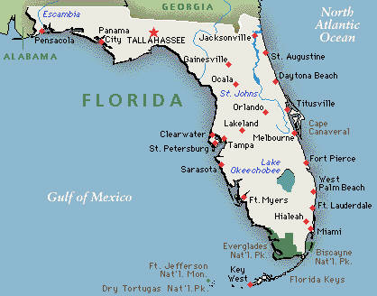
Appreciatively yours,
Jonathan Terry

